INDIAN SCHOOL AL WADI AL KABIR
STD XI -HOLIDAY WORKSHEET
INFORMATICS PRACTICES
Note : All the Questions with its coding are to be written in the Record Note Book.
Q1.
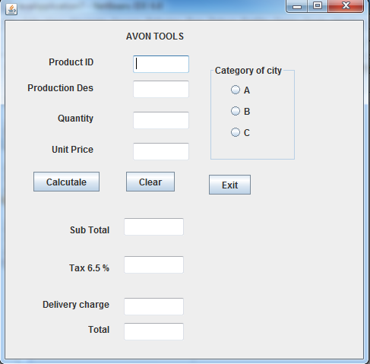
Write code to implement the following:
- When the user clicks the clear button , all values stored in text fields and radio buttons should be cleared.
- Ensure that in a text field for qualtity, the value entered is numeric only
- Close the application when exit button is clicked.
- When the button with caption “Calculate “ is clicked , sub total , tax( 6.5 % of sub total ), delivery and handling charges and total amount are computed and displayed.
The criteria of delivery and handling charges is as given below:

Category of city charges
A 2000
B ` 3000
C 3500
Sub total is calculated by multiplying quantity with unit with unit price. Tax is calculate as 6.5 % ofsub total.

Q2. The shop n save store has the following data entry screen for its operations. The store offers different types of membership discount schemes for its regular customers. Platinum members get a discount of 10 % on all their purchases, gold members get 5 % and silver members get 3% discount.
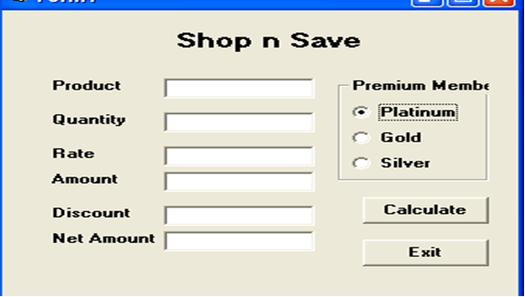
- Write the code to disable the text fieldsamounttf, discounttf and nettf.
- Write the code for calcbtn to calculate the amount, discount and net amount as per the given description and conditions.
- Write the code to remove the decimal part from the text field nettf so that the net amount contains only the integer portion in rupees. Where in which event handler) would you place this code to have its impact?
- Write the code for exitbtn to close the application , but before the application is closed it should check the net amount and if the net amount > 10000, the membership of the customer should be upgraded to and displayed. For example, if the customer already has silver it should be upgraded to gold,, gold to platinum and he should be informed of the same using a message box.

Q3.
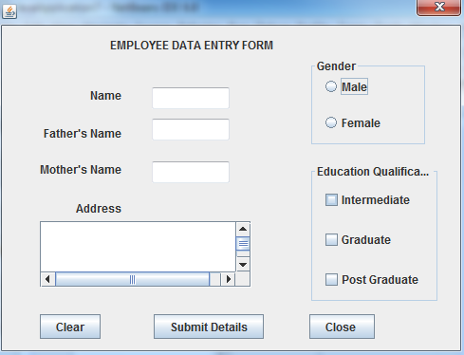

- Write a code snippnet on action event of clearformbtn clear text field objects , set default choice in a radio buttons to female and clearing all check box controls.
- Write a method procheckqualification to be called in the submit button’s action event. The procedure code will perform the following action:
If the check box postgraduateCB is checked then the prusedure will automatically check the check box esgraduateCB and intermediateCB irrespective of their initial state. Similarly if the checkbox graduateCB is checked then intermediateCB should also be automatically checked.
- Write a method procconvertcase to convert all the employees details in nameTF , fatherTF , motherTF and addressTF to uppercase characters.

Q4. Glamour Garments has developed a GUI application for their company as shown below :
The company accepts payments in 3 modes- cheque , cash and credit cards. The discount given as per mode of payment is as follows.

Code of Payment | Discount
Cash | 8%
Cheque | 7%
Credit Card | NIL
- If the Bill Amount is more than 15000 then the customer gets an additional discount of 10% on Bill Amount.
- (i) Write the code to make the textfields for Discount (named txtDisc) and Net Amount (named txtNetAmt) uneditable.
ii) Write code to do the following:
c)When "Calculate Discount" button is clicked the discount should be calculated as per the given
criteria and it should be displayed in the discount textfield. "Calculate Net Amount" button (named btnCalcNetAmt) should also be enabled. (1)
d) When "Calculate Net Amount" button is clicked the net amount should be calculated and it
should be displayed in the net amount textfield.
e)Convert txtName (jTextField1) value into uppercase.

