INDIAN SCHOOL AL WADI AL KABIR
Department of Computer Science
Holiday Home Work
Class: X
Topic: JAVA Programming
- HSBC is a bank. The Bank provides three types of loans- Car loan, House Loan,Education Loan.

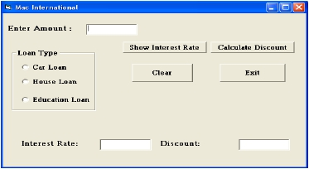

Read the following case study and answer the questions the follow:

Make a java swing frame as shown above and accept values through jTextFields.

Perform according to following questions:

a).Write the commands to show the interest rate according to the following criteria.:

Car loan – 10% of amount

House Loan – 8.5% of amount

Education Loan – 5% of amount

b.) Calculate the discount on the amount according to following criteria.
• If amount > 10,000,00 and < 20,000,00 then 20% discount.
• If amount > 20,000,00 then 25 % discount.

- Design a GUI applicaton having an interface as shown below:

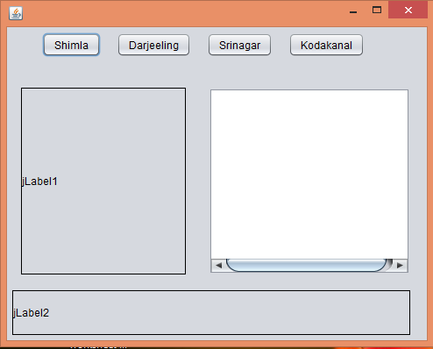

- When user clicks on a button, Lable1 should lists an image/picture of that tourist place.
- The Text Area lists the package details for the selected tourist place.
- Label2 shows some interesting information about the selected tourist place.

Date of Submission: 10-Jan-2015

Remarks:

- Coding should be written in MS word and mailed to respective computer science teacher
Email Id:
- Mrs. Archana------------acchumca@gmail.com (class 10 D)

- Mr.Ranjith Kumar----------- ranjithkumar@iswkoman.com (class 10A,10F)

- Mrs.Soumya P.V--------------- soumya2014arun@gmail.com (class 10B,10C,10E,10G and 10H)

