INDIAN SCHOOL AL WADI AL KABIR
Department of Computer Science
Holiday Home Work

Class: X
Topic :Java Programming

- Design an application that obtains three values in three text fields from user: Principal, Rate of Interest, Time. It should then compute and display Simple Interest when Calculate button is clicked. Controls names and Interface are given below
Control | Purpose | Name
Text Box | To accept Principal | jTextField1
 | To accept Rate of Interest | jTextField2
 | To accept Time | jTextField3
 | To display Simple Interest | jTextField4
Command Button | To Click for computation & display of Simple Interest | jButton1

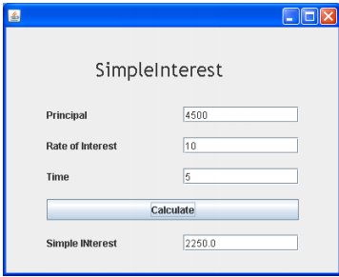

- Teachwell Public School wants to computerize the employee salary section. The School is having two categories of employees : Teaching and Non-Teaching. Now answer the following questions:

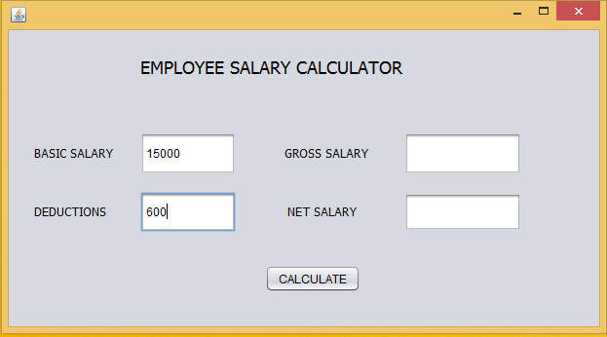

Write the code to calculate the gross salary and net salary based on the given specifications:
Gross salary=Basic salary + DA + HRA
Net salary = Gross salary – deductions

Date of Submission: 16-Aug-2015

- Remarks: Coding should be written in note book and submitted to respective computer science teacher.

