INDIAN SCHOOL ALWADI AL KABIR

DEPARTMENT OF SCIENCE 2015-16

HOLIDAY HOMEWORK – CLASS 7

To make model demonstrating mechanism of breathing:

Required materials
- clear plastic
- cylindrical plastic bottle
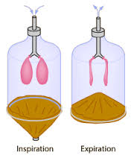
- plastic Y-tube
- modeling clay
- big rubber balloon
- two rubber bands
- adhesive tape
- scissors

Estimated Experiment Time
Approximately 30 minutes

Step-By-Step Procedure
1. Cut the bottom of the plastic bottle with a scissors (with parental support)
2. Tie balloons to each end of the Y-tube using rubber bands.
3. Carefully insert the Y-tube through the small opening made at the center of the plastic bottle.
4. Hold it in place by using modeling clay and to prevent air from entering or leaving.
5. Stretch the balloon sheet under the open bottom of the bottle.
6. Tie a string at the middle of the stretched balloon sheet.
7. Pull the balloon and observe how the balloons attached to the Y-tube change in shape. Page 1 of 2

Note
- Be careful in handling sharp objects like the scissors.
- Make sure that you tie the rubber bands tightly in places where you need them.

Observation
- What do the parts of the model represent?
- What happens when you push and pull the balloon?
- How do these movements affect the balloons inside?
- In respiration, what do these movements represent?

Result
- In this model, the stretched rubber balloon sheet represents the diaphragm; the two balloons attached to Y shaped tube represent the lungs, and the Y-tube, the respiratory passageway.
- When you push and pull the balloon sheet, the balloons also inflate and deflate. The muscular diaphragm moves when you breathe in and out. It is pulled flat when you breathe in. At the same time, the muscles between the ribs contract and pull the rib cage upward and outward.
- This action increases the volume of your chest. This allows the lungs to expand and suck in air. When you breathe out, the chest muscles and diaphragm relax. This causes the lung and the rib cage to expel air.
REFERENCE: CLASS 7 - SCIENCE TEXTBOOK
DATE OF SUBMISSION: 13.08.15 / THURSDAY 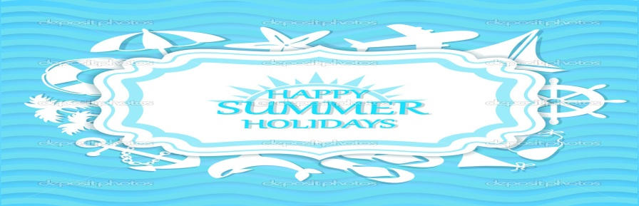

Prepared by Ms. Sreeja Page 2 of 2

