INDIAN SCHOOL AL WADI AL KABIR
INFORMATICS PRACTICES – XI
WORKSHEET –JAVA PROGRAMMING I & II

Q1. a. Rewrite the code using switch statement:
If(k==1)
Day=”Monday”;
elseif(k==2)
Day=” Tuesday”;
elseif(k==3)
Day=” Wednesday”;
else
Day=”-”;

b) Rewritethe code Using Switch case -
char c = ‘g’;
if(c = = ‘g’)
string x = “Greetings” ;
if(c = = ‘b’)
string x= “Bye” ;
if(c = = ‘d’)
string x = “ok”;
else string x = “Sorry! No Message Available”;
c. Rewrite the following code fragment using switch : if(ch = = ‘E’)
east++;
if(ch = = ‘W’)
west++;
if(ch = = ‘N’)
north++;
if(ch = = ‘S’)
south++;
else
JOptionPane.showMessageDialog(null, “unknown”);

(d) Predict the output for tan & tan1 if sac equals 7?
int tan = 0, tan1 = 4 ;
if ( sac == 2 )
{ tan = 4 ; tan1 = 0; }
else if (sac == 8)
{ tan = 0 ; tan1 = 4; }
JOptionPane.showMessageDialog( null , “ tan = “ + tan +” , tan1 = “ + tan1 ) ;

e. . int s1 = 3;
s1 ++;
JTextField1.setText(“ “+ s1);
++s1;
JTextField1.setText(“ “+ s1);
JTextField1.setText(“ “+ (++s1));
JTextField1.setText(“ “+ s1++);
JTextField1.setText(“ “+ s1);

f).
int x = 10,y = 3,z;
z = x%y;
System.out.println(“z= “+z);

g)
int x = 5;
System.out.println(++x);
System.out.println(x);
System.out.println(x++);

h) intnum = 14;
if(num>=10)
if(num ==10)
jLabel1.setText(“first string”);
else
jLabel2.setText(“Second string”);
jLabel2.setText(“third string”);

i.) What will be displayed in JTextField1 after executing the following :
JTextArea1.setText(“INDIA \n INCREDIBLE \t INDIA “);

j). Ms. Sunita has developed a Java application through which the students of her school can view their marks by entering their admission number. The marks are displayed in various text fields. What should she do so that the students are able to view but not change their marks in text fields?

k. What will be the output produced by following code fragment?
flaot x=9;
float y=5;
int z=(int)(x/y);
switch(z)
{
case1:x=x+2;
case2: x=x+3;
default:x =x+1;
}
system.out.println(“value of x:”+x);
l. Given the following code fragment :
If(a==0)
System.out.println(“zero”);
If(a==1)
System.out.println(“one”);
If(a==2)
System.out.println(“two”);
If(a==3)
System.out.println(“three”);
Write an alternative code using switch case.

Q2.
- What do you understand by a message and an event?
- What is a panel? What for it is mainly used?
- What are containers or container controls?
- What command do you need to write in actionperformed () event handler of a button , in order to make it exit button?
- What is the difference between a check box and a radio button?
- What is the difference between a text field and a text area?
- What is the difference between a getText() and getPassword( ).?
- What are the methods used for : 1. IsEditable( ) 2. setEditable( ) 3 setVisible()
- What is the significance of a button group? How do you create a button group?
- Write two properties and two methods of the following controls:
- jTextfield 2. jTextarea 3. jButton 4. jRadiobutton 5. jCheckbox6. JLabel
12. Write a statement to make jTextField as un-editable.

Q3)

a. What will be the contents of jTextarea1 after executing the following code: jTextarea1.setText(“Kendriya\tVidyalaya\nGuna”);
b )The following has some error(s).Rewrite the correct code underlining all the corrections made:
inti, j=5;
i==j+5;
ifi=j
jtextfield1.setText(“I and j are equal”)
else
jtextfield1.getText(“I and j are notequal”);
Q4. A company insured its drivers in the following cases:
- If the driver is married
- If the driver is unmarried , male and above 30 years of age
- If the driver is unmarried , female and above 25 years of age
In all other cases the driver is not insured. Nandita creates a GUI application for this company ( to check whether the driver is insured or not) as shown below.
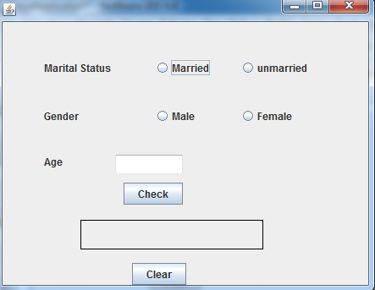
- What should be done so that only one of the radio button out of married and unmarried and one male & female could be selected at a time.
- Write code to do following:
- When “check” button is clicked , text field named txtinsured should show whether the driver is insured or not.
- Clear age and txtinsured text fields
Q5. Mr. Ram theowner of the KiddiLand enterprises has asked his programmer ekta to develop the following GUI in netbeans:
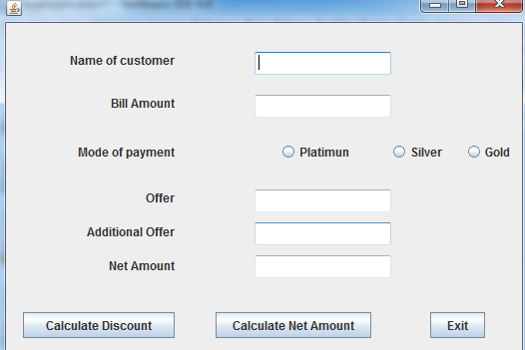
Mr. Ram accepts payment through three of credit cards. The discount is given according to the following schemes:
Type of card discount
Platimun 20 % of amount
Gold 15 % of amount
Silver 1 % of amount
If the bill amount is more than rs. 25,000 /- then the customer gets an additional offer of 5 % .
Write java code for the following:
- To assign additional discount as 0 ( jTedxtField5). Also set them as un-editable.
- [when “calculate discount” ( jButton1) is clicked]
To calculate discount as per the given criteria and display the same in jTextField3
To assign additional offer (jTextField4) as 5% of amount ( jTextField20 as per the above condition.
To enable “calculate net amount” (jButton2) button
- [when “calculate net amount “ (jButton2) is clicked ]
To calculate net amount as
[total cost (jTextField2) – discount ( jTextField3) – additional discount ( jTextField4)
To display the netamount in jTextField5.

Q6. The pizza café has computerized its billing .the following is the data entry screen used at their outlet. The outlet offers two different types of pizzas, regular and pan pizzas. The price of a regular pizza is Rs. 90 and that of a pan pizza is Rs. 110. The user can choose to have three different types of extra toppings if he wants. Each extra topping coasts Rs. 20.
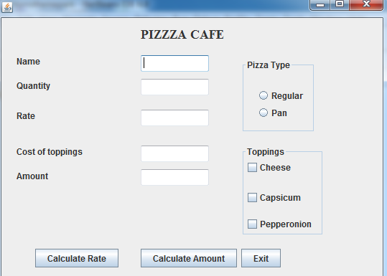
- Write the commands to disable the text fields rateTF,toppingTF, amountTF and amountBTN
- Write the code for RateBTN to calculate the rate of the pizza and display it in rateTF depending on the type of pizza selected by the customer. It should also enable the amountBTN button.
- Write the code for amountBTNbutton to calculate the total amount and display it in amountTF. The total amount is calculated by first finding the cost of extra toppings selected by the customer. Remember that each extra topping cost Rs. 20 . Therefore if the user selects 2 toppings the cost of toppings will be Rs. 40 . Then add it to the rate and multiply the resultant amount by the quality ordered.

Q7. Design a GUI to input three numbers in textfields and display the greatest number in another textfield using conditional opetator.

