INDIAN SCHOOL ALWADI AL KABIR

DEPARTMENT OF SCIENCE 2015-16

WINTER PROJECT – CLASS 6

Make a working model of a simple circuit: (Parental Guidance is recommended)

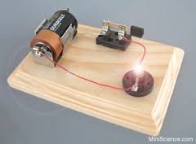
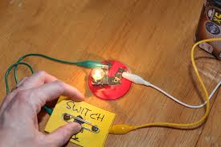
Required materials
- Bulb
- A cell
- thumb pin
- Safety pin
- Cardboard
- connecting wires

Estimated Experiment Time
Approximately 30 minutes

Step-By-Step Procedure
1. Place a bulb and a cell some distance apart on a cardboard.
Use a tape to secure their positions.
2. Plug a thumb pin some distance from the bulb.
3. Cut three pieces of wires. Peel off the ends of the wires.
4. Connect wires from each end of the bulb. Connect one wire from the bulb to the
positive terminal of the cell .Connect the second wire from the bulb to a drawing pin.
5. Connect a wire from the negative terminal of the cell to the safety pin .
6. Touch the safety pin to the thumb pin and record your observation.
7. Students can use their creativity as shown in the figure. Page 1 of 2

Note
- Be careful in handling sharp objects like the scissors.

Prepare a file with:
- the circuit diagram.
- a write-up on the making of the circuit diagram.
- REFERENCE: CLASS 6 - SCIENCE TEXTBOOK
DATE OF SUBMISSION: 10.01.16 / Sunday

Criteria for evaluation
Idea / Theme , Appropriate to the theme , Usefulness, Explanation ,
Command on the subject/model, Overall Presentation ( 5 x 2 = 10)

Prepared by Ms. Suma Senu

Jenifer Robinson
Academic Supervisor – Science
14.12.15 / Tuesday
Page 2 of 2

