INDAIN SCHOOL AL WADI ALKABIR
DEPARTMENT OF SCIENCE 2015-2016
WINTER PROJECT – CLASS 7

NAME OF THE ACTIVITY: ( Parental Guidance is recommended)
COLLAGE MAKING WITH DIFFERENT TYPES OF FIBERS

DESCRIPTION:
Students have to collect different types of fibers and prepare a collage.
- Both the animal fibers, wool and silk should be included.
- Each fabric should be labeled.
- The collage should be done in the Science notebook itself.
- Date of submission-10.1.16 / Sunday
SAMPLE : COLLAGE
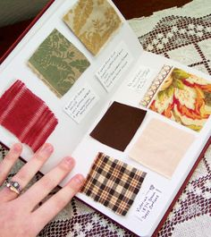
CRITERIA:
- Presentation
- Creativity
- Punctuality
- Originality
- Appropriate to the theme
(2x5)

Prepared by Ms. Sreeja A

Jenifer Robinson
Academic Supervisor – Science
14.12.15 / Tuesday Page 1 of 1

