INDIAN SCHOOL AL WADI AL KABIR
DEPARTMENT OF SCIENCE 2015-16
WINTER PROJECT - CLASS 8
MODEL MAKING (ANY ONE)
- To make your own Kaleidoscope: ( Parental guidance is recommended)
Materials required: a cylindrical cardboard tube (the inside cardboard of a tissue paper role will do), three rectangular pieces of mirrors which will fit into the tube in the form of an equilateral triangle, Make sure that the edges of the mirrors are filed so that you don’t cut yourself, small coloured pieces of glass, half a sheet each of white paper and cellophane paper, cellotape and a colourful gift-wrapping paper.

Procedure:
- Fix the three mirrors in the form of an equilateral triangle.
- Cover one end of the tube with white paper. Fix it firmly with cello tape so that the mirrors will not fall down if the tube is held vertical.
- Put in the coloured glass pieces and cover the other end of the tube with cellophane paper.
- Cover the curved portion of the tube with gift-wrapping paper. Your kaleidoscope is ready.
- Look through the kaleidoscope to see beautiful patterns. It will help if you hold it against the light. The beautiful patterns that we see in a kaleidoscope are due to multiple reflections.
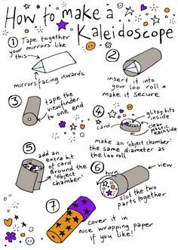
Page 1 of 3

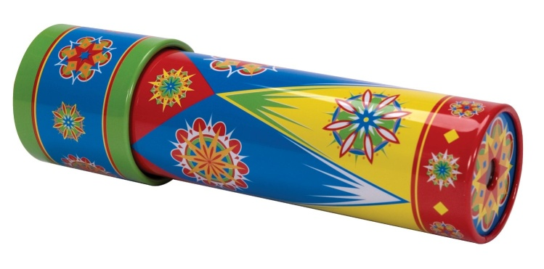
- To make your own Periscope:
Materials required: two pocket mirrors, tape, pencil, ruler, two empty tetra-packs and a knife or cutter.

Procedure:
- Cut the top of the two tetra packs. Make a hole at the bottom of the front of tetra pack. Leave about 1/4 inch of pack on each side of the hole.
- Put the carton to its side and turn it so that the hole is facing your right.
- The side that is facing up, measures 3/4 inches up the left edge of the pack.
- Use a ruler to draw a diagonal line from the bottom right corner to the mark you made. Starting at the bottom right corner, cut on that line.
- Slide the mirror through the slot so the reflecting side faces the hole in the front of the pack. Tape the mirror loosely in place.
- Set the mirrors at an angle of 45⁰ and parallel to each other at the end of the pack.
- Repeat the same procedure to cut the second tetra pack. Keep one pack up on a table, with the hole facing you.
- Place the other pack upside-down, with the mirror on the top and the hole facing away from you. Now, your periscope is ready.
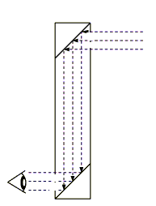

Page 2 of 3

CRITERIA:
- Presentation
- Creativity
- Punctuality
- Originality
- Appropriate to the theme
(2x5)

Date of Submission : 10.1.16 / Sunday Prepared by Ranjana S

Jenifer Robinson
Academic Supervisor – Science
14.12.15 / Tuesday

Page 3 of 3

