**INDIAN SCHOOL AL WADI AL KABIR**

**STD XI -HOLIDAY HOMEWORK –(2015-16)**

**INFORMATICS PRACTICES (Long Answers)**

Q1.

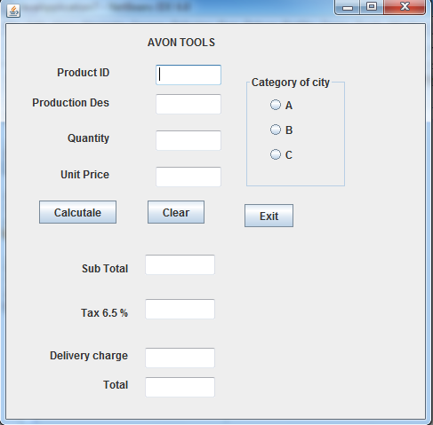

Write code to implement the following:

1. When the user clicks the clear button , all values stored in text fields and radio buttons should be cleared.
2. Ensure that in a text field for qualtity, the value entered is numeric only
3. Close the application when exit button is clicked.
4. When the button with caption “Calculate “ is clicked , sub total , tax( 6.5 % of sub total ), delivery and handling charges and total amount are computed and displayed.

The criteria of delivery and handling charges is as given below:

Category of city charges

A 2000

B ` 3000

C 3500

Sub total is calculated by multiplying quantity with unit with unit price. Tax is calculate as 6.5 % ofsub total.

Q2. The shop n save store has the following data entry screen for its operations. The store offers different types of membership discount schemes for its regular customers. Platinum members get a discount of 10 % on all their purchases, gold members get 5 % and silver members get 3% discount.

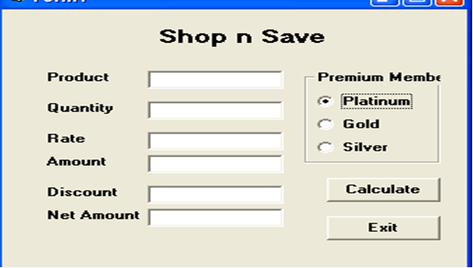

1. Write the code to disable the text fieldsamounttf, discounttf and nettf.
2. Write the code for calcbtn to calculate the amount, discount and net amount as per the given description and conditions.
3. Write the code for exitbtn to close the application , but before the application is closed it should check the net amount and if the net amount > 10000, the membership of the customer should be upgraded to and displayed. For example, if the customer already has silver it should be upgraded to gold,, gold to platinum and he should be informed of the same using a message box.

Q3. Glamour Garments has developed a GUI application for their company as shown below :

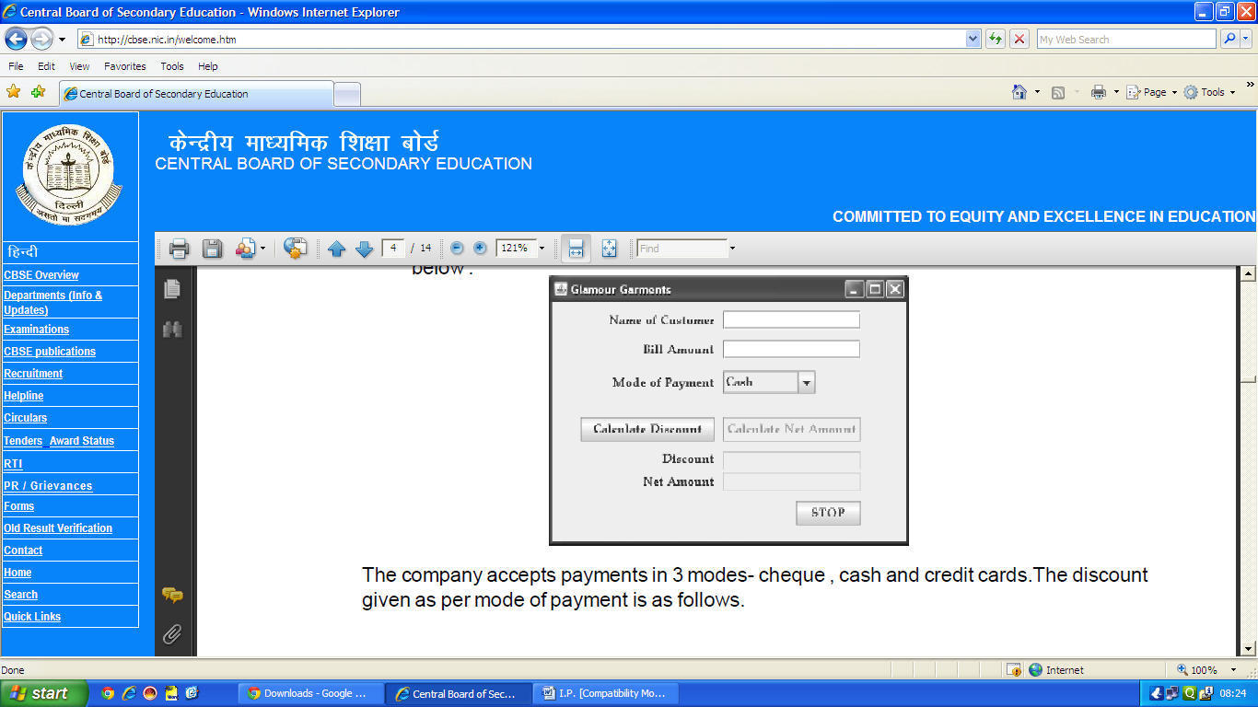The company accepts payments in 3 modes- cheque , cash and credit cards. The discount given as per mode of payment is as follows.

|  |  |
| --- | --- |
| Code of Payment | Discount |
| Cash | 8% |
| Cheque | 7% |
| Credit Card | NIL |

1. If the Bill Amount is more than 15000 then the customer gets an additional discount of 10% on Bill Amount.
2. (i) Write the code to make the textfields for Discount (named txtDisc) and Net Amount (named txtNetAmt) uneditable.

ii) Write code to do the following:

c)When "Calculate Discount" button is clicked the discount should be calculated as per the given criteria and it should be displayed in the discount textfield . "Calculate Net Amount" button (named btnCalcNetAmt) should also be enabled.

d) When "Calculate Net Amount" button is clicked the net amount should be calculated and it should be displayed in the net amount textfield.

Q 4. Regal Theater has computerized its ticketing system. The programmer has developed a GUI application in Netbeans as shown below:

At ticket counter, three types of tickets(Box, balcony and General) at the rate of 200, 150 and 100 respectively are available. If the movie is tax free , then the total amount should be deducted by Rs. 25 per ticket.

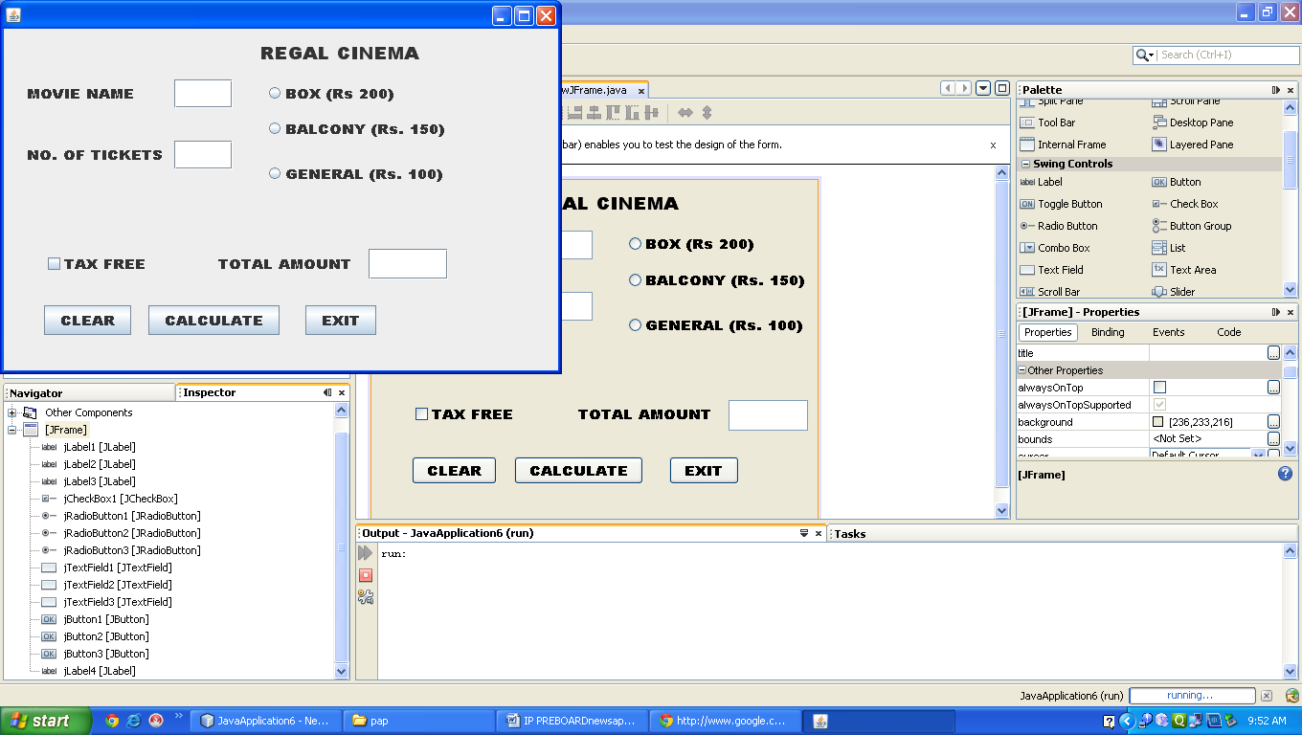

1. What should be done so that only one of the radio button (Box, Balcony and general) can be selected at a time.
2. Write code to do the followings :
3. Calculate and display the Total amount in the corresponding text field when calculate button is pressed.
4. Clear all the text fields.
5. Close the application when Exit button is clicked.

Note : (You can assume any suitable names for various controls on the form)

Q5. Read the follwoing case study and answer the following questions. Mr. Hemand works in AGC school . In order to develop the student record , he created the following in Netbeans:



The school offers different streams , commerce and science , with different grading criteria . The school also offers incentive to NCC cadets in the form of 2 % increment in percentage. The grading criteria for two streams is given below:



1. Write the code for the “Calculate percentage button “ to calculate the percentage after finding the total marks of first term and second term( ( assuming that marks are out of 100) . Also ensure that the NCC cadets gets 2 % increment in percentage
2. Write the code for “calculate grade” button to calculate the grade depending on the stream selected according to the criteria given above.
3. Write code for “exit” and “clear” button.

Q6. XYZ Pens Company sells each pen at the cost of 25.00. The Programmer has developed a GUI application as shown below :



* The number of pens bought are entered by the user.

.*The Amount is Number of Pens * 25.00

*If a person buying pens is a ‘Special Customer’, a discount of 5% is given on the amount, otherwise no discount is given.

* Amount to be paid = Amount – Discount

Write code in Java to do the following :

(i) When Calculate button is clicked the Amount, Discount and Amount to be Paid are calculated and should be displayed in appropriate text fields.

(ii) When Clear button is clicked, all the Textfields and Checkbox are cleared.

(iii) When Stop button is clicked, the application is closed.

Q7.Kanak enterprises is a Yarn Manufacturing Company. The HumanResource Department manages 100 employees on regular basis. Thecompany provides salary on two categories: Temporary employee and Permanent Employee. The account department instructs the computer

department to develop a salary calculation form as shown below:



(i)

Write code for the both Permanent and Temporary radio buttons that whenuser click Permanent button, then text boxes available in Temporary panelis automatically disabled. Similarly, when user click Temporary button,then text boxes available in Permanent panel is automatically disabled.

(ii) Write the code of clear button to clear all the values stored in all the textboxes and temporary employee should be selected as default employee.

(iii) Write code for the calculate button to calculate the salary amount, overtime amount and total amount.

The criteria for salary calculationis as given below:

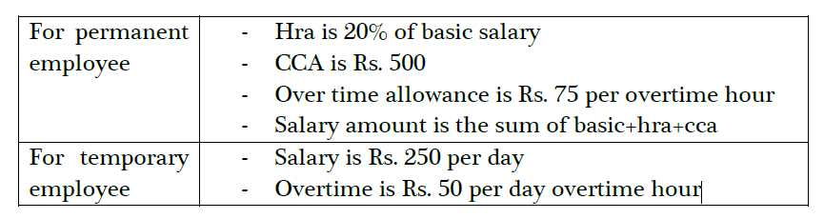

Total amount for permanent and temporary employee will be calculated as

the sum of total salary amount and over time amount.