INDIAN SCHOOL AL WADI AL KABIR
DEPARTMENT OF FRENCH 2016-17

HOLIDAY ASSIGNMENT – SUMMER VACATION

CLASS 6 - FRENCH

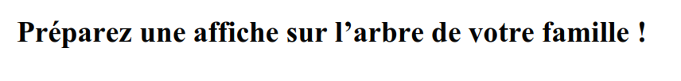

CLASS 7 – FRENCH
"Que mangez-vous?" - Decrivez les differentes repas que vous mangez.
(Describe the different meals you eat in a day using pictures, drawings etc.)
(Devoir de vacances)

CLASS 8 – FRENCH
- DATE OF SUBMISSION :7TH AUGUST,2016
- IN THE FILE FORMAT ONLY

