INDIAN SCHOOL AL WADI AL KABIR
DEPARTMENT OF SCIENCE 2016-17
HOLIDAY ASSIGNMENT – SUMMER VACATION
CLASS 6

World Environment Day is celebrated as a way to raise awareness about things that affect the world and the environment. It is an important thing to do as it provides a chance for us to show what kinds of things we can do as individuals to protect our environment.
Join the race to make the world a better place.
- STUDENTS WILL DONATE ONE PLANT AFTER THE HOLIDAYS.
- EACH STUDENT WILL GROW ONE SAPLING DURING THE HOLIDAYS AND RECORD THE GROWTH OF THE SAPLING IN A FILE.
- FILE SHOULD BE SUBMITTED TO THE SCIENCE TEACHER FOR GRADING.
- FILE SHOULD NOT CONTAIN MORE THAN ONE TO TWO PAGES.
- DATE OF SUBMISSION :7TH AUGUST,2016

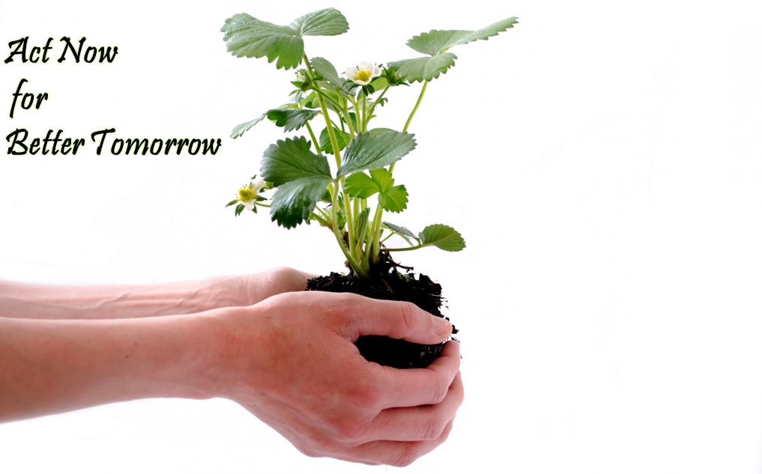
Prepared by Ms. Ranjana S

