INDIAN SCHOOL AL WADI AL KABIR
DEPARTMENT OF SCIENCE 2016-17
HOLIDAY ASSIGNMENT – SUMMER VACATION
CLASS 8
One of the greatest problems that the world is facing today is that of environmental pollution, increasing with every passing year and causing grave and irreparable damage to the earth. Environmental pollution consists of five basic types of pollution, namely, air, water, soil, noise and light.

Theme for the year : 2016
“Join the race to make the world a better place”.
- Spread awareness among people to reduce pollution using four magic words:
- Reduce
- Reuse
- Refuse
- Recycle
- Write a good review about your experiences during this campaign and show prominent/ suitable pictures.
- Prepare a cover page for your review containing:
- Name
- Class and section
- Places visited
- DATE OF SUBMISSION :7TH AUGUST,2016
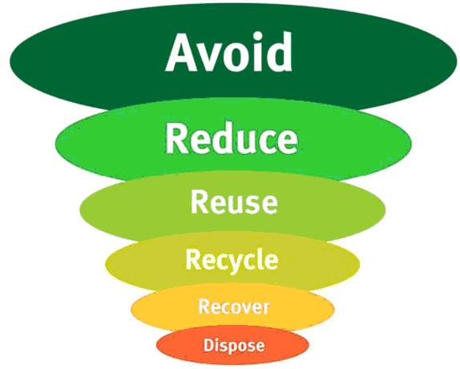
Prepared by Ms. Ranjana S

