INDIAN SCHOOL AL WADI AL KABIR
CLASS XII INFORMATICS PRACTICES
HOLIDAY HOMEWORK

Q.I: Problem solving using Java
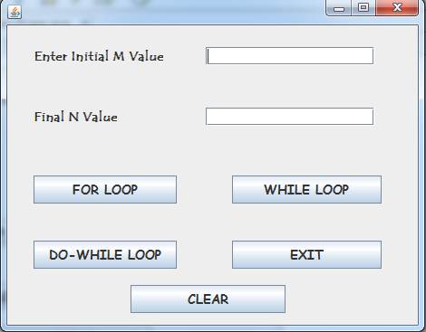
a) To find the sum of even number in the range M and N (for loop)- Display the result using a dialog box.
b) To find the sum of each digit present in the number N(while loop)
c) To display the table of M in a text area textarea1 (do-while loop)
Q.II : Problem solving using Java
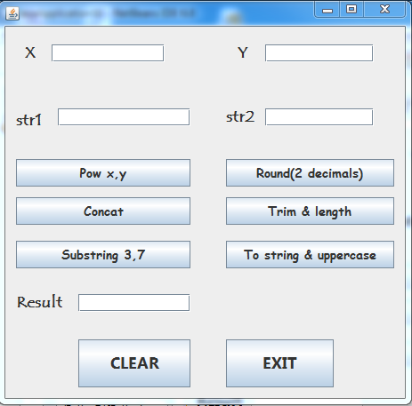 a)To find the value of X ^{Y} . b) To join both the strings . c)To display the substring of Str1 .
d)To round of the value if X e)To trim and find the length of str2 f)To display the string1 in Ucase.

Q.III : Problem solving using Java
Electronic shop E-max offers the following discount . Write code for discount and netamount button to calculate the discount offered and the net amount to be paid. Also write code for the clear and exit button.

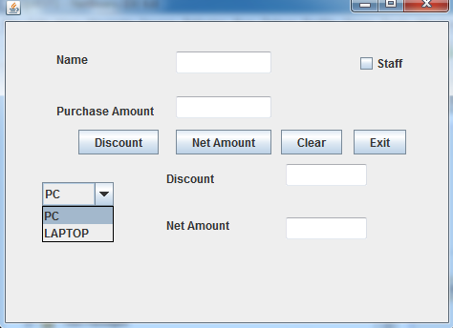

Type of Purchase Purchaseamt discount
PC <=20000 2 %
20001 – 25000 3 %
>=25001 4%

LAPTOP <=30000 2%
30001 – 45000 3%
>=45000 4 %
A discount of 2 % is given to the staff of the company

Set : IV Problem solving using Java

The owner of the shopping mall provides handsome discounts for credit card holders.
Card Type Discount
Bank Muscat 15 %
National Bank of Oman 14.5 %
SBI 10 %
Dhofar 12 %
Bank of Baroda 8 %

Enter the shopping amount (txtAmount) and do the following :
- Write the command for Discount button to compute discount amount and net amount .
- Write the code for clear button to clear all the text boxes .

The coding for the above snapshot program should be written on the practical record note book and to be submitted to the respective Class XII – Informatics Practices Teacher.

