12/18/2016
INDIAN SCHOOL AL WADI AL KABIR | DEPARTMENT OF SCIENCE

PREPARED BY
Mrs. Suma Senu

class vii | revision questions for fa iv -2017

CLASS: VII
INDIAN SCHOOL AL WADI AL KABIR
DEPARTMENT OF SCIENCE
Q.I Define the following-
(a) Weathering (b) Crystallization
(c) Soil conservation (d) Galvanization (e) Solenoid

Q.II. Answer the following in short-
1) Which type of soil –
(a) is the best for making pots, bricks, toys and statues.
(b) can hold very little water.
2) Which of the two provides more air to plant roots- sandy soil or clayey soil? Why?
3) Using the symbols of electric components given draw

an open circuit and a closed circuit diagram.

4) What is the chemical name of Baking Soda?
5) What type of change is photosynthesis?
6) a)Write down the chemical reaction involved in burning of magnesium ribbon(word equation) and pick out the reactants and products from the reactions .
b) What happens when magnesium oxide is dissolved in water?
7) Differentiate between
(a) Physical change and chemical change
(b) Exothermic and Endothermic reaction
8) Classify the following changes as physical changes and chemical changes
(a) Melting of ice (b) Burning of wood (c) Milk to curd (d) slicing a loaf of bread.
9) Burning a candle involves both physical and chemical changes –Justify the statement .

10 ) Give one example each of a chemical reaction showing the following characteristics :
(a) formation of a gas (b) change of colour (c) formation of precipitate (d) Decomposition reaction.
11) What do mean by heating effect of current?
12) What is an electric fuse?
13) Name any two effects of electric current.
Q.III) Answer the following in detail-
1) Write any three differences between sandy soil and clayey soil and loamy soil.
2) What is meant by soil profile? Draw a sketch of the soil profile and label the various layers.
3) ‘Earthworms are called as friend of farmers.’ Give two reasons for this comment.
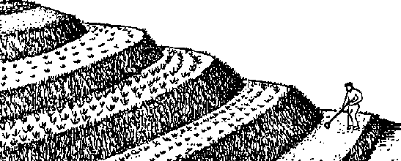
4) Identify the shown picture.

How is it useful to conserve soil?

5) A soil sample weighing 150g is dried completely by keeping in sunshine. The mass of dried soil is 135g. Calculate the moisture content in the given sample of soil.
6) A student conducted an experiment to determine the percolation rate of water in a soil. He observed that it took 45 minutes for 180ml of water to percolate through the soil. Calculate the percolation rate of water in soil.
7) What is meant by soil erosion? State the four causes of soil erosion.
8) Explain why rusting of iron objects is faster in coastal areas than in deserts.

9) . Give reasons :
a) An MCB is better than an electric fuse
b) Tungsten wire is used as filaments of bulbs and nichrome wire as heating element in heaters.
10) Identify the types of circuits shown below & write the difference between them.

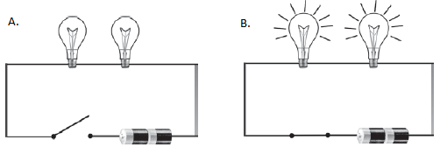
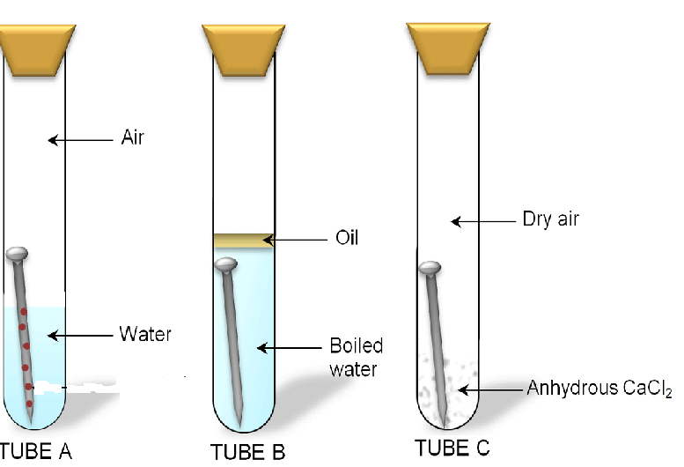
11) Observe the given figure and answer the following questions
a) In which test tube rusting will be more and why ?

b) What is the role of oil and anhydrous calcium chloride in the given activity ?

c) Write a word equation for the given process.

d) Give any three methods of preventing rusting.

12) Observe the figure given and answer the following
a) What type of reaction occurs here ?
b) What change can you observe in the colour of the solution after the dropping of iron nail into it ?
c) Write the word equation for the given chemical reaction
13) Why setting of curd is regarded as a chemical change ?
14) State the conditions necessary for an electric current to flow through a circuit .
15) How will you differentiate cells connected in series and in parallel ?
16 ) Refer to the diagram carefully:
Z
Y
X
- Identify the parts X and Y in the diagram given.
- What happens at X when the switch is closed?
- Why is it not a good idea to make Z out of steel
- Name two electrical appliances where electrical energy is converted into heat energy.
17) a. What is the relationship between potential difference and direction of flow of
current in an electric circuit?
b. What is an electromagnet? How can you increase the strength of electromagnet?
c. What is a miniature circuit breaker?

All the best

