FA4 REVISION QUESTIONS
CLASS VIII
PREPARED BY: MRS. RANJANA
CLASS COORDINATOR- VIII
12/18/2016

INDIAN SCHOOL AL WADI AL KABIR
CLASS VIII DEPARTMENT OF SCIENCE 2016-17 DATE: 18-12-2016
FA4 REVISION QUESTIONS NAME:
- a) Two sets of charges and the direction of forces felt by them are shown in the figure below. Identify the missing charges in (a) and (b).
B
A
b) State the property of charges responsible for the force shown in the figure.
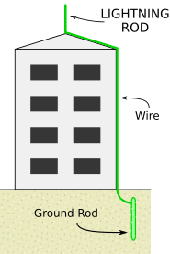
- a) What is earthing?
b) How is a lightening conductor used to protect a building?
c) Suggest any two measures to protect ourselves from lightening.
- a) What is a constellation?
b) Identify the constellation shown in the figure below.
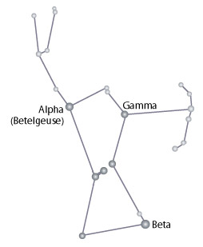
c) Name the brightest star in the nightest sky which is located close to this constellation.
d) Why does the pole star not appear to move?

- Where are asteroids located in the solar system?
- Why earth is called a unique planet?
- a) Label the figure in correct order.
b) How do phases of moon occur?
c) How is Venus different from earth in its rotation?

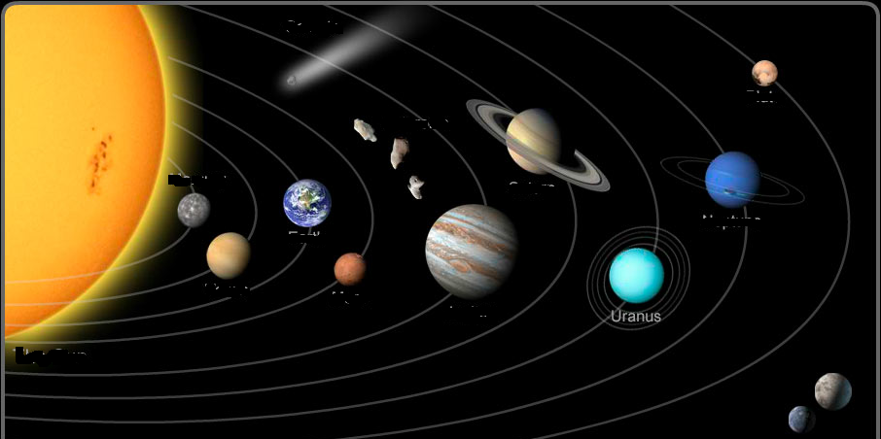

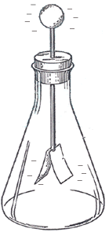
- a) Identify the device shown in the figure alongside.
b) What happens when the metal cap of this device is touched with:
- A positively charged glass rod
- A negatively charged ebonite rod
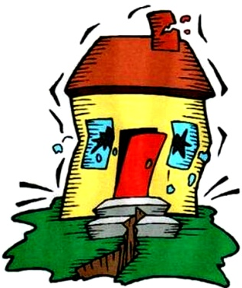
c) What are the electrical charges produced by rubbing called?
- a) Identify the destruction shown in the figure.
b) How is it caused?
c) Name the scale on which the destruction energy of this type is measured.
d) Mention any two precautions that you would take to protect yourself from this type of destruction.
- a) Identify the image shown alongside.
b) How is it different from a natural satellite?
c) Which is the earth’s only natural satellite?
d) Name the first Indian satellite.
e) Write any two practical applications of this image.
- Observe the figure carefully:
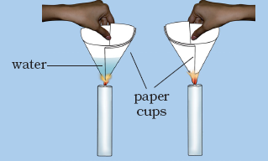
Akhil has made two paper cups by folding a sheet of paper. He poured 50ml of water in one of the cups and heated both the cups separately with a candle.
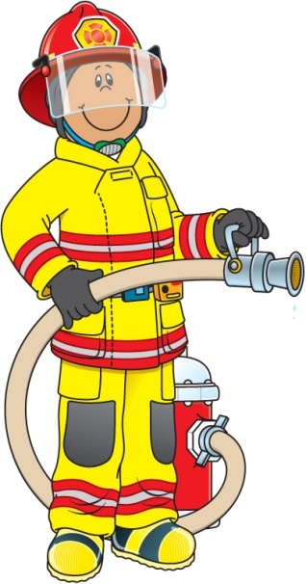
- What happens to the empty paper cup when heated?
- What happens to the paper cup with water, when heated? Does water in the cup become hot?
- a) Observe the figure shown alongside and explain the job of a firefighter.
b) What type of substances will catch fire easily? Give reason.
c) There are three essential requirements for producing fire. What are they?
d) Distinguish between rapid combustion and spontaneous combustion.
- Refer to the figures given below:
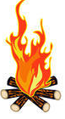
B
A

Suppose you were asked to boil a given quantity of water:
- Which fuel would you prefer? Give reason.
- Which fuel has a higher calorific value?
- What happens when A is subjected to incomplete combustion?
- Mention any two characteristics of the fuel B.

- Abida and Ramesh were doing an experiment in which water was to be heated in a beaker. Abida kept the beaker near the wick in the yellow part of the candle flame. Ramesh kept the beaker in the outermost part of the flame. Whose water will get heated in a shorter period of time?
- It is difficult to burn a heap of green leaves but dry leaves catch fire easily. Explain.

- Give reasons:
- Water is not used to control fires involving electrical equipment.
- LPG is a better domestic fuel than wood.
- List the conditions under which combustion takes place.
- Why does a match stick not catch fire on its own at room temperature?
- Give two differences between:
- An electron & a proton
- Charging by conduction & charging by induction
- What is the cause of thunder that accompanies lightning? Explain.
- How is a glass rod charged positively when rubbed with a silk cloth?
- a) What do you mean by calorific value of a fuel?
b) Write any two characteristics of ideal fuel.
c) Draw a neat labeled diagram showing the different zones of candle flame.
d) Which of the following produces flame- kerosene or coal? Give reason.

PREPARED BY: MRS. RANJANA

