INDIAN SCHOOL AL WADI AL KABIR
DEPT. OF COMPUTER SCIENCE
CLASS VIII Holiday Homework 2016 -17

CREATE A FORM AS SHOWN BELOW:-
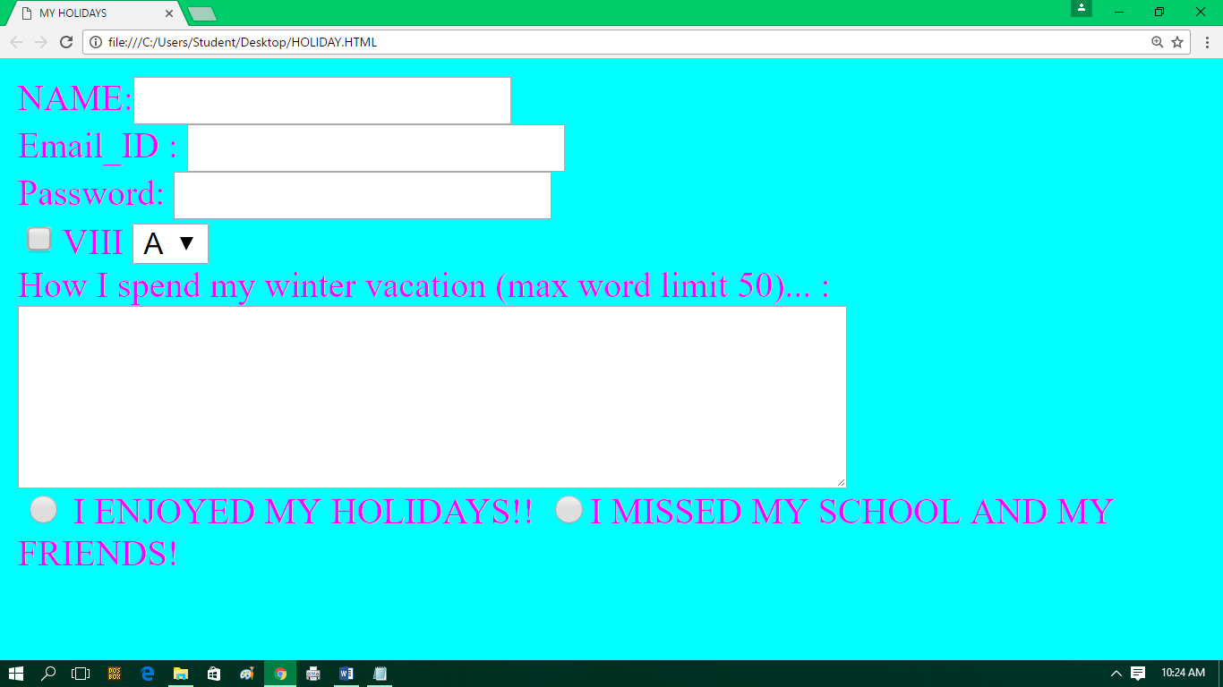

Remark: Holiday Homework should be done in Computer Notebook and submitted to respective computer science teacher on the given following dates 17/1/2017 to 24/01/2017.

HAPPY HOLIDAYS

