INDIAN SCHOOL AL WADI AL KABIR
Holiday Worksheet, 2017-18
Class: XII | Informatics Practices | Date of submission:  02/08/2017
 | Java Programming
Q.I
a. Which device is used to connect dissimilar networks?
b. Mr. Raj is confused between between MAC address and an IP address of a PC.Help him to differentiate between the two.Also explain the different parts of it.
c.Differentiate between Star topology and Bus Topology with one advantage
and one disadvantage.
d.What is the difference between a bridge and a router
e. Navneet is using software, which has been downloaded from internet and is available for one month. After one month he has to pay license fee for further use. What software Navneet is using?
f Arrange the following communication channels in ascending order of their data transmission rates.
Ethernet Cable, Optical Fibre, Telephone Cable, Co-axial Cable.
g. Which protocol is used for transfer of hyper text documents on the internet? h. Define any two threats to Network Security?
i. Which protocol is used for transferring the files to and from a remote host?
J What does the last three byte of MAC address indicate?
k. By which other name the Ring topology is called?
l. Define snooping.
m. What do you mean by topology? Write the names of two types of topologies.
n. Define the following:Bridge and a Router.
Q.II
a. Which statement is used to terminate the loop before its maturity?
b. Which property of jLabel box is used to specify the image during design time?
c. Which property of the radio button should be set to make the radio buttons
mutually exclusive?
d. In a java program Rajat wants to use a variable to store the quantity of an item which may be in whole numbers or decimals. Write a suitable java statement to declare the variable for the above mentioned purpose.
e. What is the difference between setEnabled() andsetEditable() method? What type of
values are passed to them as parameter? 1f. Convert the given coding to it’s equivalent, using if-else statement.
int a,b;
a = integer.parseInt(JTextField1.getText());
if (a==1)
b=a++;
else if(a==2||a==3)
b=--a;
else if (a==4)
b=b+a/b;
else
b = b*a++;
System.out.println(“ “+ b);
g. What will be the value of sum after executing the following code?
int sum = 4;
for(int i = 15; i > = 9 ; i - - )
{ if ( i % 3 == 0)
sum + = i;
else
sum - = i;}
h. Given a string Object namely month having value as “11” stored in it. What will be the result of following code?
JOptionPane.showMessageDialog(null,“ ” + (month.length() + Integer.parseInt( month) ) );

i.What will be displayed in jTextField1 and jTextField2 after the following code:
Inta,b,c;
a = 25;
b = ++a;
c = a + b++;
jTextField1.setText(“ “ + c);
jTextField2.setText(“ “ + b);

Q.III
a)Guess the output of the following code:
String S=" ISWKOman ";
String S1 = S.toUpperCase();
for (int i = 0; i < S1.length(); i+=4)
{ String str = S1.substring(i,i+3);
jTextArea1.append(str+"\n"); }
b. What will be the content of jTextField1 and jTextField2 after execution of the following code:
jTextField1.setText(Math.round(245.453));
jTExtfield2.setText(Math.pow(4,3));
c Develop a GUI to input a string in a textfield and display its reverse in another textfield
d.
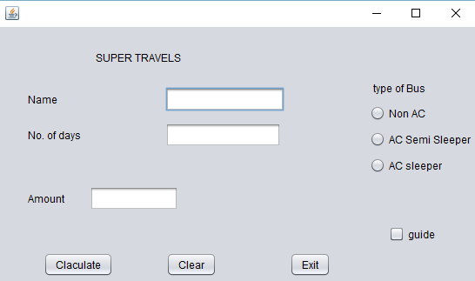
- Write the code for calculate button to calculate the amount to be paid as per the following:
Type of Bus Rate / Day
Non AC 2000
Semi Sleeper AC 6000
Sleeper AC 10000

Extra charge of Rs.1000 per day if guide is required.
- Write the code for clear button to clear all textfields, radiobuttons and checkbox.
- Write the code for exit button.

QIV.

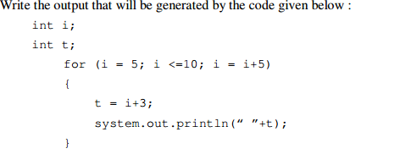

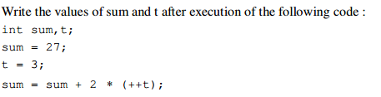

- What will be the contents of jTextField1 and jTextField2 after executing the following code.
String s=”ROHIT PUBLICATIONS”;
jTextField1.setText(s.length()+” “);
jTextField2.setText(s.toLowerCase());

*****************************

