INDIAN SCHOOL AL WADI AL KABIR
DEPT. OF COMPUTER SCIENCE
CLASS VIII Holiday Homework 2017 -18

- Create a “Students Admission List Using Ms-Excel”:
  - Display the S.No, Name, Age, Gender in a table format as shown below
    - Using Auto Fill Command Fill the S.No
    - Using filter option in Gender Column ,Display only Male(M).
    - Using Sorting option Display the name of student in Ascending order
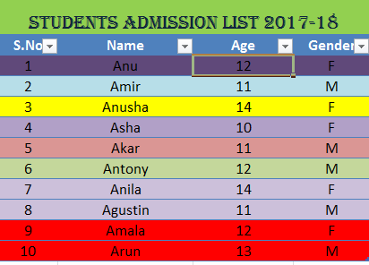
Remark: Holiday Homework Practice at Home. Evaluation will be done after holidays during the regular practical session.

HAPPY HOLIDAYS

