INDIAN SCHOOL AL WADI AL KABIR
Department of Computer Science
Holiday Home Work
WORKSHEET SOLVING
Class: X
Topic :Java Programming

- Design an application that obtains three values in three text fields from user: Principal, Rate of Interest, Time. It should then compute and display Simple Interest when Calculate button is clicked. Controls names and Interface are given below.

Control | Purpose | Name
Text Box | To accept Principal | jTextField1
 | To accept Rate of Interest | jTextField2
 | To accept Time | jTextField3
 | To display Simple Interest | jLabel3
Command Button | To Click for computation & display of Simple Interest | jButton1

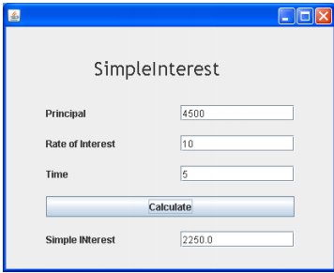

- Design a jframe as shown in the following screenshot. The application should obtain age of a student and the present age of student and calculate the age in 2019 in a jLabel.

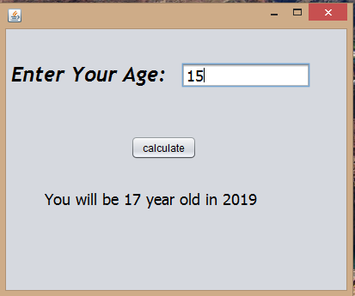

Date of Submission: 31-july-2017
- Remarks: Coding should be written in note book and submitted to respective computer science teacher.

