INDIAN SCHOOL AL WADI AL KABIR
Department of Computer Science
Holiday Home Work

- A hardware store wants you to create an application for it that allows buyers to browse through ‘Offer of the Day’. The store wants to start with five of its most selling products: keyboard, mouse, monitor, printer and modem. User should be able to click on any of the buttons and the offer pertaining to the product should get displayed.
The design of the application should be as per the following screenshot

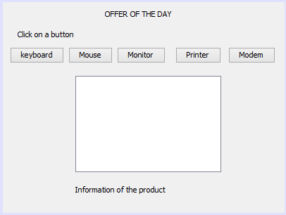
jLabel 3
jTextArea1
jButton 1 to 5
jLabel 2
jLabel 1

Note: In the screenshot,
- jButton1 is keyboard.
- jButton2 is Mouse.
- jButton3 is Monitor.
- jButton4 is Printer
- jButton5 is Modem

- Design a GUI applicaton as per the screenshot to calculate commission for the salesmen.The commission is calculated according to following rates.

SALES | COMMISSION RATE
30001 onwards  22001-30000  12001-22000  5001-12000  0-5000 | 15%  10%  8%  3%  0%

SCREENSHOT:
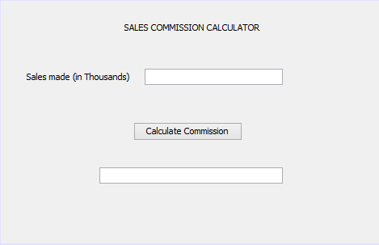
jLabel3
jButton1
jTextField1
jLabel2
jLabel1

Note: In the screenshot, result must be displayed in the label (jLabel3).

Date of Submission: 21- Jan -2017
- Remarks: Answers should be written in note book and submitted to respective computer science teacher.

