INDIAN SCHOOL AL WADI AL KABIR
DEPT. OF COMPUTER SCIENCE
CLASS VII Holiday Homework 2017-18

CREATE FOLLOWING WEBPAGE USING <HR> AND <BR> TAG
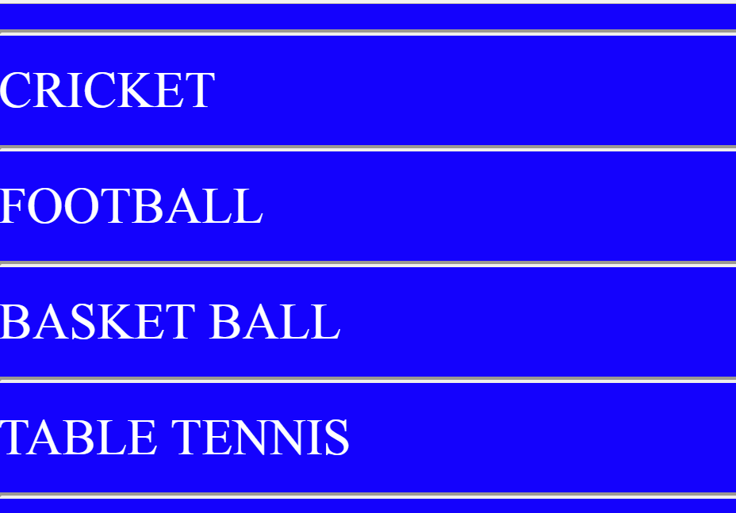

Remark: Holiday Homework Practice at Home. Evaluation will be done after holidays during the regular practical session.
HAPPY HOLIDAYS

