INDIAN SCHOOL AL WADI AL KABIR
Excel Budget Homework 2018-19 CLASS IX
PREPARATION OF LIST OF CONSUMABLE ARTICLES OF A FAMILY EXPENDITURE

Execute the following steps in MS-EXCEL.
Create a ExcelHmwk folder in your CSE3/Lab4 folder or on the desktop as desired.
Open a new Microsoft Excel spreadsheet and save it as Budget.xlsx in your ExcelHmwk folder.

Step 1: Create some row headings as shown below:

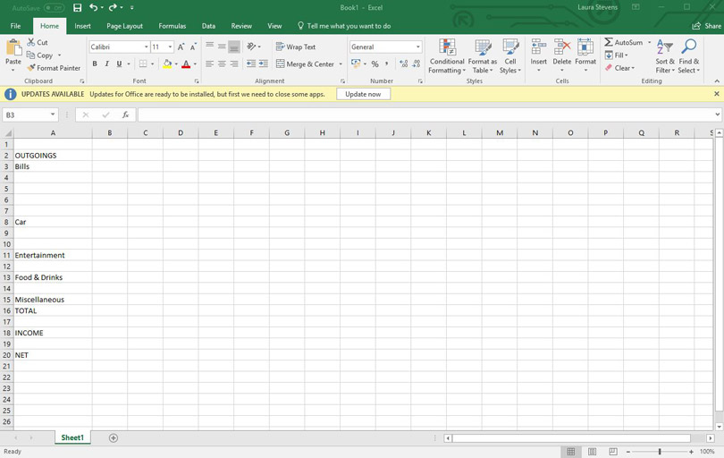
Launch your spreadsheet application and create a new, blank sheet. We’re going to start by listing types of outgoing in columns A and B. Type the following in the corresponding cells:
A2: OUTGOINGS
A3: Bills
A8: Car
A11: Entertainment
A13: Food & drink
A15: Miscellaneous
A16: TOTAL
A18: INCOME
A20: NET

Step 2: Create some categories
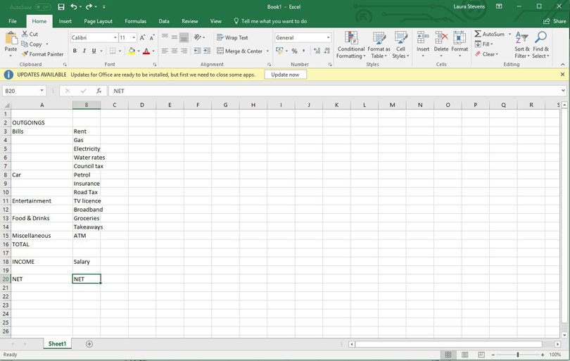
Now move to cell B3 and type the following in the corresponding cells:
B3: Rent
B4: Gas
B5: Electricity
B6: Water rates
B7: Council tax
B8: Petrol
B9: Insurance
B10: Road tax
B11: TV licence
B12: Broadband
B13: Groceries
B14: Takeaways
B15: ATM
B18: Salary
B20: NET

Step 3: Create column headings for months
Finally, type Jan in cell C2 and then continue with Feb, Mar and so on across the rest of that row until you get to N2 to create column headers for 12 months.
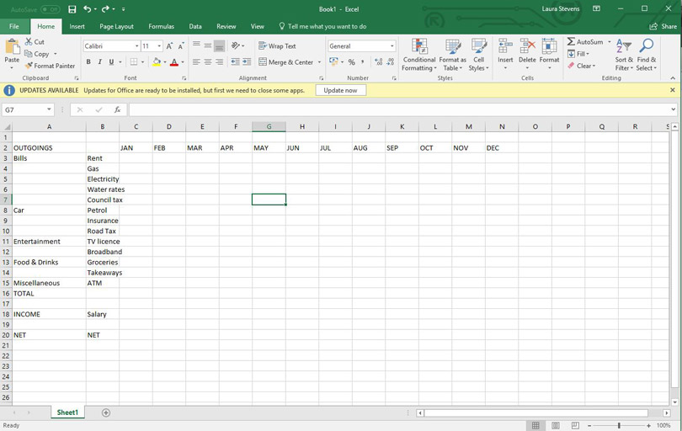

Step 4: Enter the figures for one month
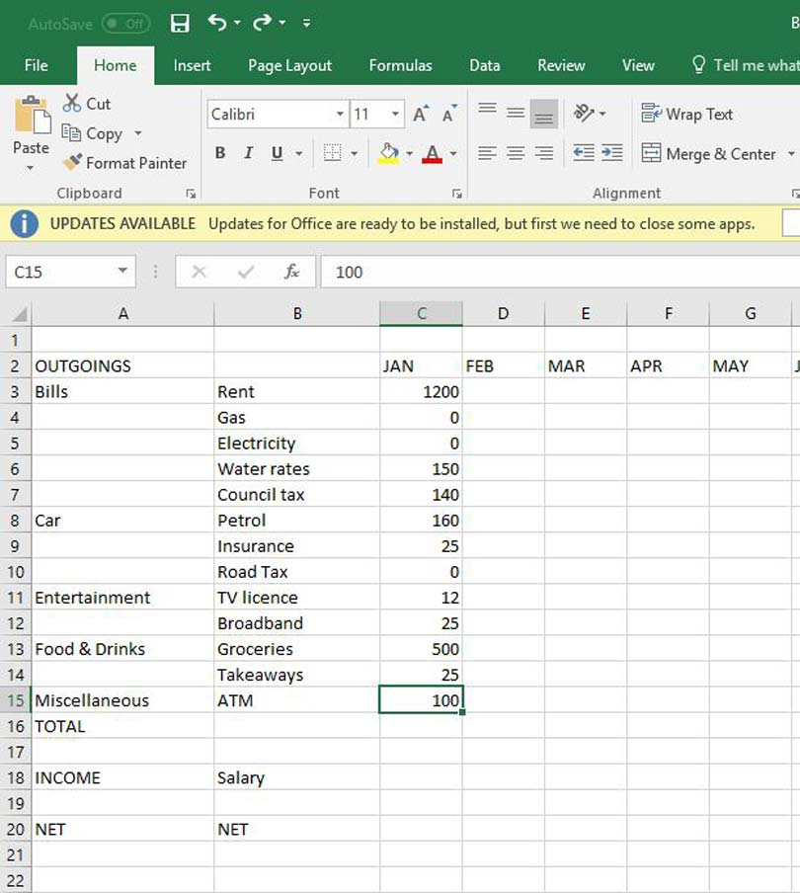
Now to enter some figures for monthly outgoings and income, starting with the Jan column. Again, it’s simpler to copy our figures here, but feel free to use your own, particularly if you’ve modified the categories in columns A and B.

Step 5: Add up the total outgoings
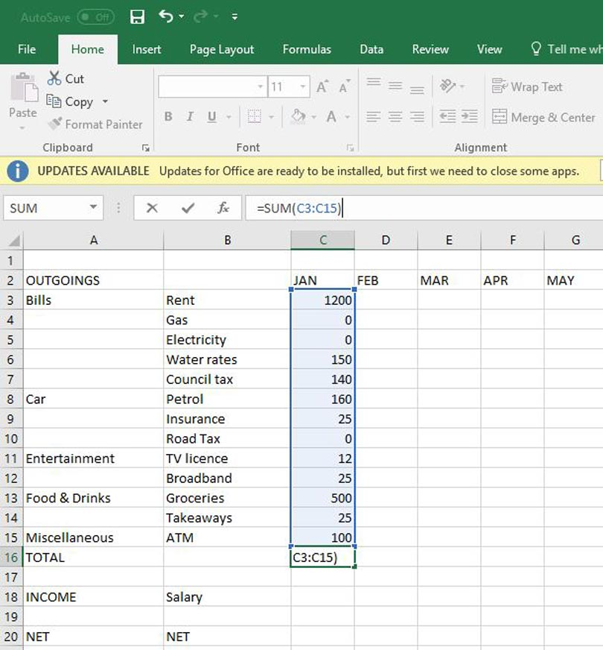
Now to work out the total expenditure. Select cell C16 and type:
=SUM(C3:C15)
…and press the Return key. This is known as a ‘formula’ in spreadsheet parlance and the opening = sign tells Excel that it needs to perform a calculation using what follows. sum is the actual formula and it adds together the range of cells in brackets - C3 to C15, inclusive, in this case.

Step 6: Work out income minus outgoings
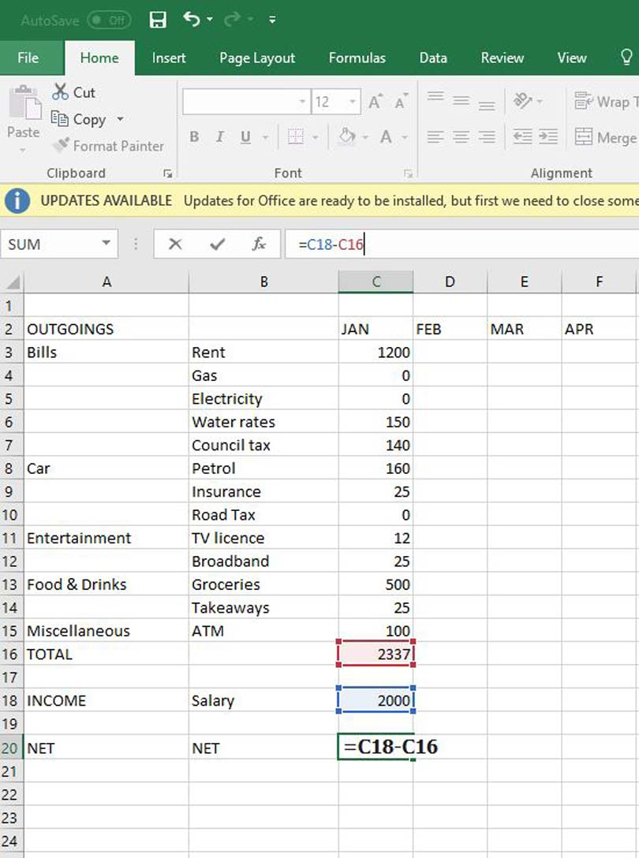
Enter your income in cell C18 and now we can work out how much money is left at the end of the month. This is a much simpler formula that just subtracts the total outgoings from the income, so type the following into cell C20:
=C18-C16

Step 7: Copy one month’s figures
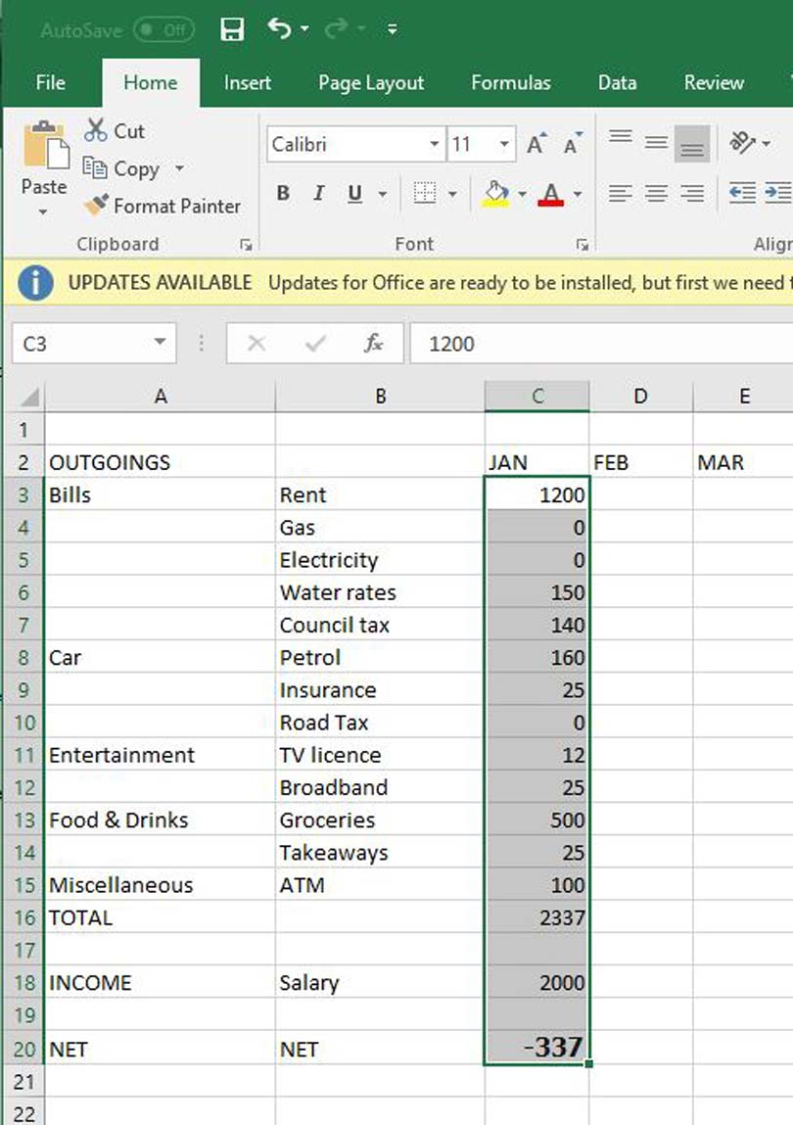
Rather than type more figures into the Feb (D) to Dec (N) columns, it’s simpler to copy and paste the Jan (C) column. Click cell C3 and drag the mouse down to cell C20 to select all of the figures. The press the Ctrl + C keyboard shortcut for Copy. The selected range of cells will now be highlighted with a blinking dotted outline.

Step 8: Paste the figures to the rest of the sheet
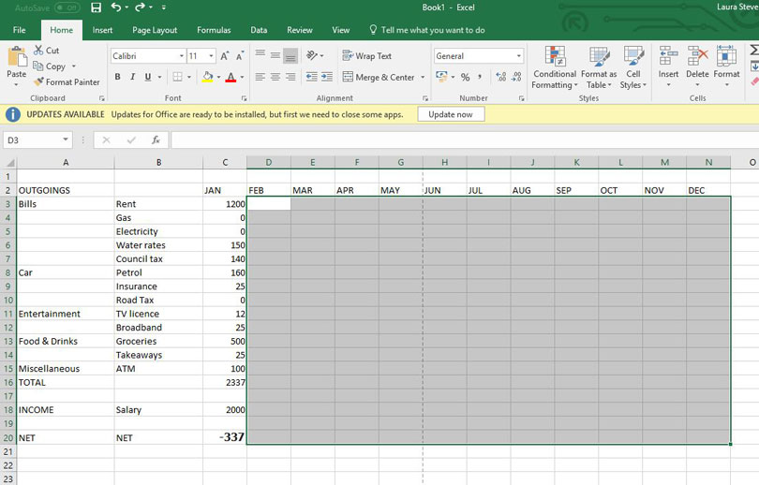
Now to select the range of cells to paste the Jan column to. Select cell D3 and, just as before, drag the mouse to cell N20. Now press the [Ctrl] + [V] keyboard shortcut to paste the cells copied in Step 7.
Excel will apply a bit of intelligence here to paste the cells and update any formulas to keep them consistent. In our example, we’ve then added quarterly gas and electricity payments in the Mar, Jun, Sep and Dec columns.

Step 9: Modify the monthly NET formula
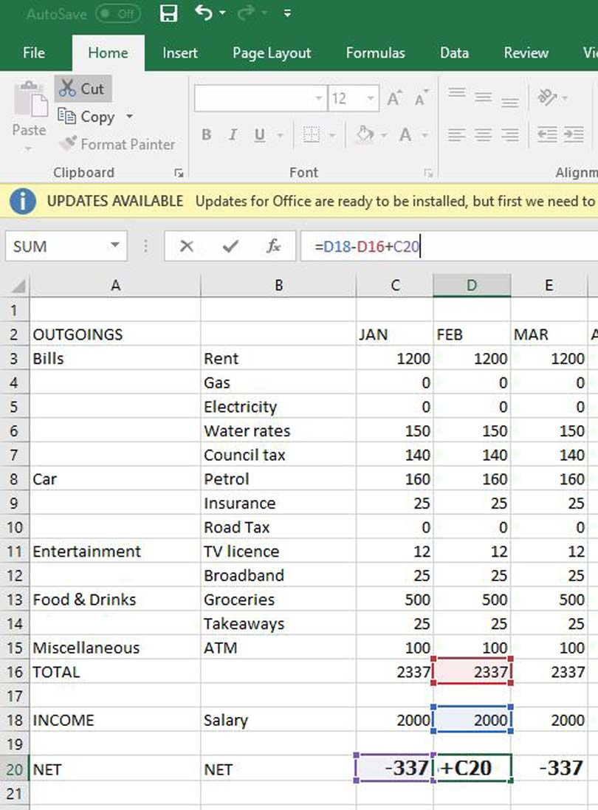
The only problem now is that the formulas in row 20 (NET) don’t take into account the previous month’s balance, so we’ll need to make a minor change. Select cell D20 and type:
=D18-D16+C20
This will replace the existing contents of the cell and will add the NET figure for Jan to the NET figure for Feb. You can now copy cell D20 and paste it to cells E20 to N20, using the same technique as Step 8.

Step 10: Format the sheet
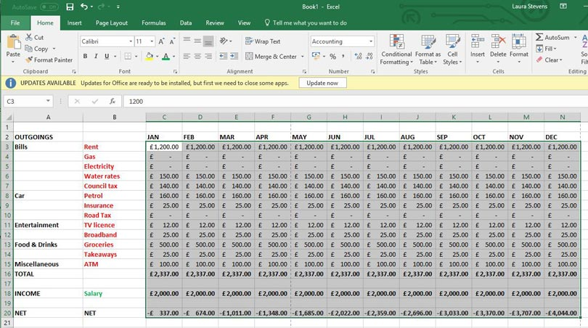
The final step is to format the spreadsheet to make it more understandable. In our example, we’ve made the row (Row 2) and column (A and B) headings bold, along with the rows for TOTAL, INCOME and NET. We’ve also applied some colour and alignment, and formatted all figures as Currency (£ English).

Date of Submission: 10th August 2018

- Remarks: Output should be written in note book and submitted to respective computer science teacher.

