INDIAN SCHOOL AL WADI AL KABIR
Excel Budget Homework 2018-19 CLASS X
Annual & Monthly Expenditure

ANNUAL BUDGET

Step 1:
Create a ExcelHmwk folder in your CSE3/Lab4 folder or on the desktop as desired.
Open a new Microsoft Excel spreadsheet and save it as Budget.xlsx in your ExcelHmwk folder.

Step 2:
Create a list of YOUR sources of income (if you feel uncomfortable, feel free to make up sources or numbers or just follow along with the examples given here):
  - In cell B3:
    - Write the word Income
    - Make it bold by clicking the B button in the Font group of the Home tab on the Ribbon
  - In cell C4 begin a list of your sources of income
    - 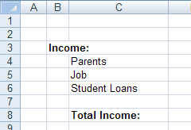Examples:
      - Parents
      - Job
      - Student Loans
    - Each source should be in its own cell on its own line
  - You can resize the columns to best display your information.
  - When your list is done, skip a line and then enter Total Income in the C column. Make the entire row bold.
Step 3:
Create a list of YOUR expenses:
  - Whatever line your list of income ended:
    - Skip a line and then write the word Expenses in column B
    - Make it bold
  - On the next line in the C column write School Expenses and make the entire row bold
    - Underneath it, still in the C column, create a list of all your school expenses
      - Tuition and Fees
      - Health Insurance
      - Books and Supplies
      - Parking

  - When you have entered all of your school expenses, skip a line and write Living Expenses, still in the C column. Make the entire row bold.
    - 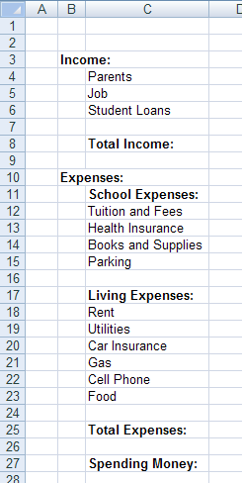Underneath it, still in the C column, create a list of all the living expenses
      - Rent
      - Utilities
      - Car Insurance
      - Gas
      - Cell Phone
      - Food
Step 4:
  - When you’ve entered all of your living expenses, skip a line and write Total Expenses, still in the C column. Make the entire row bold.
  - Finally, skip another line and write Spending Money in bold in the B column
  - Your final list should look something like this:

Step 5:
  - Now move back up to the top
    - In cell D2 write Per Year
    - In cell E2 write Per Month
    - In cell F2 write Per Week
    - In cell G2 write Per Day
  - Select the entire second row by clicking on the number 2 on the left-hand side of the spreadsheet and make it bold
  - Select columns D-H and on the Home tab, under the
Number group, change “General” to “Currency”.

Step 6:
You now have a nice little spreadsheet set up with which to calculate all sorts of information.
  - Fill in information – ONLY ONE NUMBER per row EXCEPT the Spending Money row. Do not calculate values.
  - If you know how much rent you pay per month for example, enter it in the Per Month category, and leave the other columns blank.
Here is information from UCSD’s website about estimated annual costs that you can use in the Per Year column:
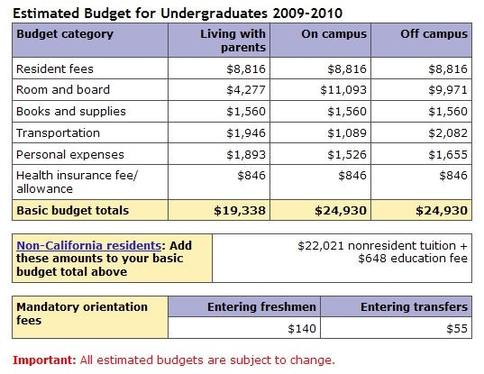

Step 7:
You should now have one cell filled in for each row EXCEPT Spending Money. If you don’t know the value for a row, estimate. You can change it later.

For any cell that has a number in it, highlight that cell using the highlighter button in the Font
group of the Home tab of the Ribbon.

Your spreadsheet should look something like:

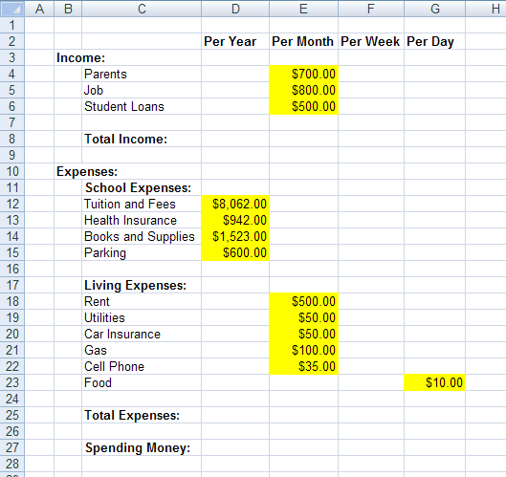
Step 8:
Let’s format this using color so that it’s easier to read.
  - Select all the data cells for Income, even cells that are currently blank
    - Make the text GREEN by
      - clicking on the Text Color button in the Font group on the Home tab of the
Ribbon
  - Select all the data cells for Expenses, even cells that are currently blank
    - Make the text RED
    - In accounting, it’s standard to have expenses and negative numbers be red.
o
Step 8:
Now comes the fun part. We get to write formulas to calculate the values to fill in our chart.

  - If we have a number in our Per Year column, how do we calculate:
    - Per Month?
      - There are 12 months per year
    - Per Week?
      - 52 weeks per year
    - Per Day?
      - 365 days per year

    - Example:
      - If you have that your annual tuition is in cell D12 as it is in the spreadsheet above, then to calculate the Per Month value, you would enter the following formula into cell E12
• =D12/12
      - For Per Week the formula would be =D12/52
      - For Per Day the formula would be =D12/365

    - Fill in formulas for all the rows in your spreadsheet that have Per Year filled in.
      - Once you have all the formulas in place for ONE ROW, you can drag the formulas down for all the other rows with Per Year information

  - Fill in formulas for all the rows that have Per Month, Per Week, Per Day information
    - The easiest way to do this is to FIRST calculate the Per Year column and then to do the other calculations from that.
  - Any cell that you calculate should NOT be highlighted yellow. The highlighting tells you that you can play with those numbers because they are not calculated.

Step 9:
Once you have all of the data calculated, we can start calculating totals.

  - For Total Income Per Year we can write a formula using SUM to sum up all the Per Year
income cells.
    - In the spreadsheet above, that formula in cell D8 would be
▪ =SUM(D4:D6)
  - Once we have the formula for the total Per Year we can drag it over to fill in the Total Income
row.
  - You should be able to calculate Total Expenses on your own.

Step 10:
Once you have calculated your Total Income and Total Expenses you can calculate the difference to determine how much Spending Money you have.
  - Your Spending Money formula should subtract Total Expenses from your Total Income
You can play with the numbers in yellow to see how they affect your Spending Money. Step 11:
You can add borders to your spreadsheet to make it easier to read.
Select a group of cells and click on the boarder button in the Font group of the Home tab on the
Ribbon to specify what kind of a border you want that group of cells to have.

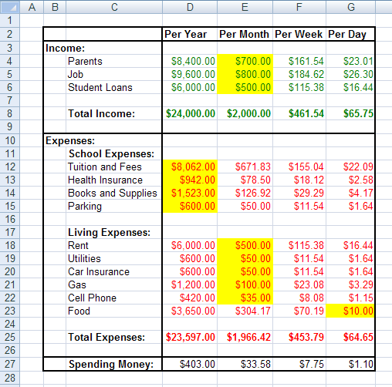Your final spreadsheet should look something like this:

Step 12:
Your basic Budget should now be done, but before we do anything else, let’s check your work and make sure that you’re formulas are correct.
  - Underneath your chart, sum together all of your expenses (NOT using your Total Expenses row
– remember, this is a check to make sure you did it correctly) for Per Year, Per Month, etc…
  - Add your spending money calculation to your expenses figures
  - Verify that the result equals your Total Income numbers.
    - If it doesn’t, you made a mistake somewhere.

Step 13:
Your Budget is done, but let’s create a pie chart of all of your expenses.
  - This is a little more complicated than what we did in lab
    - Hold down the Ctrl button and select all of the cells in Column’s C and D under your
Expenses section that have numbers in them EXCEPT for Total Expenses
    - Holding down the Ctrl button, select your Per Year Spending Money value
    - In our example, cells C12:D15, C18:D23, C27:D27 would now be selected
    - On the Insert tab of the Ribbon, select one of the Pie Chart options in the Charts
group.
    - You should now see a pie chart of your Budget Expenses
    - Under the Layout Chart tab, in the Labels group, play with how you want your data

displayed:
      - You can specify Data Labels for your chart and how and where you want them
      - Give your chart a Title

Food

Spending Money:

Tuition and Fees

      - Get rid of the Legend
      - Finally, you can move the chart onto its own page if you want by clicking the Move Chart
button on the Design tab.

Your chart will look something like:

Date of Submission: 10th August 2018

- Remarks: Output in the note book should contain both final spreadsheet and chart.

- Submit the homework to your respective computer science teacher.

