INDIAN SCHOOL AL WADI AL KABIR
DEPT. OF COMPUTER SCIENCE
CLASS VI Summer Holiday Homework 2018-19

Create a MS Power point presentation with 4 slides describing about your vacation as shown below.
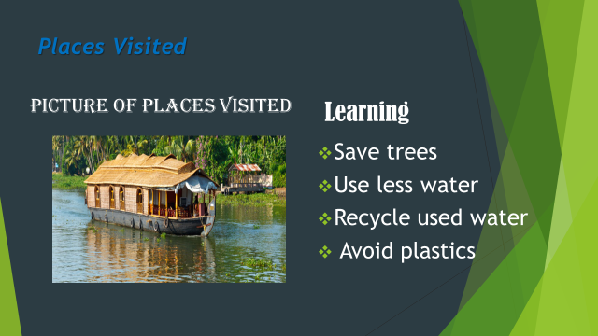
1)insert Picture related to the topic
2)change the layout
3. Using formatting options change the font style, size, colour
4)Using bulleting ->star bullet options
Using formatting options and different types of views
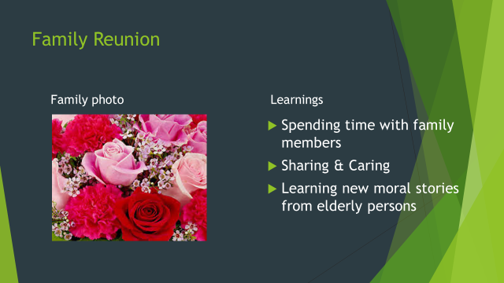
Use handout view and print the slides you created four slides in one page
Remark: Holiday Homework Practice at Home and Evaluation will be done after holidays during the regular practical session.
HAPPY HOLIDAYS

