INDIAN SCHOOL AL WADI AL KABIR
DEPT. OF COMPUTER SCIENCE
CLASS VIII Holiday Homework 2018 -19

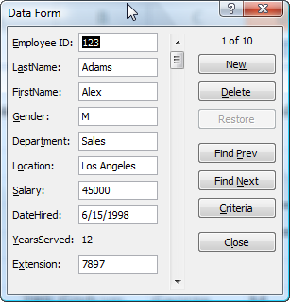
- Create following Data form in MS-Excel. Enter 10 records in the excel worksheet using data form.

Remark: Holiday Homework Practice at Home. Evaluation will be done after holidays during the regular practical session.
HAPPY HOLIDAYS

