INDIAN SCHOOL AL WADI AL KABIR-2018-19
DEPT OF ENGLISH- ClASS: VI
Winter Holiday Homework
- Every story has a beginning, middle and
What makes a good story?
- Typically short story has five key elements – Memorable Characters, Setting (brief but poetic and vivid), Plot (as simple and interesting as possible), Conflict (intense but one), and Theme. Introduce monologue, dialogue or conversation; but be careful to make it interesting and natural.
- Give a suitable title.

Write a beautiful story based on what you see in the picture given below. (Word limit- 150 to 180)
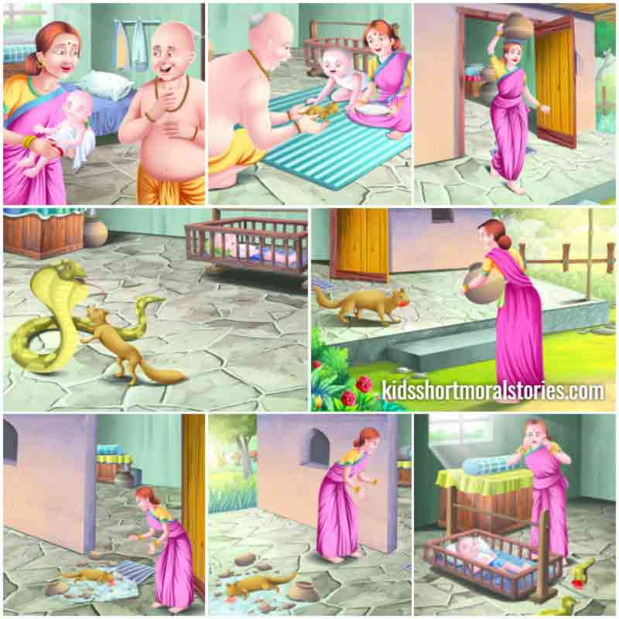
- Read unit 15 ‘A Genius without Frontiers’ in your MCB. Some professions from Leonardo da Vinci’s story are described here. Find them in the word grid. (MCB Page-140)

- He makes a living by painting portraits and murals.
- He plays a musical instrument or composes music.
- He studies plants and their classification.
- He studies the origin, history and composition of Earth.
- He is a scientist who studies or practices physics.
- He writes stories, essays and poem for a living.

P | R | I | A | C | I | T | W | S | T
A | W | R | B | C | I | A | R | N | E
I | G | E | O | L | O | G | I | S | T
N | S | E | T | A | A | R | T | I | A
T | F | R | A | G | I | R | E | O | H
E | S | T | N | I | F | E | R | P | J
R | E | I | I | A | N | P | H | Y | I
P | H | Y | S | I | C | I | S | T | R
L | Y | H | T | S | R | P | E | F | T
P | M | U | S | I | C | I | A | N | N

- Reading Skills
Read the passage and answer the questions. (MCB Page 114 & 116)

WISH YOU ALL A BLESSED CHRISTMAS AND A GREAT AND WONDERFUL NEW YEAR.

