INDIAN SCHOOL AL WADI ALKABIR
DEPARTMENT OF SCIENCE 2018-19
HOLIDAY HOMEWORK
PRACTICAL BASED QUESTIONS - CLASS X
PHYSICS
- Draw a labelled circuit diagram showing three resistors R_{1,}R₂ and R₃ connected with a battery,a rheostat,a plug key and an ammeter using standard circuit symbols. Use this circuit to show that same current flows through every part of the circuit. list two precautions you would observe while performing the experiment.
- Draw a circuit to study the dependence of electric current with potential difference across the resistor.

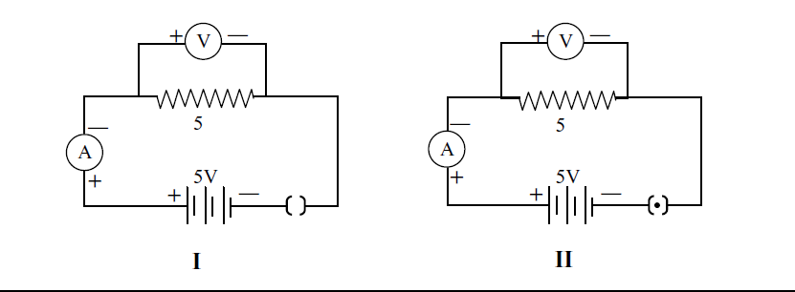What is the ammeter reading in the above given circuits ?
- 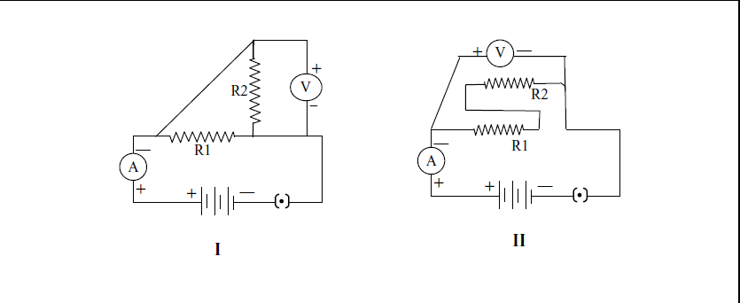

How are the resistors connected in the above given diagram?
- Which out of the set of an ammeter and voltmeter will be chosen for verifying ohm’s law. Give reason.

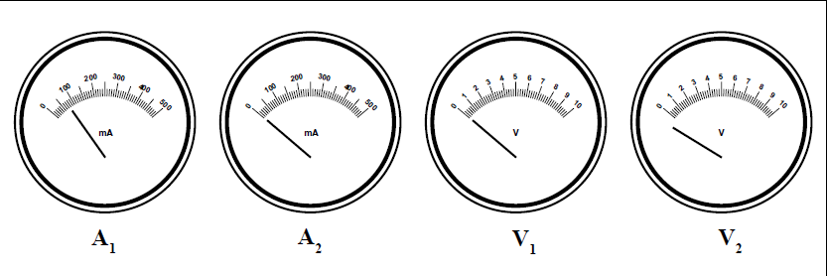

- 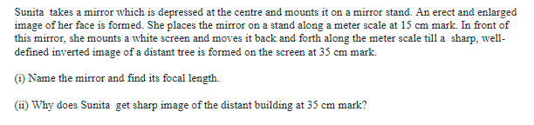The voltmeter,ammeter and resistor shown in the below given diagram have been checked.on plugging the key the voltmeter reads 4.5 v but the ammeter reads 1.5A .what could be the reason ?

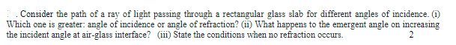
9. in an experiment, to find the equivalent resistance of a series combination of two
resistors r1 and r2, a student uses the circuit shown here.

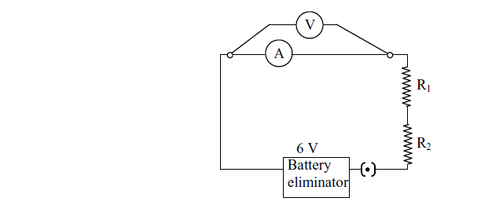

will the voltmeter and ammeter show the correct reading ?give reason for the observation.
10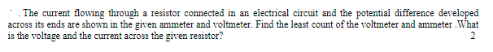
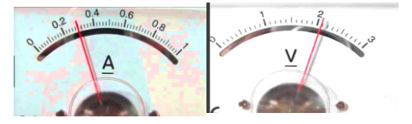

11)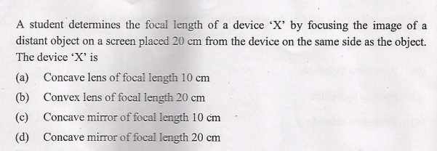
12)
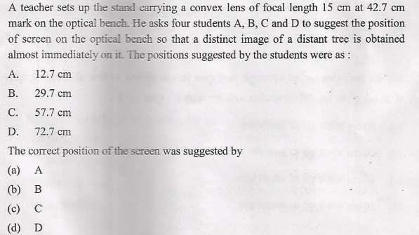
13)
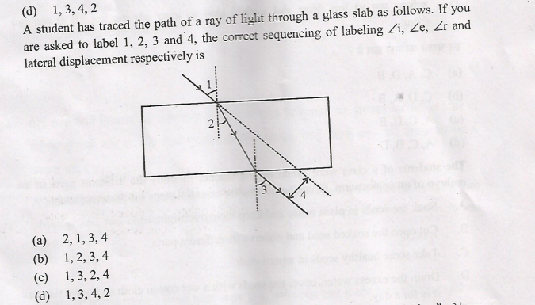
14)
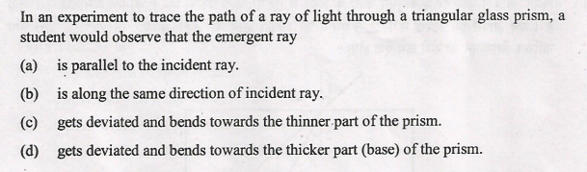
15)
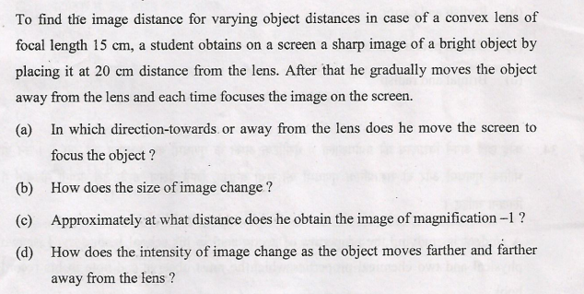
16)

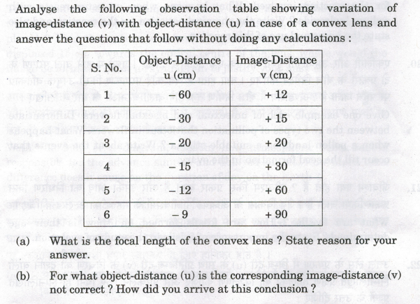
17) a student obtained a sharp image of a lighted candle on a screen using a convex lens. now he wants to focus a distant lamp on a far away electric pole. in which direction should the lens be moved for this purpose with respect to the screen, to get a sharp image on the screen? justify your answer.
Ans- He should move the lens towards the screen. As the distance of object increased, the image formed by a convex lens will be more close to the focus.
18) A student used a device ‘X’ to obtain the image of a well illuminated distant building on a screen ‘S’ as shown below in the diagram.
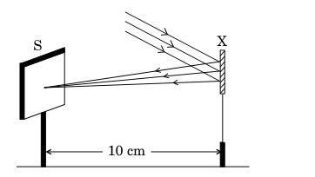
Identify the device and find the focal length of the device.
19) A student traces the path of a ray of light through a rectangular glass slab for four different values of angle of incidence. He observes all possible precautions while fixing the pins and also while measuring different angles. On analysing the measurements of angle of incidence, angle of refraction at the first interface and angle of emergence what are the conclusions he is likely to draw?
20) Consider the following traces of the path of a ray of light passing through a glass prism. Identify the diagram which shows the correct path of a ray of light. Give reason.
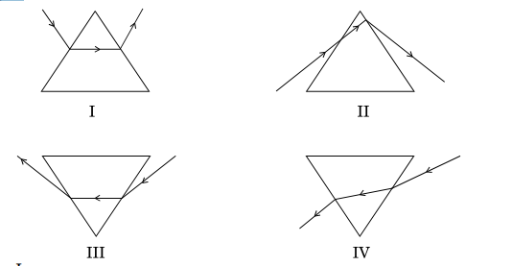

CHEMISTRY

- 2g of ferrous sulphate crystals are heated in a dry test tube.
- List any two observations.
- Name the type of chemical reaction taking place.

- 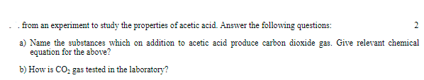 Which gas is produced when zinc metal reacts with hydrochloric acid? Explain with the help of chemical equation.
- In order to study the properties of HCl acid, a student adds dil.HCl to a test tube containing a compound X .As a result a colourless and odourless gas is evolved, which turs the lime water milky. What could be compound X? Name the gas formed. What will happen on passing the gas in excess of lime water?
- Why does the colour of copper sulphate solution change, when an iron nail is dipped in it?
- What is the residue left in the boiling tube, when ferrous sulphate crystals are strongly heated? What is its colour?
- A student mixes solid sodium sulphate powder in solid barium chloride powder. What change on mixing the two solids would the student observe? Justify your answer and explain how he can obtain the expected change?
- In order to study the properties of acids and bases a student added red litmus solution to A and observed that it changed in to blue. When she added another solution B to A in excess, she observed that the solution turned red. Identify the solutions A and B.
- In a laboratory to study :
- Combination reaction
- Decomposition reaction and
- Double displacement reaction , Following chemicals are obtained in solid form:- Calcium oxide, Ferrous sulphate, barium chloride and sodium sulphate.
Mention which chemicals will be used in solid form and which chemicals will be used in aqueous form.
- Why does a moist blue litmus paper turn red when it is brought near the mouth of the test tube in which ferrous sulphate crystals are being heated?
- Which of the following pairs will give displacement reaction? Why?
- FeSO₄ and copper metal
- FeSO₄ and aluminium metal
- ZnSO₄ and copper metal
- CuSO₄ and iron metal

BIOLOGY
1. Mention any two precautions that should be taken while preparing the temporary mount of a leaf peel.
2. Draw the experimental setup to demonstrate the process of respiration. Label it.
3. What are the precautions taken to show that light is essential for photosynthesis.
4. Write down the steps of an experiment that light is essential for photosynthesis.
5. A part of destarched leaf of a potted plant was covered with black paper strips on both sides and the plant was kept in the sunlight for eight hours. The leaf was then tested with iodine after boiling it in alcohol. Only the uncovered part of the leaf
turned blue black. The inference is that______.
6. What is the sequence of steps in the preparation of temporary mount of a stained leaf peel?
7. Draw a labeled diagram of a stomatal apparatus with open stomatal pore.
8. Mention any two precautions that should be taken to prove that carbon-dioxide is given out during respiration.
9. In the experiment to prove that light is necessary for photosynthesis, which one is not required?
a. Alcohol b. Iodine, c. KOH, d. Water. Justify your answer.

10. In the experimental setup to demonstrate the process of respiration which chemical
is required in a small test tube? What is its importancein this experiment?
******************************
PREPARED BYMrs. ANU ANNIE MATHEWS & Mrs.JENESHA JOSEPH Mrs.ASHA JOHN AND Mr. GERARD THOMAS.

