INDIAN SCHOOL AL WADI AL KABIR
DEPT. OF COMPUTER SCIENCE
CLASS VIIIWINTER Holiday Homework 2018-19

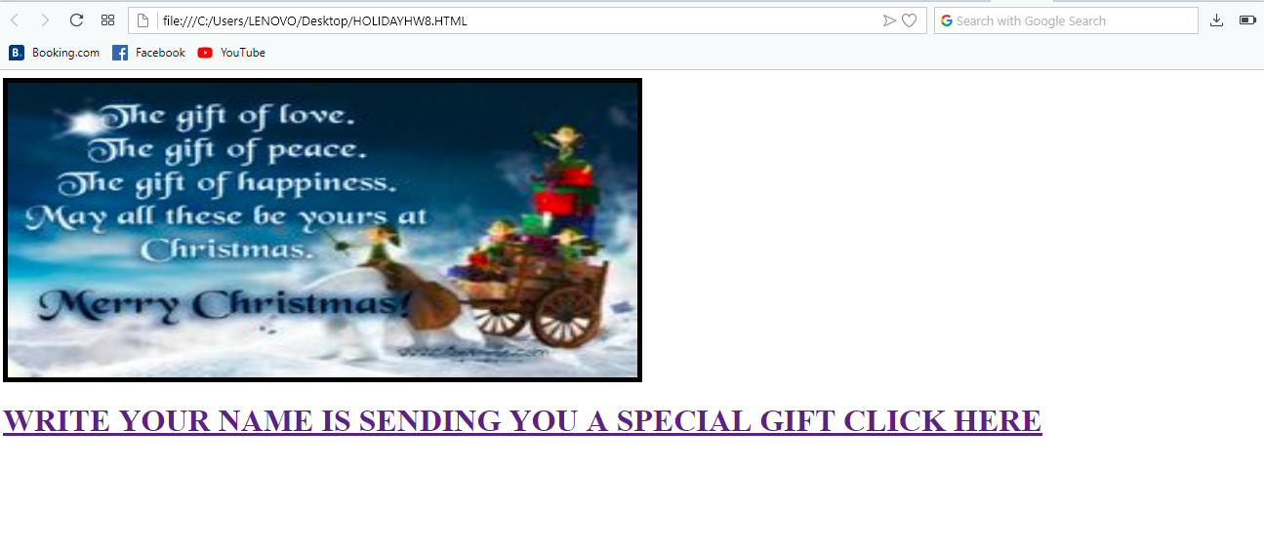
WHEN ABOVE LINK IS CLICKED OPEN NEXT WEB PAGE
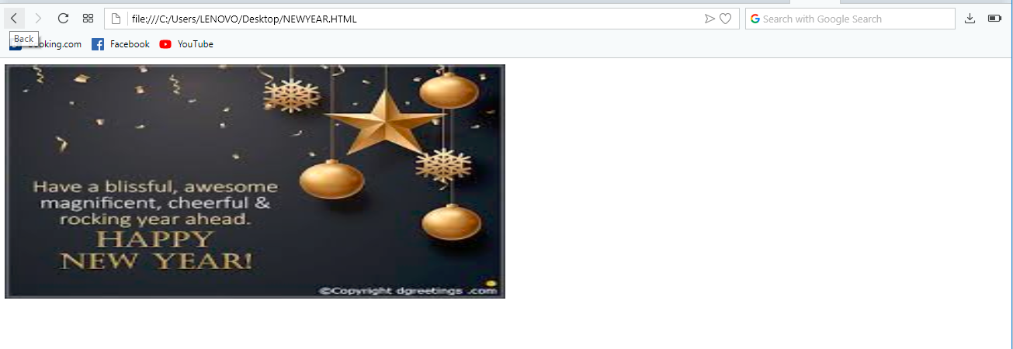
CREATE FOLLOWING WEBPAGE USING <IMG>TAG, with all its attributes to display it in attractive manner
Hint: Use height, width, align, border and heading tags

Remark: Holiday Homework Practice at Home and write the code in notebook, Evaluation will be done after holidays during the regular practical session.
HAPPY HOLIDAYS

