INDIAN SCHOOL AL WADI AL KABIR
Department of Computer Science
Holiday Home Work

- Design a GUI applicaton as per the screenshot to calculate commission for the salesmen.The commission is calculated according to following rates.

SALES | COMMISSION RATE
25001 onwards  20001-25000  15001-20000  10001-15000  0-10000 | 15%  10%  8%  5%  2%

SCREENSHOT:
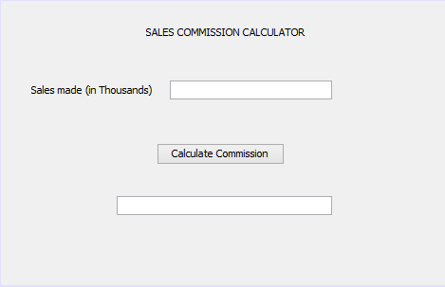
jLabel3
jButton1
jTextField1
jLabel2
jLabel1

Note: In the screenshot, result must be displayed in the label (jLabel3).

- Design a GUI applicaton as per the screenshot that obtains the price and quantity of an item, calculates the sale-value,discount and net payable amount.Discount is calculated as 10% of the sale value.
SCREENSHOT:
jTextField1
jLabel4

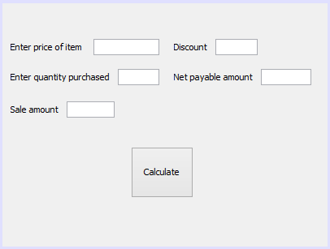
jButton1
jTextField5
5
jTextField4
jTextField3
jTextField2
jLabel5
jLabel3
jLabel2
jLabel1

Date of Submission: 20- Jan -2019
- Remarks: Code must be written in the note book and submitted to respective computer science teacher.

