INDIAN SCHOOL AL WADI AL KABIR

Class: VII | Department: Computer Science | Date of submission:  18/8/2019
Holiday Homework No:1 | Topic: HTML | Note: Holiday homework will be graded during practical session , practice in holidays
- Create a web page as given below

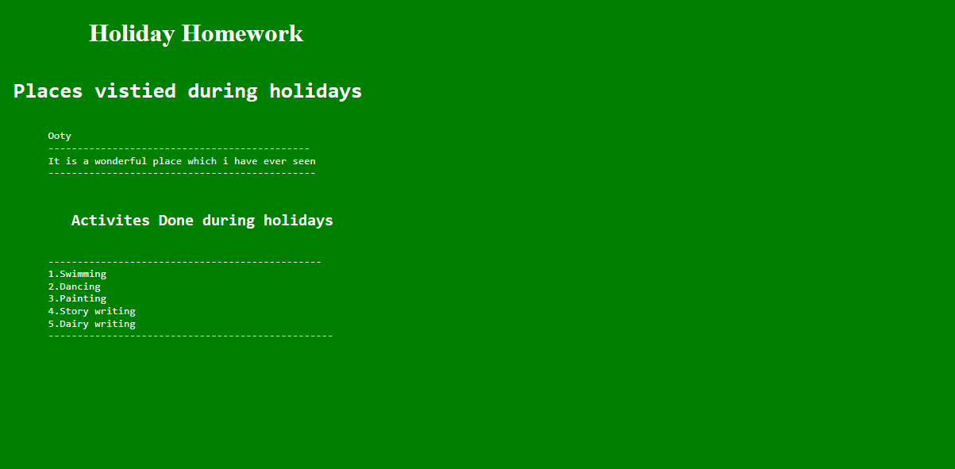

Points to be noted to create a webpage
- Use marquee tag for page heading HOLIDAY HOMEWORK
- Use different heading tags to display page content (H1……H6)
- Use <pre> tag to display the page content appearance
- You can specify the place which you have visited during holidays
- Different background color(bgcolor) and text color can be given

