INDIAN SCHOOL AL WADI AL KABIR

Class: X | Department: Computer Science | Date of submission:  18/8/2019
Holiday Homework No:1 | Topic: HTML | Note: Holiday homework complete it in A4 Sheet with proper coding in HTML
- Create a web page as given below

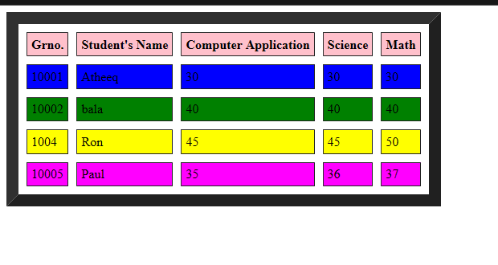

Points to be noted to create a webpage
- Use <th> tag for table heading.
- Use different color in <tr> tag to make each row with distinct color
- Use border size of 10 .
- You can specify the cell spacing and cell padding using pixel

- Create a web page as given below
- “Welcome to our Robotic World” use the marquee tag to make the text scrolling
- H1 tag is used to make text heading bigger in size
- Use image width and height using pixel
- Use border around the image and specify the size to be 5

