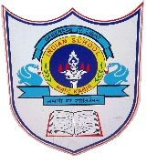
INDIAN SCHOOL AL WADI AL KABIR

Class: VIII | Department: Social Science | Date of submission:  16-1-2020
Winter Holiday Assignment | Topic: The Changing of Visual Arts | Year: 2019-20

I | Answer the following questions
1 | How did oil painting help artists?
2 | Who was Samuel Bourne?
3 | How were colonial portraits different from traditional Indian portraits?
5 | Who was Raja Ravi Varma?
6 | What did Indian photographers often recorded?

