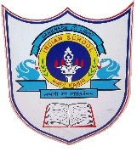
INDIAN SCHOOL AL WADI AL KABIR

Class: IX | Department: Social Science | Date of submission:  12/1/2020
Worksheet No: | Topic: HOLIDAY ASSIGNMENT | YEAR:2019-20

Prepare a Creative and Innovative collage of the Parliament of India by including both the Houses along with following information with relevant pictures:-
1. President
2. Vice-President
3. Prime Minister
4. Cabinet Ministers and their current portfolio.

Note
*The Assignment should be made in the Political science note book. (Graded Activity)
*It should be presentable.

