**INDIAN SCHOOL AL WADI AL KABIR**

**DEPARTMENT OF SCIENCE 2016 17**

**TERM II – SYLLABUS – CLASSES IX AND X**



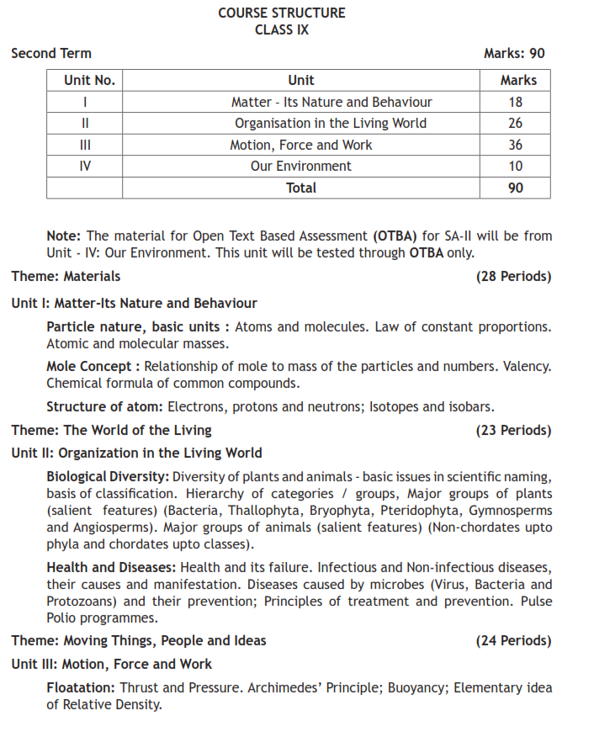

**1**

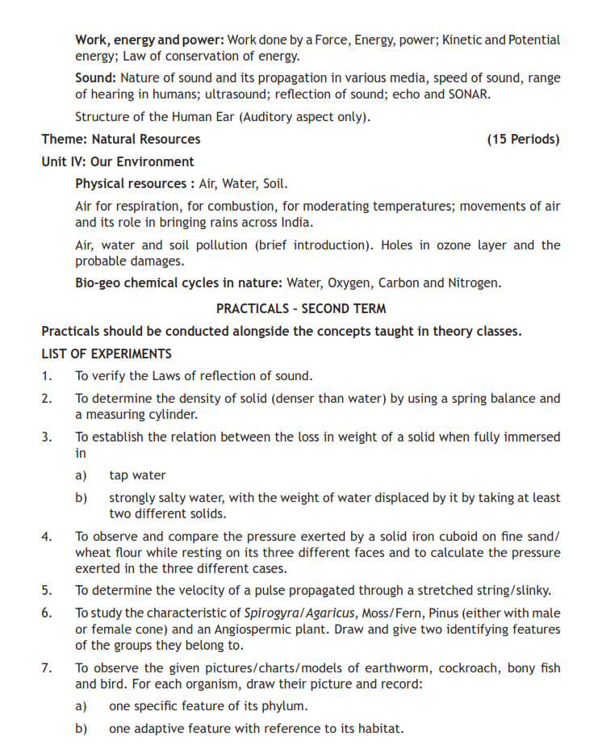

**2**

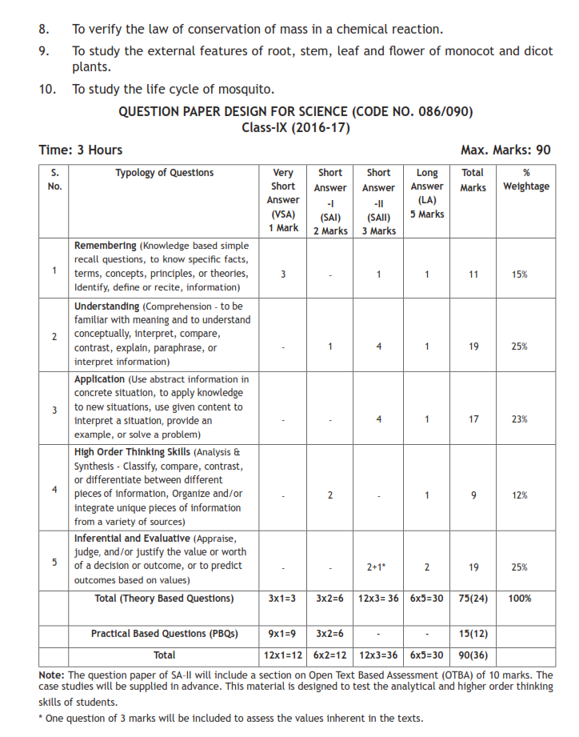

**3**

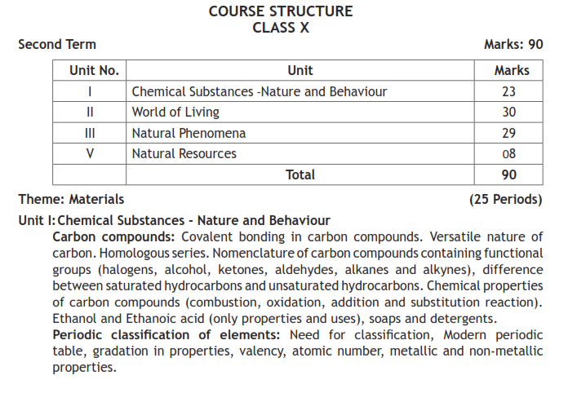

**4**

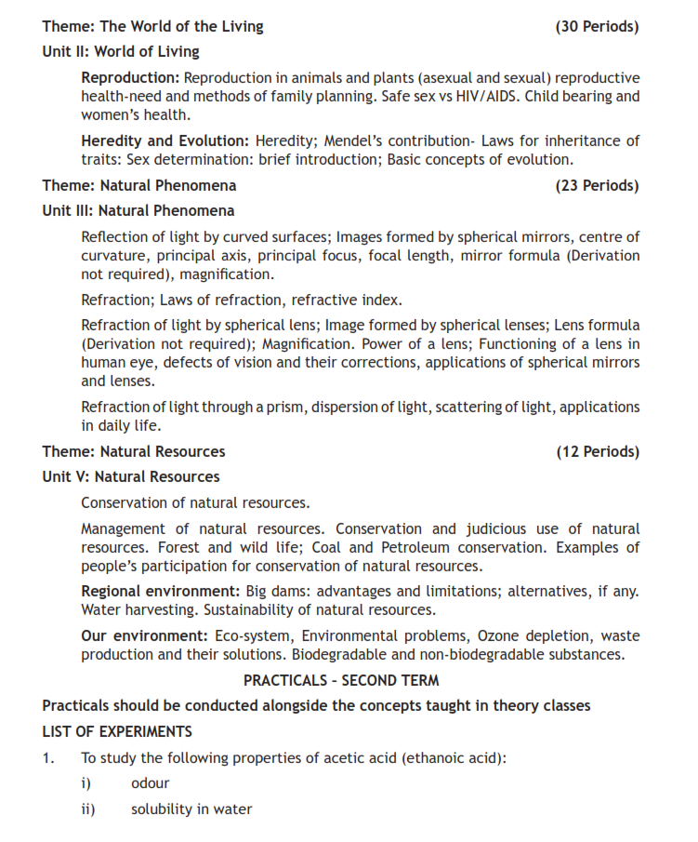

**5**

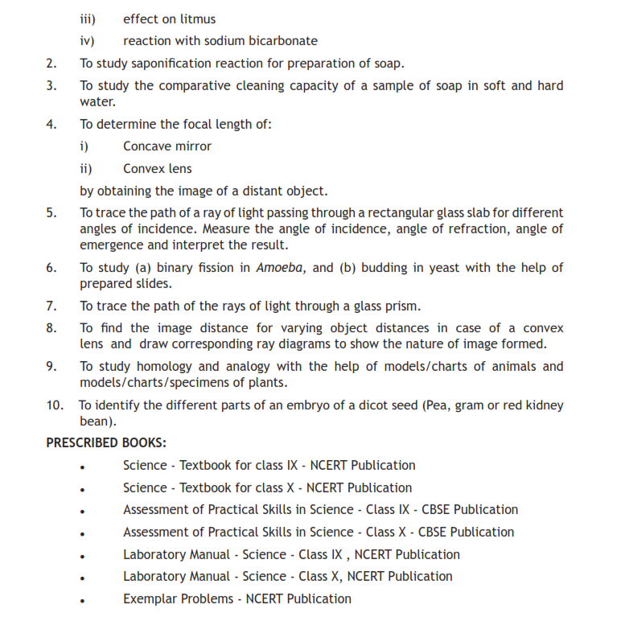

**6**

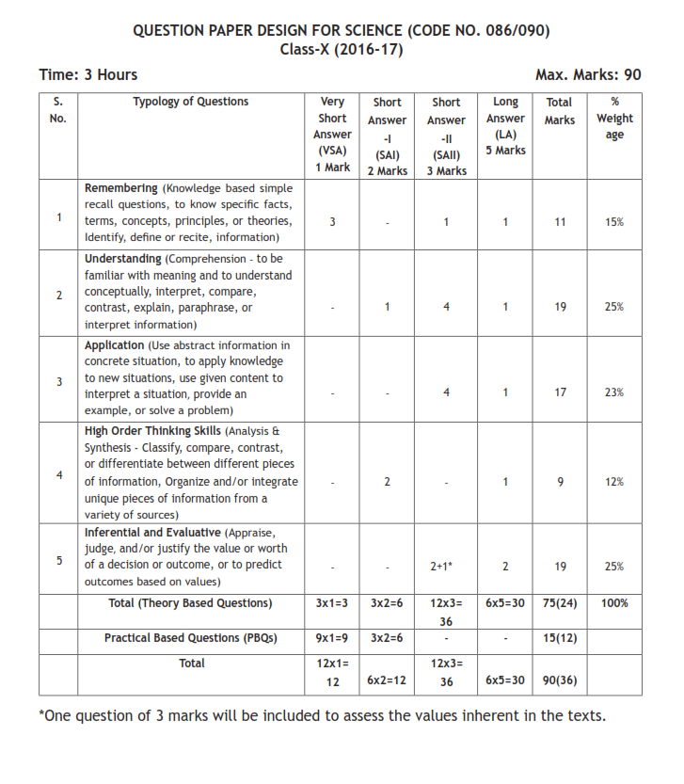

**7**