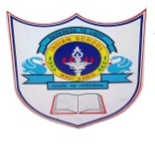
INDIAN SCHOOL AL WADI AL KABIR
DEPARTMENT OF COMPUTER SCIENCE
ACADEMIC YEAR: 2017-2018
DETAILED PLAN -APRIL-AUG CLASS : l Teacher’s Name: Hemilin Jolly
Month | No. of periods | Topic | Activities
APRIL  09-4-2017 – 30-04-2017 | 08 | UNIT -1  DIFFERENT TYPES OF MACHINE  - Machine made by people  - Machine make our work easier, faster and better.  Parts of the computer  - Moniter,Key board, Mouse. | 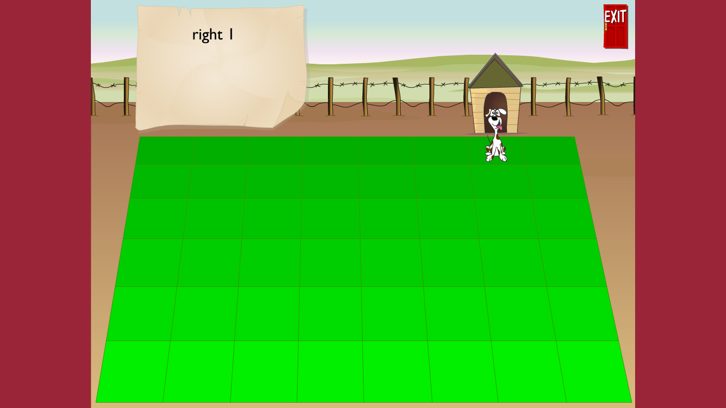  Using the mouse to follow the instructions displayed on the screen.
MAY  01-05-2017 – 25-05-2017 | 08 | UNIT -2  CHARACTERISTICS OF THE COMPUTER  - Works very fast.  - Remember the things.  - It does not make mistake.  USES OF THE COMPUTER  - Drawing and colouring  - Read and write  - Play games | UNIT TEST 1  Using the mouse to follow the instructions displayed on the screen  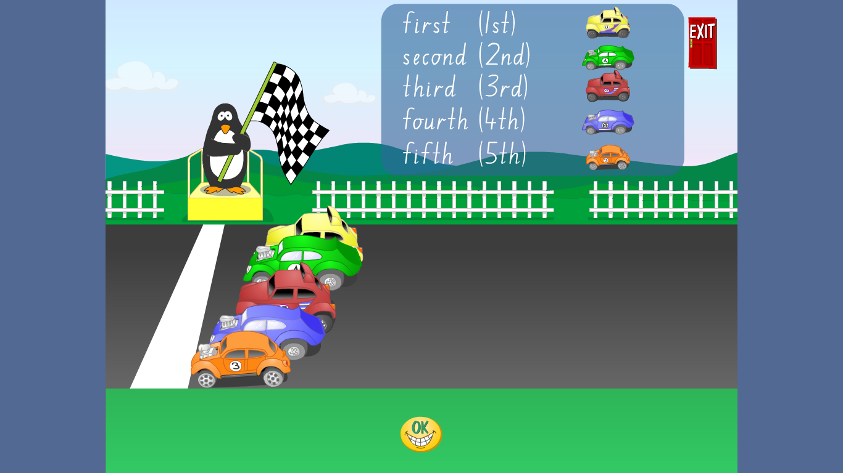  The option used: click and drag
JULY  24-07-2017 - 31-06-2017 | 02 | UNIT -3  TYPES OF COMPUTER  - Desk top computer  - Laptop computer  - Tablet  - Smartphone. | 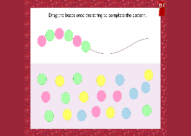  Using the mouse to follow the instructions displayed on the screen  The option used: click and drag
AUGUST  01-08-2017- 31-08-2017 | 08 | UNIT -4  COMPUTRE PERIPHERALS AND ITS USEES  MONITOR, KEY BOARD, CPU, MOUSE. | Using the mouse to follow the instructions displayed on the screen.  

