INDIAN SCHOOL AL WADI AL KABIR
DEPARTMENT OF COMPUTER SCIENCE
ACADEMIC YEAR: 2017-2018:
April-Aug
CLASS: II
Month | No. of periods | Topic | Activities
APRIL  09-4-2017 – 30-04-2017 | 08 | Using the Keyboard (T)  Starting with Microsoft word.  typing – Enter Key / Caps Lock Key/Numeric Keyboard/arrow keys  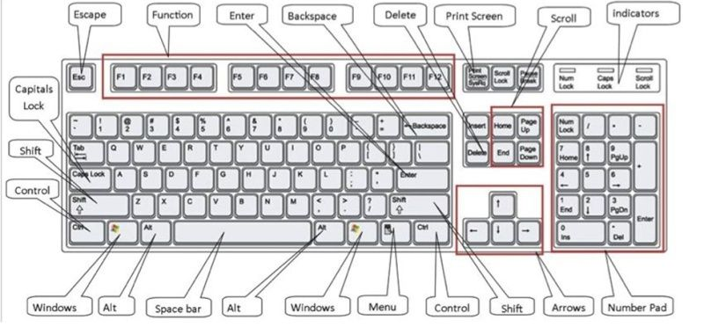 | Lab Exercise – Typing sentences given on the board by using different keys on the keyboard.  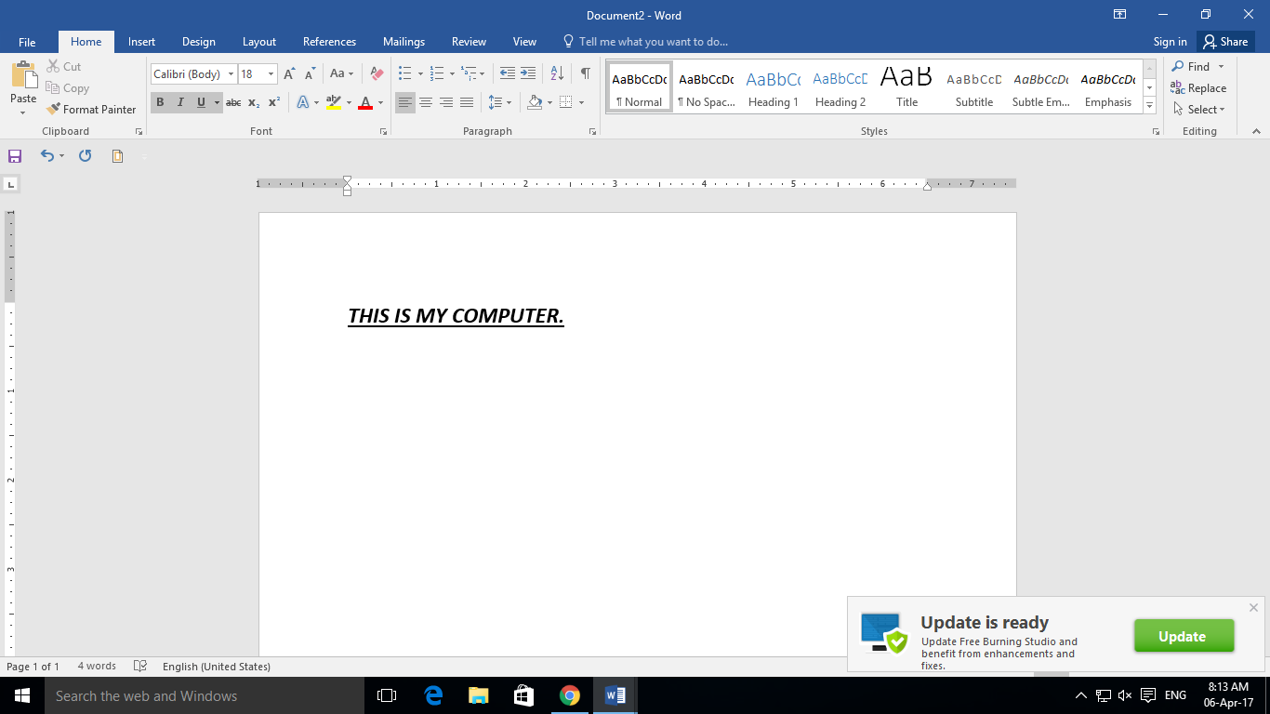  Page no. 88 – Activity on MS - word.
MAY  01-05-2017 – 25-05-2017 | 08 | Using the Mouse (T)  To use different tools in MS – Word, for Eg. Select Text/Bold text/underline text/change font/font size. Etc.  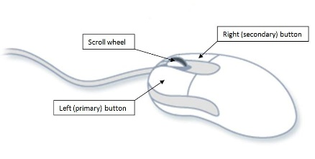 | UNIT TEST 1  Test paper  Activity - Label the mouse (page :53)
JULY  24-07-2017 - 31-06-2017 | 02 | Revision – MS – Word
AUGUST  01-08-2017- 31-08-2017 | 08 | Introduction to Paint –  To get them familiarized with toolbox, color box & Menu bar etc.  Use of tools – line tool with options, rectangle, fill, color | Activity: draw the pictures using paint. (page no. 79)

