INDIAN SCHOOL AL WADI AL KABIR
POST MID TERM -DECEMBER -2017
CLASS VI- SCIENCE - BLUE PRINT
SL NO | NAME OF THE CHAPTER | VERY SHORT ANSWER-VSA(1 MARKS) | SHORT ANSWER-I SA-I(2 MARKS) | SHORT ANSWER-II SA-II(3 MARKS) | LONG ANSWER-LA (5 MARKS) | TOTAL MARKS | %  WEIGHTAGE
1 | MOVEMENTS IN BODY |  | 1 | 2 |  | 8 | 26.66
2 | ADAPTATIONS IN LIVING ORGANISMS | 1 |  | 1 | 1 | 9 | 30
3 | MEASUREMENT AND MOTION |  | 1 | 1 | - | 5 | 16.66
4 | LIGHT SHADOWS AND REFLECTIONS | 1 | 1 | 1 |  | 6 | 20
5 | TO MEASURE THE LENGTH OF CURVED LINE WITH DIVIDER | - | 1 |  | - | 2 | 6.66
 | WORKING OF PINHOLE CAMERA
 | TOTAL | 1X2=2 | 2X4=8 | 3X5=15 | 5X1=5 | 30 | 100

CLASS COORDINATOR
RANJANA SANGTANI

INDIAN SCHOOL AL WADI AL KABIR
POST MID TERM -DECEMBER -2017
CLASS VII- SCIENCE - BLUE PRINT
S. NO. | NAME OF THE CHAPTER | VERY SHORT ANSWER-  VSA  (1 MARKS) | SHORT ANSWER-I  SA-1  (2 MARKS) | SHORT ANSWER-II  SA-II  (3 MARKS) | LONG ANSWER-  LA  (5 MARKS) | LAB BASED-  (2MARKS) | TOTAL MARKS | %  WEIGHTAGE
1 | RESPIRATION IN ORGANISMS | - | 1 | 2 | - | - | 8 | 26.6
2 | TRANSPORTATION AND EXCRETION | 1 | - | 1 | 1 | - | 9 | 30
3 | PHYSICAL AND CHEMICAL CHANGES | - | 1 | 1 | - | 1 | 7 | 23.4
4 | TIME AND MOTION | 1 | 1 | 1 | - | - | 6 | 20
 | TOTAL | 1X2=2 | 2X3=6 | 3X5=15 | 5X1=5 | 1x2=2 | 30 | 100

PREPARED BY
Mrs. Leena Chaudhary

INDIAN SCHOOL AL WADI AL KABIR
POST MID TERM -DECEMBER -2017
CLASS VIII- SCIENCE
BLUE PRINT
SL NO | NAME OF THE CHAPTER | VERY SHORT ANSWER-VSA(1 MARKS) | SHORT ANSWER-I SA-I(2 MARKS) | SHORT ANSWER-II SA-II(3 MARKS) | LONG ANSWER-LA (5 MARKS) | TOTAL MARKS | %  WEIGHTAGE
1 | COAL AND PETROLEUM | 1 |  | 2 |  | 7 | 23.3
2 | SOUND |  | 1 | 2 |  | 8 | 26.66
3 | CROP PRODUCTION AND MANAGEMENT | 1 | 1 |  | 5 | 8 | 26.66
4 | NATURL PHENOMENA |  | 1 | 1 |  | 5 | 16.66
5 | TO DEMONSTRATE CHANGE OF PITCH ( JAL THARANG) | - | 1 |  | - | 2 | 6.66
 | TO SEPARATE HEALTHY SEEDS FROM UNHEALTHY ONES.
 | TOTAL | 1X2=2 | 2X4=8 | 3X5=15 | 5X1=5 | 30 | 100
CLASS COORDINATOR
SUMA SENU

 | VSA (1mark)  (no of questions& Typology of questions) | SAQ (2 marks)  (no of questions& Typology of questions) | SAQ (3marks)  (no of questions& Typology of questions) | LAQ (5 marks)  (no of questions& Typology of questions) | PRACTICAL BASED (2marks each) | Total marks (no of questions)
PHYSICS |  | 1(Evaluative)  1 (application) | 3 (value based,understanding,application) | 2( Understanding,Application) | 2 | 27(9)
CHEMISTRY |  |  | 4( Knowledge based,Understanding,application, Remembering) | 2 ( Understanding,Application) | 2 | 26(8)
BIOLOGY | 2( Remembering) | 1 (understanding) | 3 ( Knowledge based, Understanding,Application) | 2(HOTS, Remembering) | 2 | 27(10)
Total marks (no of questions) | 2 (2) | 6(3) | 30 (10) | 30 (6) | 12 (6) | 80(27)

INDIAN SCHOOL AL WADI AL KABIR
POST MID TERM -DECEMBER -2017
CLASS IX- SCIENCE - BLUE PRINT

Prepared by Mr. Gerard

INDIAN SCHOOL AL WADI AL KABIR
POST MID TERM -DECEMBER -2017
CLASS X- SCIENCE- BLUE PRINT
 | VSA (1mark)  (no of questions& Typology of questions) | SAQ (2 marks)  (no of questions& Typology of questions) | SAQ (3marks)  (no of questions& Typology of questions) | LAQ (5 marks)  (no of questions& Typology of questions) | PRACTICAL BASED (2marks each) | Total marks (no of questions)
PHYSICS |  | 1(Evaluative)  1 (application) | 3 (Knowledge based, understanding, application) | 2( Understanding, Application) | 2 | 23(9)
CHEMISTRY | 1 ( Remembering) |  | 4 (Value based, Understanding,application, Remembering) | 2 ( Understanding, Application) | 2 | 23(9)
BIOLOGY | 1 ( Remembering) | 1 (understanding) | 3 ( Knowledge based, Understanding, Application) | 2(HOTS, Remembering) | 2 | 22(9)
Total marks (no of questions) | 2 (2) | 6(3) | 30 (10) | 30 (6) | 12 (6) | 80(27)

Prepared by Ms. Anu Mathews

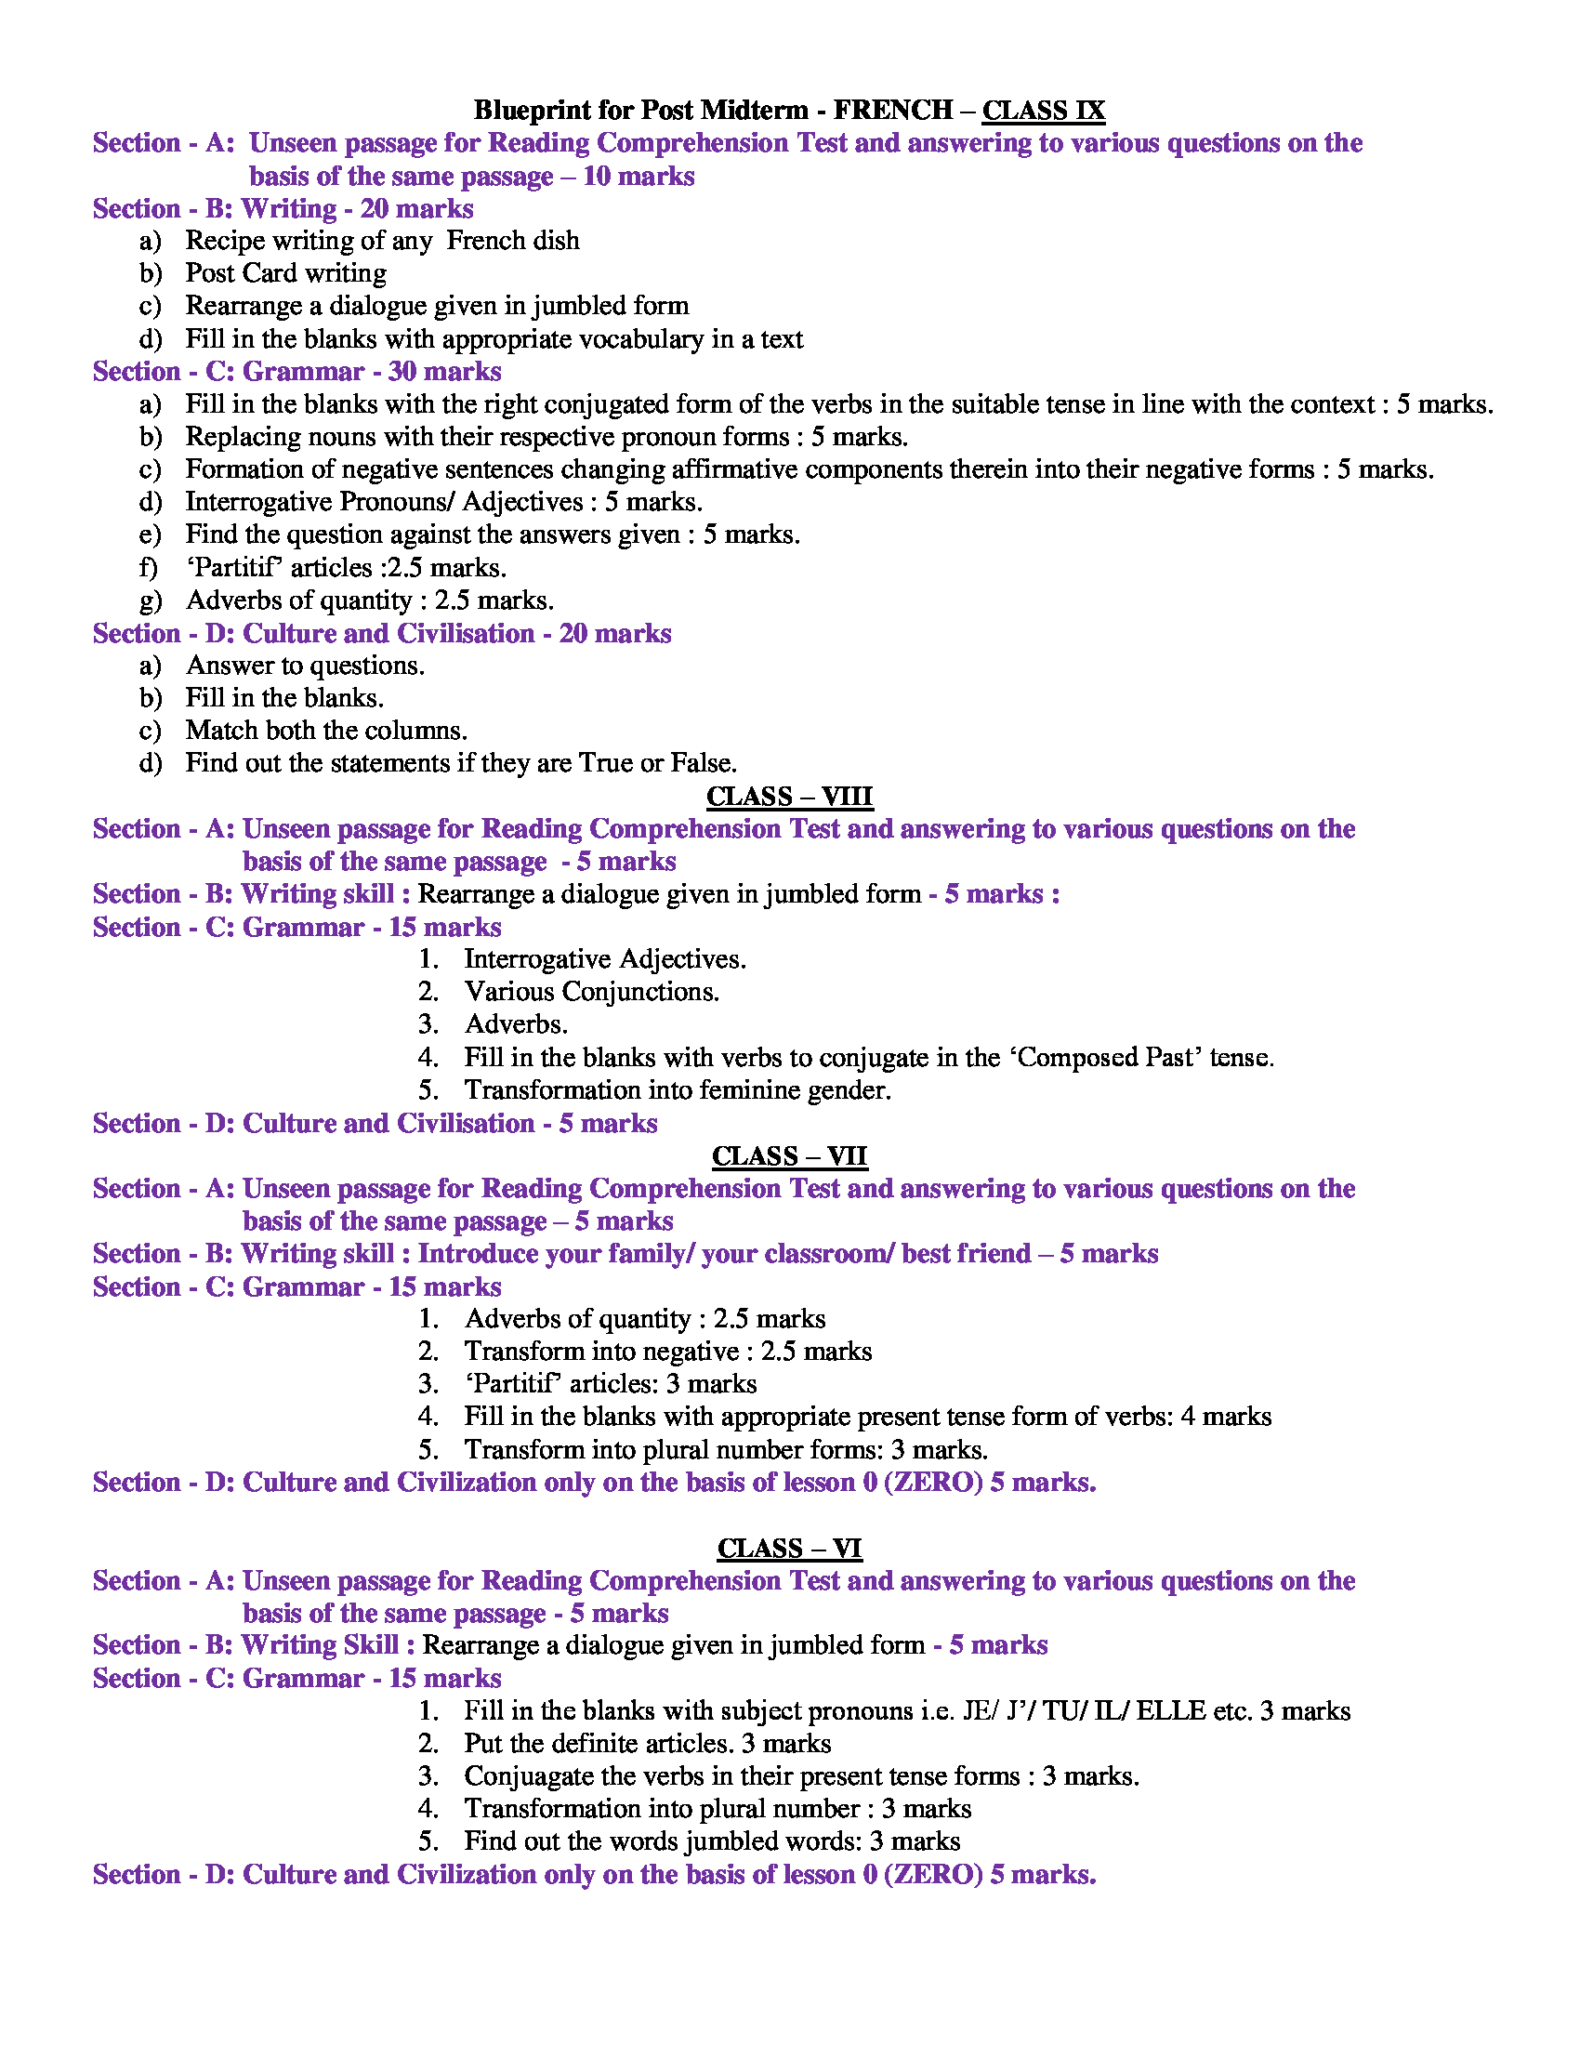
Prepared by Ms. Sima Ghosh
Indian School Al Wadi Al Kabir 2017-18
CLASS XI PHYSICS
Assessment 2 - Blue Print
 | UNIT | VSA |  |  | SA-I |  | SA-II |  | VBQ |  | LA |  | TOTAL
 | UNITS AND MEASUREMENT |  |  |  |  |  | 3(1) |  |  |  |  |  | 3(1)
 | KINEMATICS |  |  |  |  |  | 6(2) |  | 4(1) |  |  |  | 10(3)
 | LAWS OF MOTION | 1(1) |  |  | 2(1) |  | 3(1) |  |  |  | 5(1) |  | 11(4)
 | WORK, ENERGY AND POWER | 1(1) |  |  | 2(1) |  | 3(1) |  |  |  | 5(1) |  | 11(4)
 | SYSTEM OF PARTICLES | 1(1) |  |  | 2(1) |  | 6(2) |  |  |  |  |  | 9(4)
 | GRAVITATION | 1(1) |  |  | 2(1) |  | 9(3) |  |  |  |  |  | 12(5)
 | PROPERTIES OF MATTER (SOLIDS AND FLUIDS) | 1(1) |  |  | 2(1) |  | 6(2) |  |  |  | 5(1) |  | 14(5)
 | TOTAL | 5(5) |  |  | 10(5) |  | 36(12) |  | 4(1) |  | 15(3) |  | 70(26)
Prepared by Mr. Manu
Indian School Al Wadi Al Kabir 2017-18
CLASS XII PHYSICS
Rehearsal I Blue Print
UNIT |  |  | VSA | SA-I |  | SA-II |  | VBQ |  | LA |  | TOTAL
ELECTROSTATICS |  |  |  | 2(1) |  | 6(2) |  |  |  |  |  | 8(3)
CURRENT ELECTRICITY |  |  | 1(1) |  |  | 6(2) |  |  |  |  |  | 7(3)
MAGNETIC EFFECTS OF CURRENT AND MAGNETISM |  |  |  |  |  | 3(1) |  |  |  | 5(1) |  | 8(2)
EMI AND AC |  |  | 1(1) | 2(1) |  |  |  |  |  | 5(1) |  | 8(3)
EM WAVES |  |  |  |  |  | 3(1) |  |  |  |  |  | 3(1)
OPTICS |  |  |  |  |  | 6(2) |  | 4(1) |  | 5(1) |  | 15(4)
DUAL NATURE OF MATTER |  |  | 1(1) | 2(1) |  |  |  |  |  |  |  | 3(2)
ATOMS AND NUCLEI |  |  | 1(1) | 2(1) |  | 3(1) |  |  |  |  |  | 6(3)
ELECTRONIC DEVICES |  |  | 1(1) |  |  | 6(2) |  |  |  |  |  | 7(3)
COMMUNICATION SYSTEM |  |  |  | 2(1) |  | 3(1) |  |  |  |  |  | 5(2)
TOTAL |  |  | 5(5) | 10(5) |  | 36(12) |  | 4(1) |  | 15(3) |  | 70(26)

Prepared by Mr. Manu

INDIAN SCHOOL AL WADI AL KABIR
ASSESSMENT II – DECEMBER 2017
CLASS 11 - CHEMISTRY
BLUE PRINT

S.NO | CHAPTER | VSA (1) | SA(2) | SA(3) | VBQ(4) | LA(5) | TOT MARKS | WEIGHTAGE  %
1 | Some Basic Concepts of Chemistry | 1 |  | 2 |  |  | 7 | 10
2 | Structure of atom |  | 1 |  |  | 1/1 | 7 | 10
3 | Classification of Elements and periodicity in properties | 1 |  | 1/1 |  |  | 4 | 5.71
4 | Chemical Bonding |  | 1 | 2 |  |  | 8 | 11.42
5 | Hydrogen | 1 |  | 2 |  |  | 7 | 10
6 | Organic Chemistry- Some Basic Principles and Techniques |  | 1/1 | 2 |  |  | 8 | 11.42
7 | Hydrocarbons |  | 1 | 1 |  | 1/1 | 10 | 14.28
8 | States of Matter | 1 |  | 2 |  |  | 7 | 10
9 | Thermodynamics |  | 1 |  |  | 1/1 | 7 | 10
10 | Environmental Chemistry | 1 |  |  | 1 |  | 5 | 7.14
 | TOTAL | 1×5= 5 | 2×5 =10 | 12×3=36 | 1×4=4 | 5×3=15 | 70 | 100%

Prepared by Ms. Jasmin J

INDIAN SCHOOL AL WADI AL KABIR
FIRST REHEARSAL EXAMINATION – DECEMBER 2017
CLASS 12 - CHEMISTRY
BLUE PRINT

S.NO | CHAPTER | VSA (1) | SA(2) | SA(3) | VBQ(4) | LA(5) | TOT MARKS | WEIGHTAGE  %
1 | Solid State | 1 |  | 1 |  |  | 4 | 5.71
2 | Solutions |  | 1 | 1 |  |  | 5 | 7.14
3 | Electrochemistry |  |  |  |  | 1/1 | 5 | 7.14
4 | Chemical Kinetics |  | 1/1 | 1 |  |  | 5 | 7.14
5 | Surface Chemistry | 1 |  | 1 |  |  | 4 | 5.71
6 | General Principles and Processes of Isolation |  |  | 1 |  |  | 3 | 4.28
7 | p Block Elements | 1 | 1 | 1 |  |  | 6 | 8.57
8 | d and f Block Elements |  |  |  |  | 1/1 | 5 | 7.14
9 | Coordination Compounds |  | 1 | 1 |  |  | 5 | 7.14
10 | Haloalkanes and Haloarenes | 1 |  | 1 |  |  | 4 | 5.71
11 | Alcohols, Phenols and Ethers |  |  |  |  | 1/1 | 5 | 7.14
12 | Aldehydes, Ketones and Carboxylic acids |  | 1 | 1/1 |  |  | 5 | 7.14
13 | Amines | 1 |  | 1 |  |  | 4 | 5.71
14 | Biomolecules |  |  | 1 |  |  | 3 | 4.28
15 | Polymers |  |  | 1 |  |  | 3 | 4.28
16 | Chemistry in Everydaylife |  |  |  | 1 |  | 4 | 5.71
 | TOTAL | 1×5= 5 | 2×5 =10 | 12×3=36 | 1×4=4 | 5×3=15 | 70 | 100%

Prepared by Ms. Jasmin J

Indian School Al Wadi Al Kabir 2017-18
CLASS XI BIOLOGY
Assessment 2 Blue Print
UNIT |  | VSA |  | SA-I |  | SA-II |  | VBQ |  | LA |  | TOTAL
HUMAN PHYSIOLOGY |  | 1 |  | 2 |  | 3 |  |  |  | 1 |  | 19
PLANT PHYSIOLOGY |  | 2 |  | 1 |  | 3 |  | 1 |  | 1 |  | 22
CELL - THE UNIT OF LIFE |  | 2 |  | 2 |  | 6 |  |  |  | 1 |  | 29
TOTAL |  | 5(5) |  | 10(5) |  | 36(12) |  | 4(1) |  | 15(3) |  | 70(26)
Prepared by REJITHA SAJITH
Prepared by Ms. Rejitha S

Indian School Al Wadi Al Kabir 2017-18
CLASS XII BIOLOGY
Rehearsal I Blue Print
UNIT | VSA(1) |  | SA-I(2) |  | SA-II(3) |  | VBQ(4) |  | LA(5) |  | TOTAL
REPRODUCTION | 3 |  |  |  | 2 |  |  |  | 1 |  | 14
GENETICS AND EVOLUTION | 1 |  | 1 |  | 3 |  | 1 |  |  |  | 16
BIOLOGY IN HUMAN WELFARE |  |  | 2 |  | 2 |  |  |  |  |  | 10
BIOTECHNOLOGY | 1 |  | 1 |  | 2 |  |  |  | 1 |  | 14
ECOLOGY |  |  | 1 |  | 3 |  |  |  | 1 |  | 16
TOTAL | 5(5) |  | 10(5) |  | 36(12) |  | 4(1) |  | 15(3) |  | 70(26)

Prepared by Ms. Rejitha S

INDIAN SCHOOL AL WADI AL KABIR
ENGINEERING GRAPHICS - ASSESSMENT II
BLUE PRINT OF THE PAPER - Class 11.B
UNITS | MCQ( 1) | SA (3) | VBQ (4) | LA (5) | VLA (7) | TOTAL
Unit 1  Plane Geometry  (3 Chapters) | 2 | 1 | 1 | 1 | 1 | 21
Unit 2  (2 chapter) | 2 | 2 | 1 | 2 | 1 | 29
Unit 3  Solid Geometry  (1 chapter) | 1 | 1 | 1 | 1 | 1 | 20
TOTAL | 5 | 12 | 12 | 20 | 21 | 70

Prepared by Ms. Aishwarya

Checked and Verified by :
Jenifer Robinson
Academic Supervisor – Science
20.11.17 / Monday

