BLUE PRINT – CLASS 6 - SCIENCE
SL NO | CHAPTER | VSA-1 MARK | SA- 2MARKS | SA -3 MARKS | LA-5 MARKS | LAB ACTIVITY | TOTAL | % WEIGHTAGE
1 | MOVEMENTS IN THE BODY |  |  | 1 | 1 |  | 8 | 10
2 | ADAPTATIONS IN LIVING ORGANISMS |  | 1 | 2 |  |  | 8 | 10
3 | MEASUREMENT AND MOTION | 1 |  |  | 1 | 2 | 6+2= 8 | 10
4 | LIGHT,SHADOWS AND REFLECTIONS |  | 1 | 2 |  | 2 | 8+2=10 | 12.5
5 | ELECTRICITY AND CIRCUITS |  |  | 1 | 1 | 2 | 8+2=10 | 12.5
6 | MAGNETS AND THEIR EFFECTS |  |  | 1 | 1 | 2+2 | 8+2+2=12 | 15
7 | AIR AROUND US |  | 1 | 1 | 1 |  | 10 | 12.5
8 | WASTE AND ITS MANAGEMENT | 1 |  |  | 1 |  | 6 | 7.5
9 | SEPARATION OF SUBSTANCES(PREVIOUS PORTION) |  |  | 2 |  | 2 | 6+2=8 | 10
 | TOTAL MARKS | 2 | 6 | 30 | 30 | 12 | 80 | 100

BLUE PRINT-CLASS 7 - SCIENCE

SL NO | NAME OF THE CHAPTER | VERY SHORT ANSWER-VSA  (1 MARK) | SHORT ANSWER-I SA-I  (2 MARKS) | SHORT ANSWER-II SA-II  (3 MARKS) | LONG ANSWER-LA  (5 MARKS) | LAB ACTIVITY  (2marks) | TOTAL MARKS | %  WEIGHTAGE
1 | RESPIRATION IN ORGANISMS | - | - | 1 | 1 | - | 8 | 10%
2 | TRANSPORTATION AND EXCRETION | - | - | 1 | 1 | - | 8 | 10%
3 | PHYSICAL AND CHEMICAL CHANGES | - | - |  | 1 | 1 | 7 | 8.75%
4 | TIME AND MOTION | - |  | 1 | - | 1 | 5 | 6.25%
5 | REPRODUCTION IN PLANTS | - | 1 | 1 | 1 | - | 10 | 12.5%
6 | FOREST AND THEIR CONSERVATION | 1 | - | 1 | - | - | 4 | 5%
7 | WEATHER, CLIMATE AND ANIMAL ADAPTATIONS | - | - | 2 | - | - | 6 | 7.5%
8 | WIND AND STORM |  | - | - | 1 | 1 | 7 | 8.75%
9 | ELECTRIC CURRENT AND SIMPLE CIRCUITS | - | 1 | - | 1 | 1 | 9 | 11.25%
10 | ACIDS, BASES AND SALTS (1ST TERM) | - | - | 2 | - | 1 | 8 | 10%
11 | LIGHT AND ASSOCIATED PHENOMENA(1ST TERM) | 1 | 1 | 1 | - | 1 | 8 | 10%
 |  | 2x1=2 | 3x2=6 | 10X3=30 | 6X5=30 | 6X2=12 | 80 | 100

BLUE PRINT- CLASS 8 - SCIENCE
SL NO | NAME OF THE CHAPTER | VERY SHORT ANSWER-VSA(1 MARKS) | SHORT ANSWER-I SA-I(2 MARKS) | SHORT ANSWER-II SA-II(3 MARKS) | LONG ANSWER-LA (5 MARKS) | TOTAL MARKS | %  WEIGHTAGE
1 | FORCE AND FRICTION |  | 1 | 1 | 1 | 10 | 12.5
2 | METALS AND NON-METALS |  |  | 2 | 1 | 11 | 13.75
3 | COAL AND PETROLEUM |  | 1 | 1 |  | 5 | 6.25
4 | SOUND | 1 |  | 1 | 1 | 9 | 11.25
5 | CROP RPODUCTION AND MANAGEMENT |  |  |  | 1 | 5 | 6.25
6 | SOME NATURAL PHENOMENON |  | 1 | 1 |  | 5 | 6.25
7 | CHEMICAL EFFECTS OF ELECTRIC CURRENT | 1 |  | 1 |  | 4 | 5
8 | POLLUTION OF AIR AND WATER |  |  | 1 |  | 3 | 3.75
9 | MORE ABOUT LIGHT |  |  | 1 | 1 | 8 | 10
10 | CONSERVATION OF PLANTS AND ANIMALS(HAND OUT) |  |  | 1 |  | 3 | 3.75
11 | COMBUSTION,FLAME AND FUEL |  |  |  | 1 | 5 | 6.25
 | LAB BASED
1 | FORCE AND FRICTION (ACT 5) |  | 1 |  |  | 2 | 2.5
2. | METALS AND NON-METALS (ACT 3) |  | 1 |  |  | 2 | 2.5
3 | SOUND(ACT 3) |  | 1 |  |  | 2 | 2.5
4 | CROP RPODUCTION AND MANAGEMENT(ACT 1) |  | 1 |  |  | 2 | 2.5
5 | MORE ABOUT LIGHT(MULTIPLE REFLECTION) |  | 1 |  |  | 2 | 2.5
6. | COMBUSTION,FLAME AND FUEL  (ACT 2) |  | 1 |  |  | 2 | 2.5
 | TOTAL | 1X2=2 | 2X9=18(6+12) | 3X10=30 | 5X6=30 | 80 | 100

BLUE PRINT – CLASS 9 - SCIENCE
Units |  | Marks
I | Matter - Its Nature & Behaviour | 23
II | Organisation in the Living World | 20
III | Motion, Force and Work | 27
IV | Our Environment | 06
V | Food; Food Production | 04
 | Total | 80

BLUE PRINT – CLASS 10 - SCIENCE

Units |  | Marks
I | Chemical Substances - Nature & Behaviour | 25
II | World of Living | 23
III | Natural Phenomenon | 12
IV | Effects of Current | 13
V | Natural Resources | 07
 | Total | 80

BLUE PRINT – CLASS 11 - PHYSICS
Unit | Chapter / Topic | Marks
I | Physical World and Measurement | 23
 | Chapter–1: Physical World
 | Chapter–2: Units and Measurements
II | Kinematics
 | Chapter–3: Motion in a Straight Line
 | Chapter–4: Motion in a Plane
III | Laws of Motion
 | Chapter–5: Laws of Motion
IV | Work, Energy and Power | 17
 | Chapter–6: Work, Energy and Power
V | Motion of System of Particles
 | Chapter–7: System of Particles and Rotational Motion
VI | Gravitation
 | Chapter–8: Gravitation
VII | Properties of Bulk Matter | 20
 | Chapter–9: Mechanical Properties of Solids
 | Chapter–10: Mechanical Properties of Fluids
 | Chapter–11: Thermal Properties of Matter
VIII | Thermodynamics
 | Chapter–12: Thermodynamics
IX | Kinetic Theory of Gases
 | Chapter–13: Kinetic Theory
X | Oscillation & Waves | 10
 | Chapter–14: Oscillations
 | Chapter–15: Waves
 | Total | 70

BLUE PRINT – CLASS 11 – CHEMISTRY
Unit | Title | Marks
I | Basic Concepts of Chemistry | 11
II | Structure of Atom
III | Classification of Elements & Periodicity in Properties | 04
IV | Chemical Bonding and Molecular Structure | 21
V | States of Matter: Gases and Liquids
VI | Thermodynamics
VII | Equilibrium
VIII | Redox Reactions | 16
IX | Hydrogen
X | s-Block Elements
XI | Some p-Block Elements
XII | Organic Chemistry: Basic Principles & Techniques | 18
XIII | Hydrocarbons
XIV | Environmental Chemistry
 | Total | 70

BLUE PRINT – CLASS 11 – BIOLOGY

Unit | Title | Marks
I | Diversity of Living Organisms | 07
II | Structural Organisation in Plants & Animals | 12
III | Cell: Structure and Function | 15
IV | Plant Physiology | 18
V | Human Physiology | 18
 | Total | 70

BLUE PRINT – CLASS 11 – ENGG. GRAPHICS
UNITS | MCQ( 1) | SA (3) | VBQ (4) | LA (5) | VLA (7) | TOTAL
Unit 1  Plane Geometry  (3 Chapters) | 2 | 3 | 0 | 1 | 0 | 16
Unit 2  Solid Geometry  (2 chapters) | 1 | 1 | 1 | 1 | 2 | 27
Unit 3  Machine Drawing  (3 chapters) | 2 | 0 | 2 | 2 | 1 | 27
TOTAL | 5 | 12 | 12 | 20 | 21 | 70

BLUE PRINT – CLASS 12 – PHYSICS
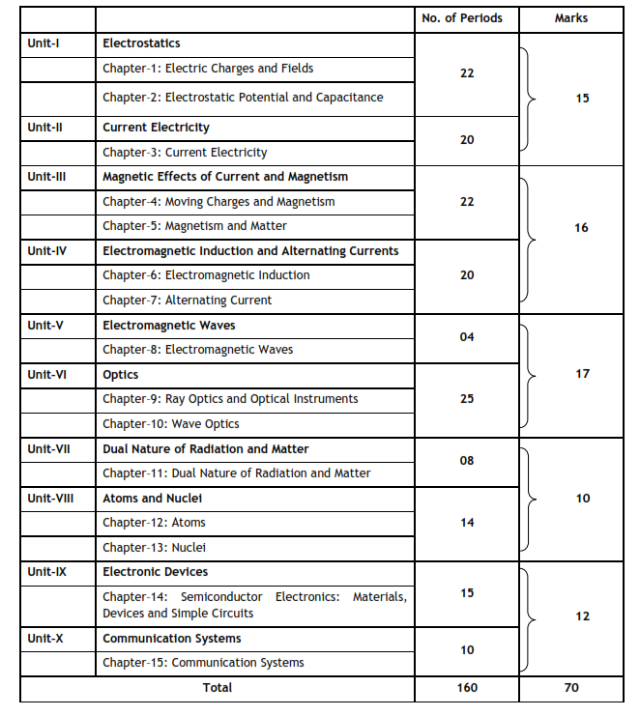

BLUE PRINT – CLASS 12 – CHEMISTRY
S.NO | CHAPTER | Marks
1 | Solid State | 22
2 | Solutions
3 | Electrochemistry
4 | Chemical Kinetics
5 | Surface Chemistry
6 | General Principles and Processes of Isolation | 19
7 | p Block Elements
8 | d and f Block Elements
9 | Coordination Compounds
10 | Haloalkanes and Haloarenes | 29
11 | Alcohols, Phenols and Ethers
12 | Aldehydes, Ketones and Carboxylic acids
13 | Amines
14 | Biomolecules
15 | Polymers
16 | Chemistry in Everydaylife
 | TOTAL

BLUE PRINT – CLASS 12 – BIOLOGY

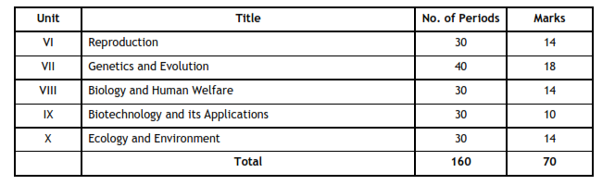

Jenifer Robinson
Academic Supervisor

