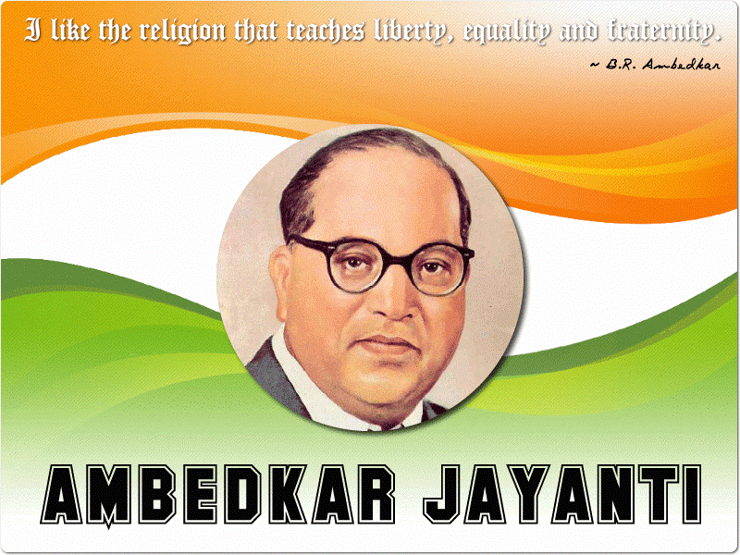
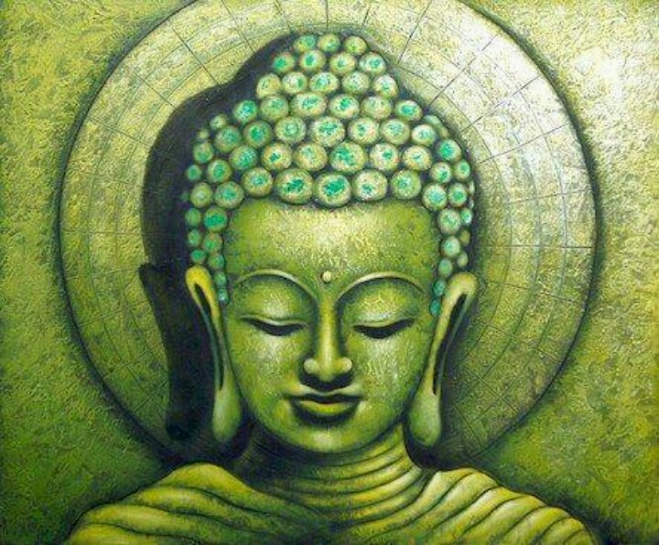

Dr. B.R. Ambedkar's birthday falls on 14th April, and each year sees countrywide celebration in his honour. This day is officially recognized as ‘Ambedkar Jayanti'. Known as the 'Father of the Indian Constitution', he chartered the course of the Indian social and political system.
Dr. Ambedkar's life has inspired people from the oppressed classes to earn a life of self-respect and dignity. Babasaheb set out an exemplary path by imbibing a modern outlook, embracing western education, and envisioning a society bereft of social bigotry and regressive thinking.
Here at ISWK Primary Section, the Afternoon Shift students of Class V celebrated this day in a grand manner. The children sang a melodies song, entertained us through a dance performance and enacted the journey of Dr. Ambedkar’s life through a mime show entitled ‘I AM AMBEDKAR’.
