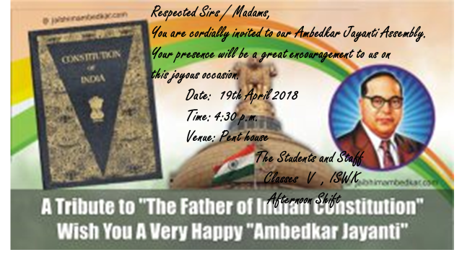
AMBEDKAR JAYANTI ASSEMBLY
PRIMARY AFTERNOON SHIFT
Ambedkar Jayanti is observed on 14th April every year in India. The class V students of the afternoon shift conducted the Ambedkar Jayanti special Assembly on 19th April at 4.30 p.m. in the Penthouse. The students of the primary afternoon section assembled in the penthouse for the assembly.
The assembly started with a welcome address followed by a video on the life and works of Dr. B.R. Ambedkar, the founder architect of the Indian Constitution. He was an eminent jurist and politician. His contribution to eradicate social evils like untouchability and caste restrictions from Indian society is remarkable. The students actively viewed the video. Based on the video a quiz was conducted by the teacher. The winners were awarded and congratulated. Later students shared a few inspiring quotes of Dr. B.R. Ambedkar. Finally, our vice principal addressed the gathering. He spoke on the important aspects of Dr. Ambedkar’s life and teachings. The assembly concluded with a tribute song to a great leader of our country.
