ISWK SUCCESS CONTINUES!!!
GRAND SUCCESS IN CBSE CLASS X BOARD EXAMINATIONS – 2018
After a spectacular performance in class XII examinations 2018, class X students of Indian School Wadi Kabir have come out with flying colours in the CBSE Board Examinations held in March 2018.
School toppers:
School First Rank shared by two students
1. Ms. Shradha Jayaprakash – 97.6%
2. Ms. Sarengi Radhika - 97.6%
2nd Rank & 3rd Rank
3. Master Sankalp Sandeep Kshirsagar - 97.2%
4. Master Arjun Manoj Kumar - 97 %
ISWK proudly announces the subject toppers- Sarengi Radhika, Sankalp Sandeep Kshirsagar and Tessa Elizabeth Joby have scored 100% marks in Social Science.

SUBJECTS | A1( 90% above)
English(101) | 100
Malayalam(12) | 11
Maths(41) | 82
Hindi(85) | 24
Science(86) | 123
Social(87) | 96
FIT(165) | 2

It’s indeed a significant achievement under revised evaluation pattern introduced by CBSE. The final examination was conducted covering the entire year syllabus and therefore the above performance of the students is truly commendable. Shradha Jayaprakash and Sarengi Radhika have topped the list of successful candidates with a stupendous performance with 97.6% each. Following them is Sankalp Sandeep Kshirsagar in the second place with an aggregate of 97.2% and Arjun Manoj Kumar (97%) in the third place.

The total number of students appeared in the board exams from ISWK for the academic year 2017-2018 were 364. Out of 364 students, 75 students have secured more than 90% in all subjects. ISWK has once again proven their academic prowess by securing a school average of more than 75% in all the subjects. The students’ hard work, unrelenting commitment and an earnest desire to excel have culminated in this great success.
SCIENCE TOPPERS (SCORED 99%): Arjun Manoj Kumar, Diwaakar Adinathan, Jeyoos Jaison, Kamini Mishra, Neha Ann Mathew, Priyosmita Kar, Reshma Rose Jose, Sankalp Sandeep Kshirsagar, Sarengi Radhika and Shradha Jayaprakash.
Karan Gupta and Aditya Mukundan in English with 98%; Arjun Manoj Kumar and Swetha S. Iyer in Hindi with 96%; Fadiya Ashraf in Malayalam with 99% ; Lisa Sanjay Verma, Aleena Thomas and Dhriti Bhatt in Mathematics with 99% and Rain Ephraim Varghese in FIT with 99%.
The School Management and Principal, congratulates all the staff, students and their parents on the grand success and compliments them for their dedication and hard work.
Kudos to all !!!

FIRST RANK |  | SECOND RANK | THIRD RANK
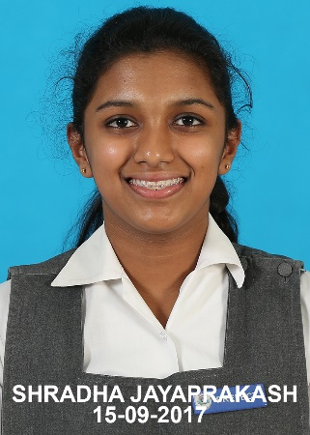 | 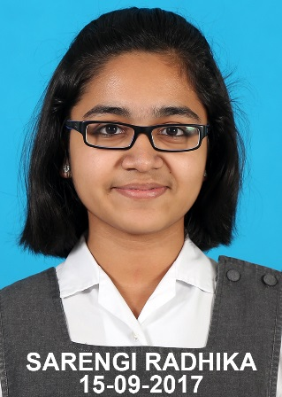 | 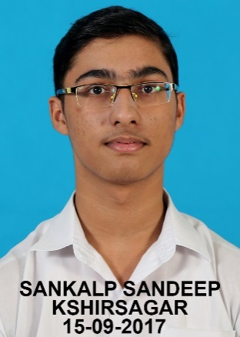 | 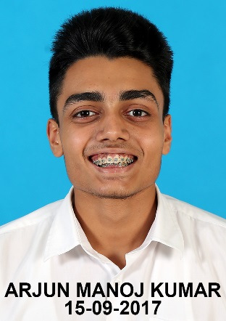
SHRADHA JAYAPRAKASH (97.6%) | SARENGI RADHIKA (97.6%) | SANKALP SANDEEP KSHIRSAGAR (97.2%) | ARJUN MANOJ KUMAR (97%)

SUBJECT TOPPERS
SOCIAL SCIENCE (100 %)
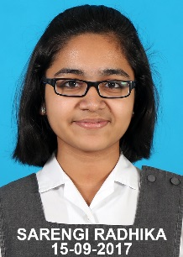 | 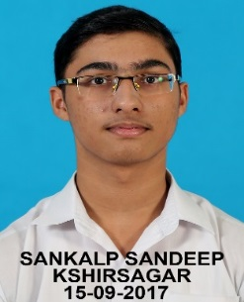 | 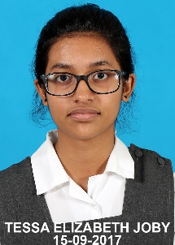
SARENGI RADHIKA | SANKALP SANDEEP KSHIRSAGAR | TESSA ELIZABETH JOBY

SCIENCE (99%)
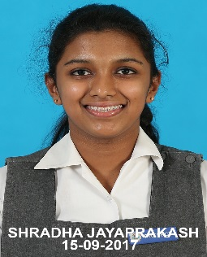 |  | 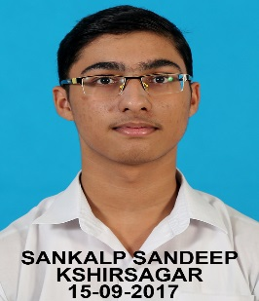 | 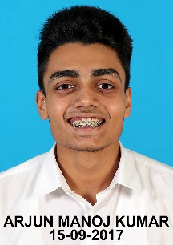 | 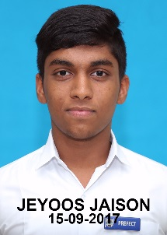
SHRADHA JAYAPRAKASH | SARENGI RADHIKA | SANKALP SANDEEP KSHIRSAGAR | ARJUN MANOJ KUMAR | JEYOOS JAISON
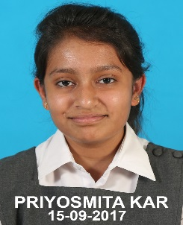 | 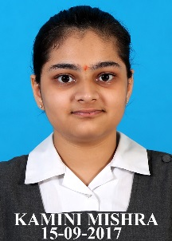 | 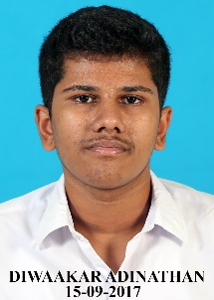 | 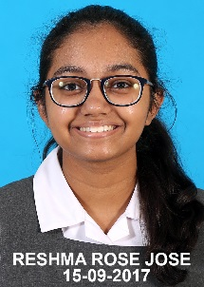 | 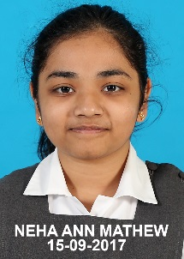
PRIYOSMITA KAR | KAMINI MISHRA | DIWAAKAR ADINATHAN | RESHMA ROSE JOSE | NEHA ANN MATHEW

MATHEMATICS (99 %)
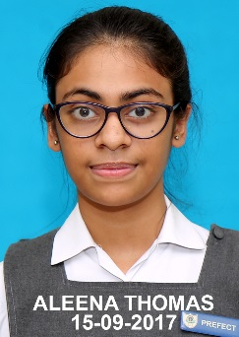 | 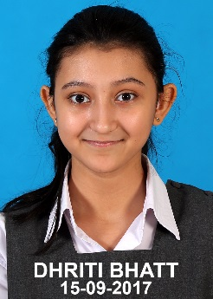 | 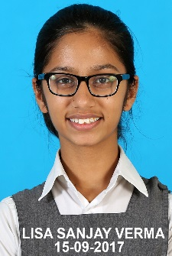
ALEENA THOMAS | DHRITI BHATT | LISA SANJAY VERMA

MALAYALAM (99 %) | FOUNDATION OF IT (99 %)
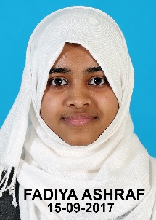 | 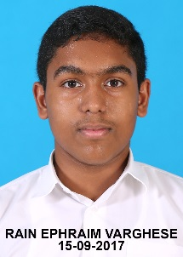
FADIYA ASHRAF | RAIN EPHRAIM VARGHESE

ENGLISH (98 %)
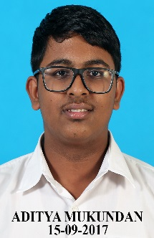 | 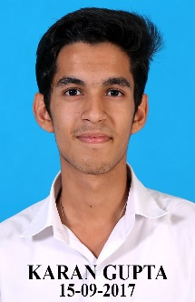
ADITYA MUKUNDAN | KARAN GUPTA
HINDI (96 %)
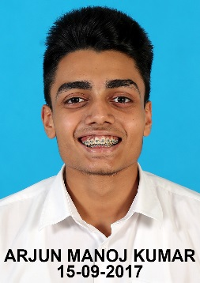 | 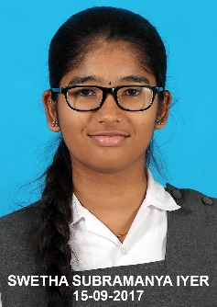
ARJUN MANOJ KUMAR | SWETHA SIVA SUBRAMANYA IYER

