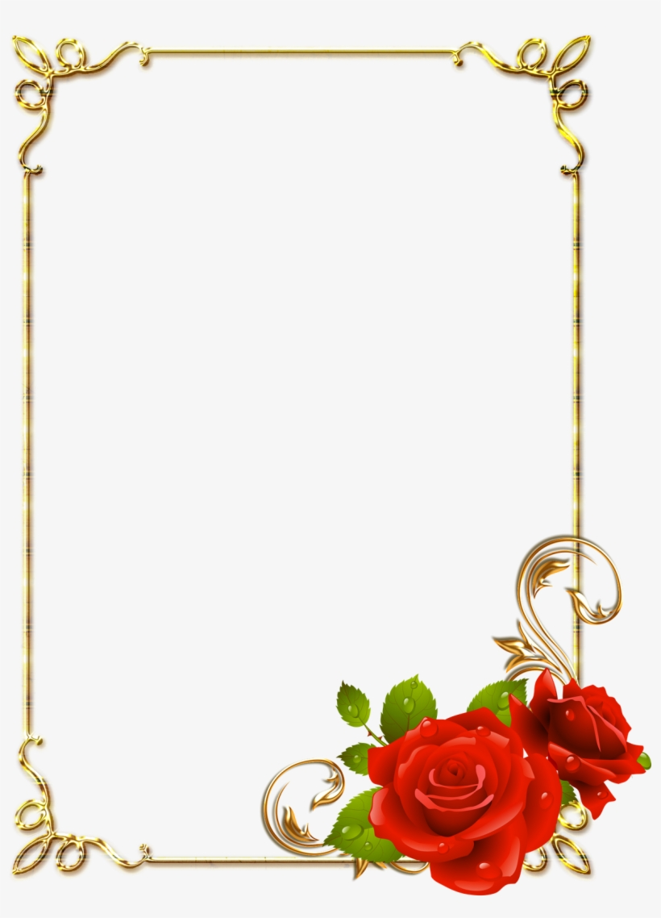
Diwali Special Assembly
Deepavali or Diwali is a festival of lights; it comes around the month of ‘Karthikamasam’ which normally falls around October or November. It is celebrated to mark the return of lord Rama from fourteen years of exile and his victory over the demon “Ravana”. Hindus regard it as a celebration of life and use the occasion to strengthen family and relationships. In some parts of India, it also marks the beginning of the New Year. People worship God Ganesha and goddess Laxmi during Diwali.
Generally, people light up their homes and shops using Diyas and colorful lanterns to welcome Goddess Laxmi. On the day of Diwali, people wear new and joyous clothes and exchange gifts, sweets and greetings with their friends and family.
At Indian School Al Wadi Al Kabir, we aim to introduce our Indian culture to our students making it a ‘home away from home’ whilst sustaining our life overseas. Conducting special assemblies on a particular occasion helps us to enhance cultural activities in our students. On 12th November 2018, the Hindi Department conducted the Diwali Special Assembly in which we celebrated by decorating the school with paper hanging lamp. This was then followed by a Diwali song, a folk tale performed by the students to brighten up their knowledge about the festival. To add some fun and enjoyment to the assembly we managed to have a group of students perform dances to end the program on a good note.

