[](https://www.colourbox.com/image/green-leaves-border-image-6825134)

**EARTH DAY ACTIVITIES**

**CLASS II (AFTERNOON SHIFT)**

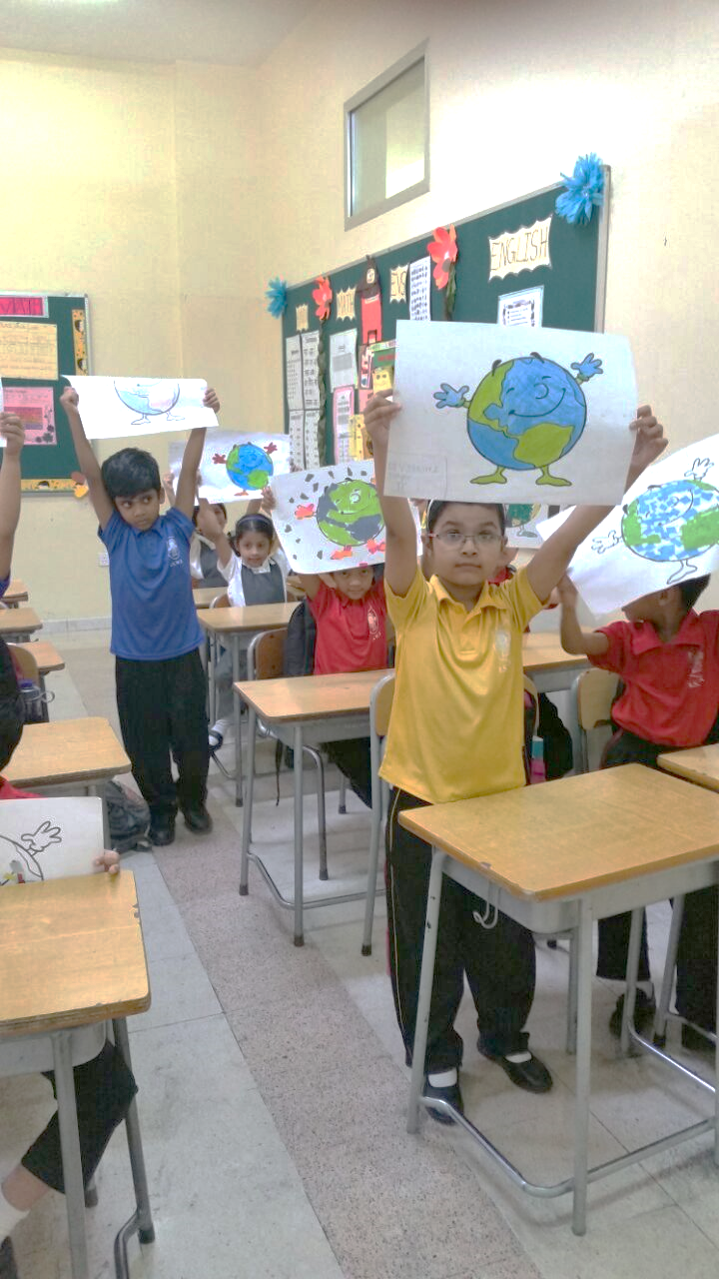

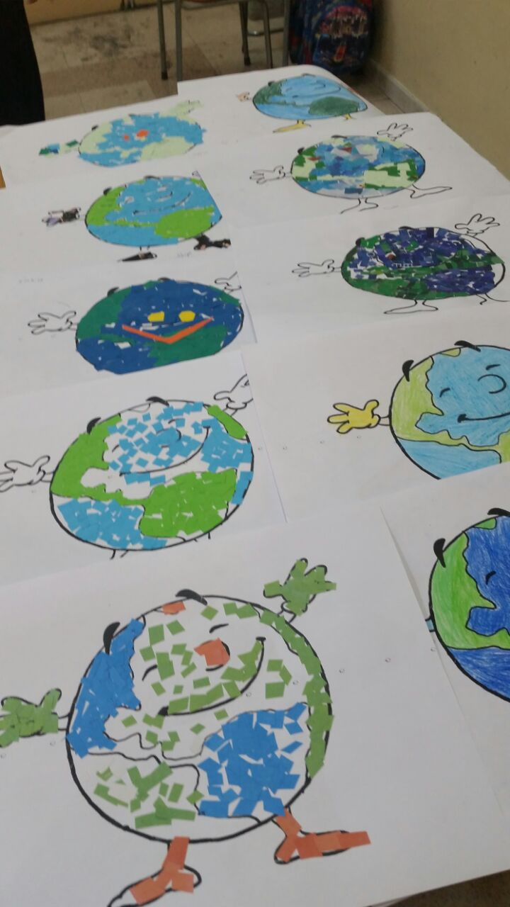

**Earth Day annually celebrated on 22nd April worldwide marks the anniversary of the birth of the modern environmental movement in 1970.**

**To commemorate the event, the week**

**(16th – 20th April) celebrated by class II in the**

**Afternoon Shift, was filled with an assortment**

**of activities. Children were given**

**opportunity to showcase their talent which**

**encouraged collaboration and fostered**

**their creativity.**

* **17th April – Video on Earth Day.**
* **18th April – Q.C.T Session**
* **20th April – Collage Making Competition**

**The children participated**

**with great zeal and vigour and**

**presented their**

**fascinating collages.**

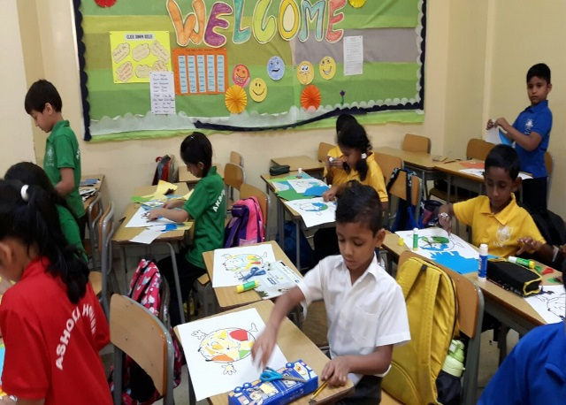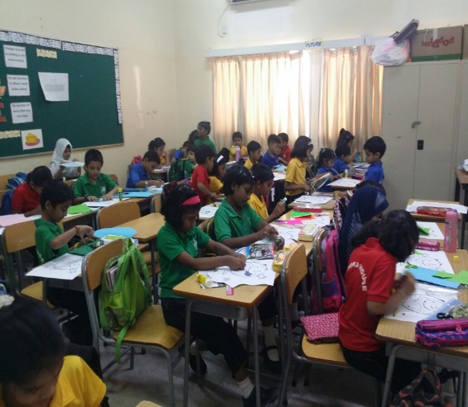

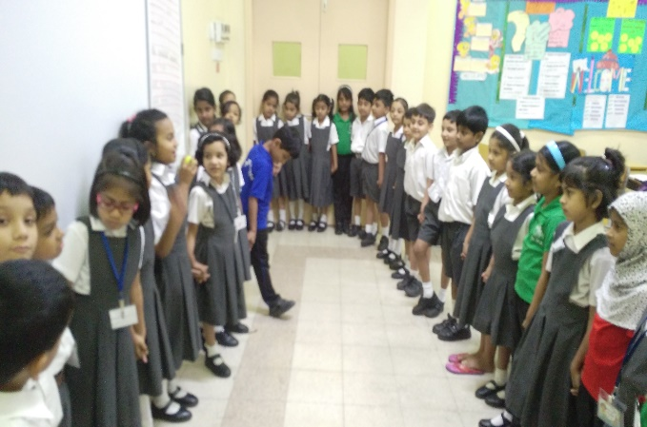

[](http://www.google.com/url?sa=i&rct=j&q=&esrc=s&source=images&cd=&cad=rja&uact=8&ved=0ahUKEwjwxuGVpfvTAhWPSxoKHQL2BQIQjRwIBw&url=http://cwallpapersgallery.blogspot.com.br/2015/04/&psig=AFQjCNEqaPWInT5HxRHkSk0PuwSD4jEZjw&ust=1495260313022928)

CONGRATULATIONS

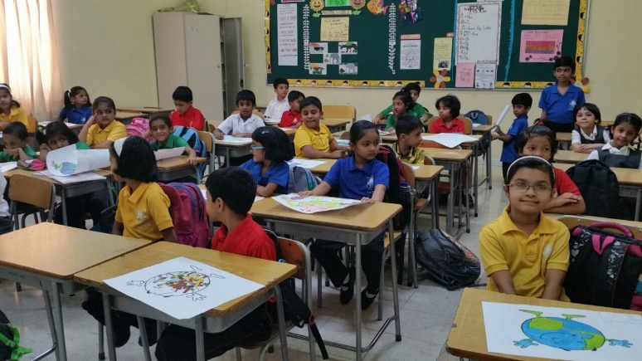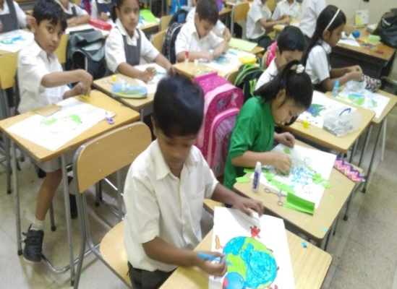

II K – LAKSHMI VIDYA SANDEEP

JOHAN JOBY JOHN

JASON ITHIEL SAM

II L – ANVITHA.P

SANDRA MARIYAM

MALAVIKA SREEJITH

II N – SARVESH VINOD PANJWANI

ARSLAAN AZIZ MANKAR

ALMOULA VRISHANK KUNAL

II M – NAAWED NAIR AHMED

ANIKA PUTHANVEEDU

AADHANA S.I. SUBHA

**to the little winners**

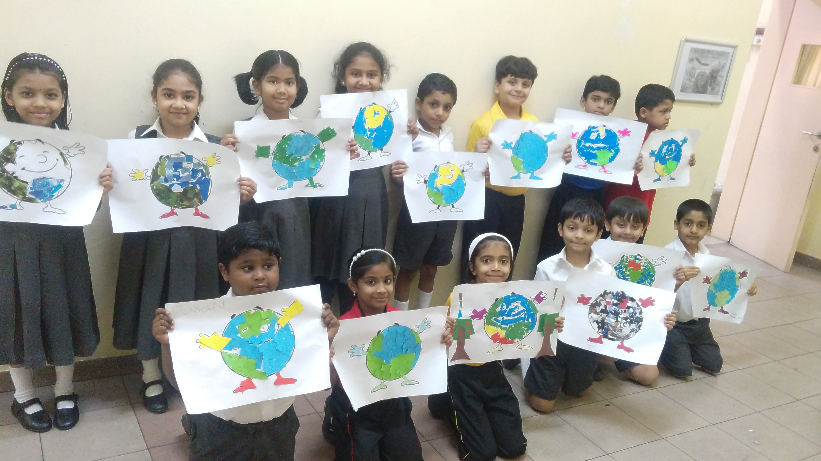

II O – UMAR FAROOQ SHAIK

RICHA VIJAY BHAGAT

MOHAMOOD HASAN

**We are proud of you and your accomplishments.**

**We are confident that you will continue with even more enthusiasm.**