INDIAN SCHOOL AL WADI AL KABIR

EARTH DAY ACTIVITY
(AFTERNOON SHIFT 2017-18)
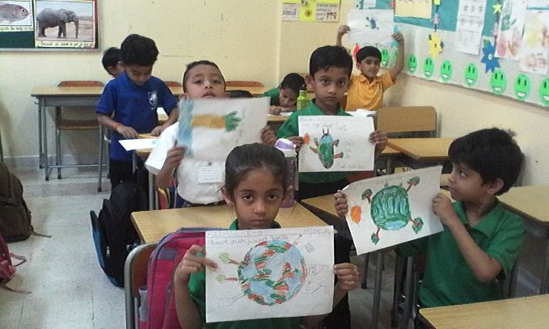
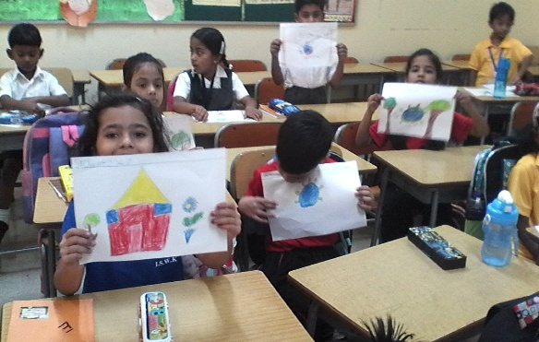
(AFTERNOON SHIFT)

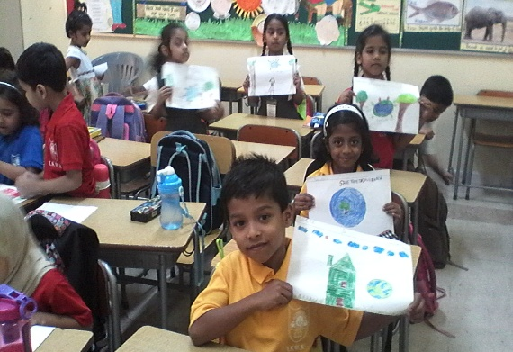
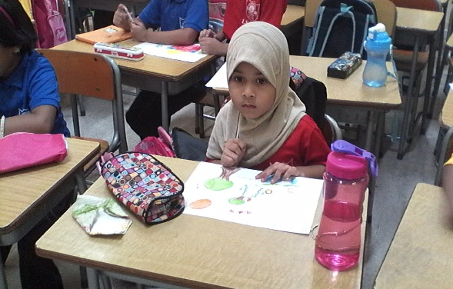

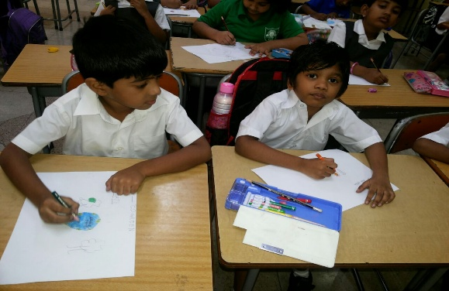
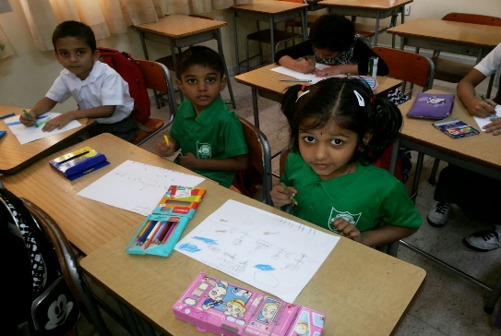

INDIAN SCHOOL AL WADI AL KABIR
EARTH DAY ACTIVITY
CLASS I (AFTERNOON SHIFT)

The Earth Day which is celebrated internationally on April 22nd every year offers opportunities to both, teach about the issue and make a tangible environmental impact. ISWK – Afternoon Shift organized a medley of activities for the students of Class 1 to commemorate the event.

On 17th April 2017 the children were made to watch a video on Earth Day which was followed by a QCT session on 18th April wherein children had to share ideas on their awareness to save the planet. The Poster Making Competition was held on 20th April 2017. The children participated with great enthusiasm. They exhibited their talent through their art work. The theme for the competition was “SAVE OUR PLANET EARTH”.

The students expressed their ideas through colour and form, many of them using black for polluted Earth and blue and green colours to represent eco-friendly land accompanied with relative captions and slogans. It was a great opportunity to watch these young minds trying to create their ideas of a better environment on paper.
