**INDIAN SCHOOL AL WADI AL KABIR**

**EARTH DAY ACTIVITY**

**CLASS I & II (AFTERNOON SHIFT)**

**Earth Day began on April 22nd, 1970 and has been an important day ever since. It’s a day to reflect on our planet, our environment and what we can do to keep them healthy.**

**Children have the most important stake in keeping our planet healthy. Younger children can get a feel of what Earth Day is all about by making craft items, singing songs, colouring pictures, etc. Keeping this in mind, ISWK, Afternoon Shift, organized craft making competitions on April 22nd, 2018 for the students of Classes 1 & 2 to commemorate the event.**

**Students of Class 1 made recycled bins using a cardboard box and highlighted the importance of the three R’s: Reduce, Reuse and Recycle.**

**A paper tree craft making competition was conducted for the students of Class 2. Through this competition, the students promised to save trees so that our planet Earth will remain healthy and beautiful.**

**The little ones of both classes displayed their creativity and presented their learnt ideas in the best possible way.**

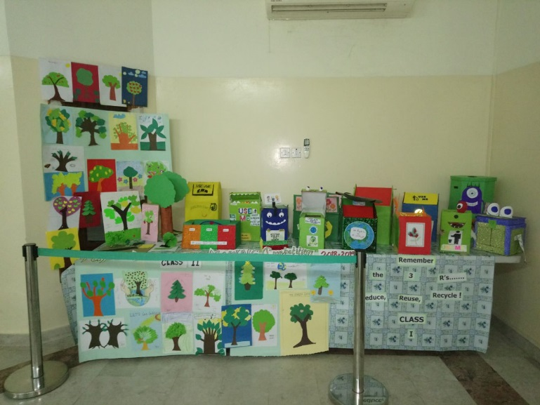

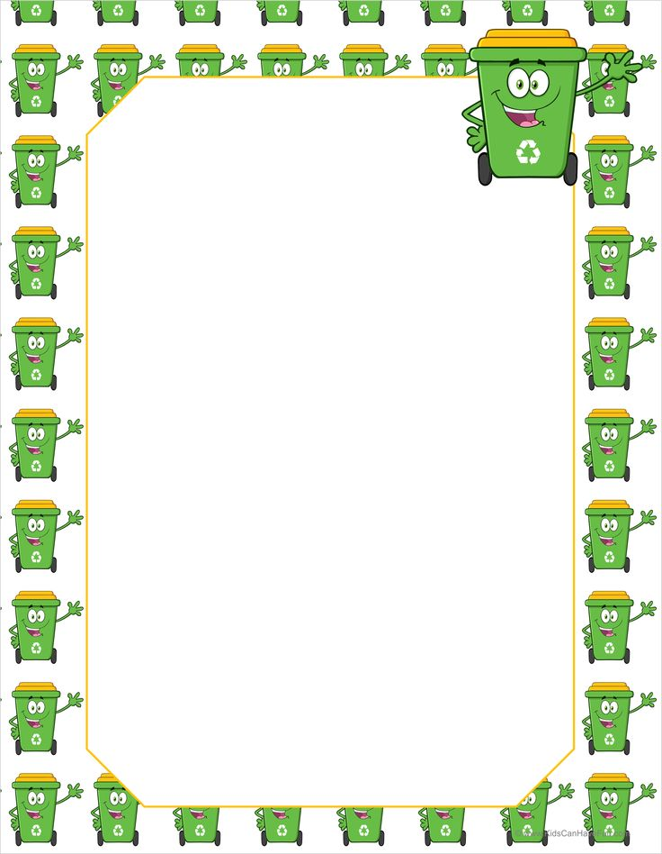

**CLASS - I**

**Recycle Bin using**

**cardboard box**

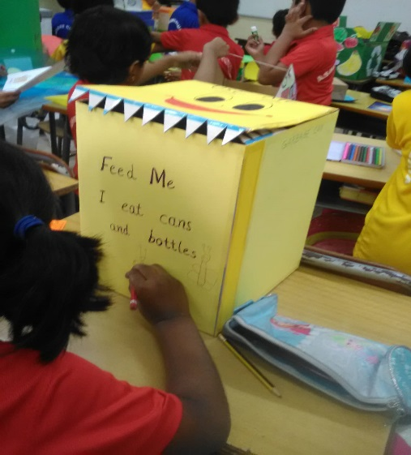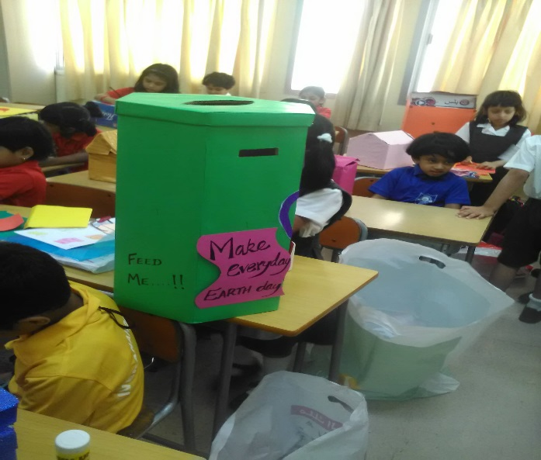

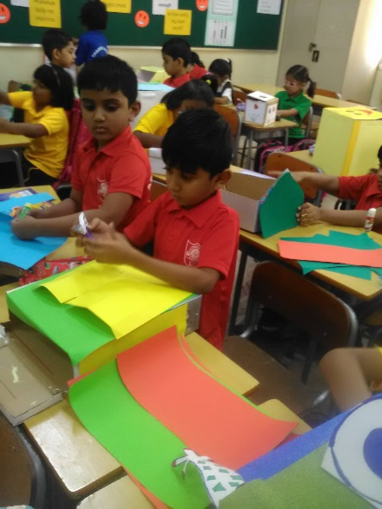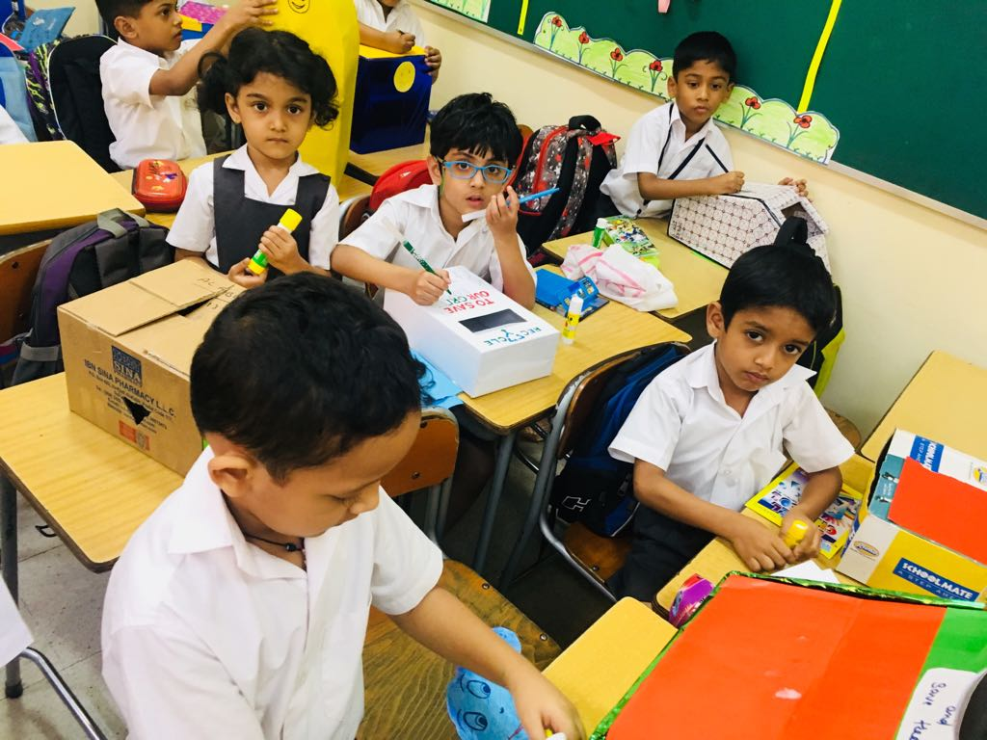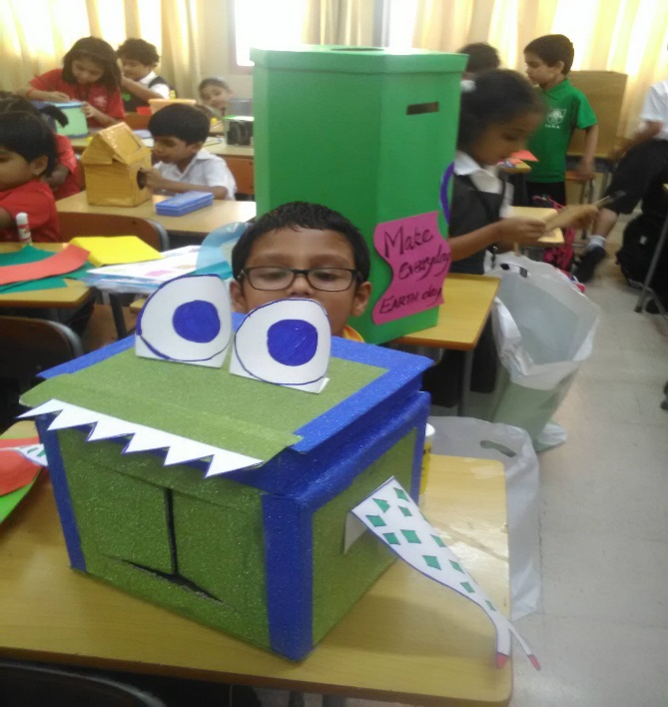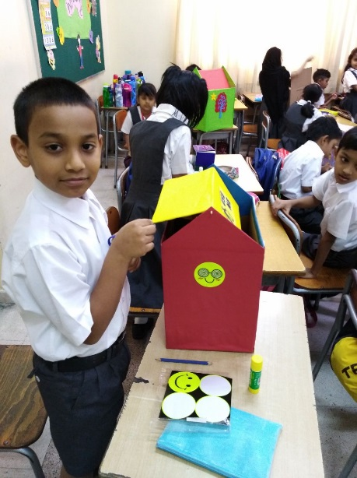



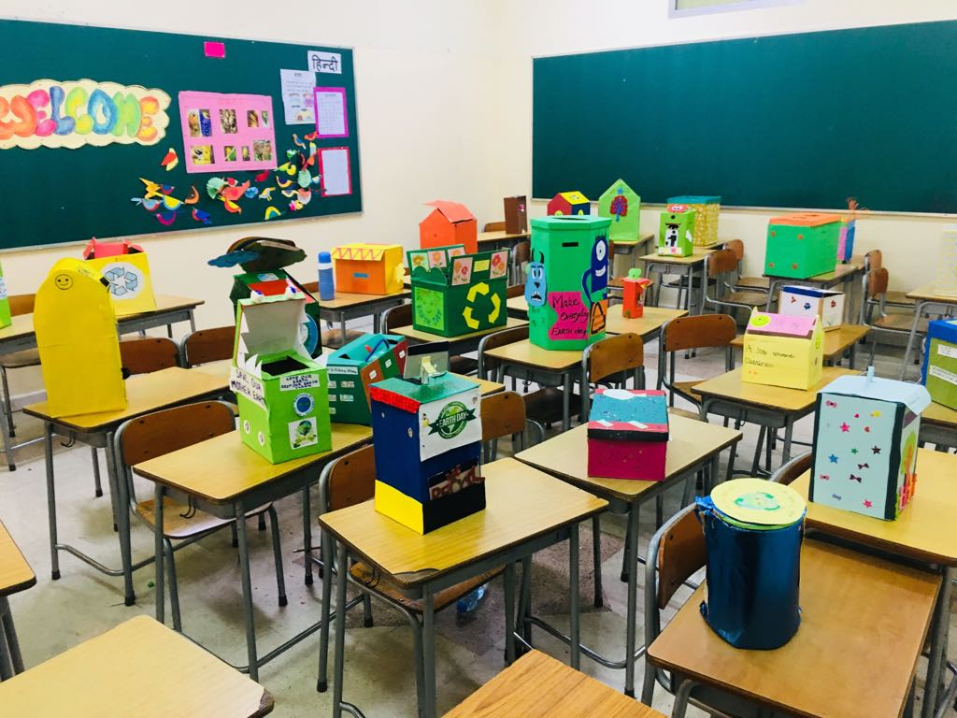

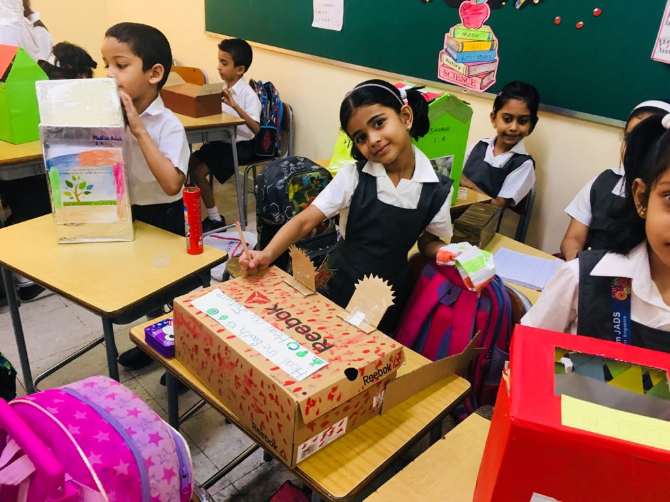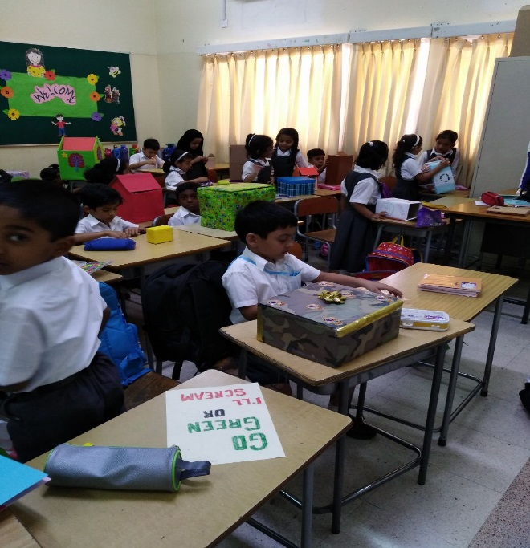

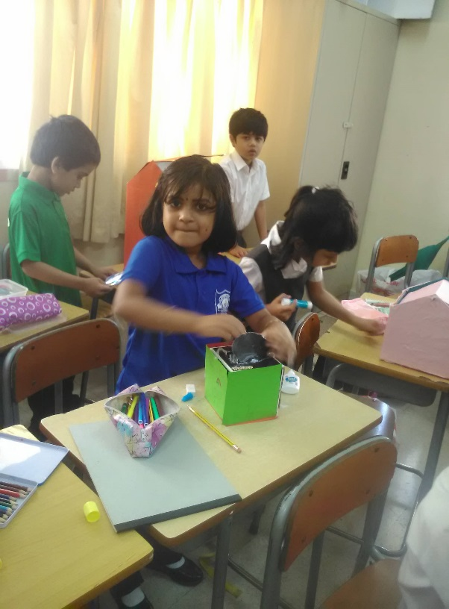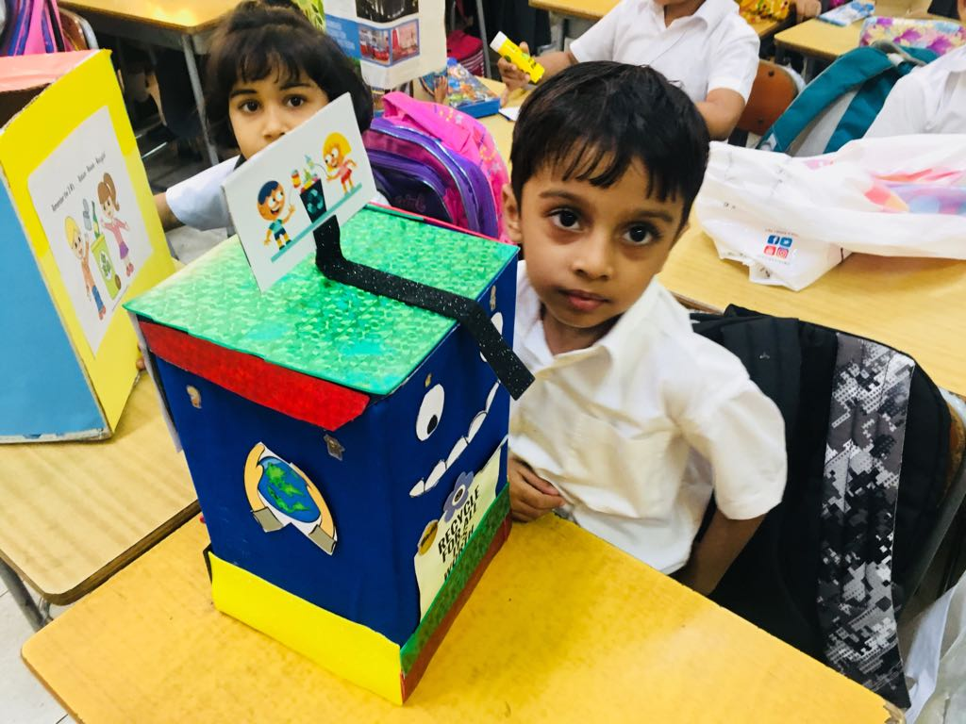

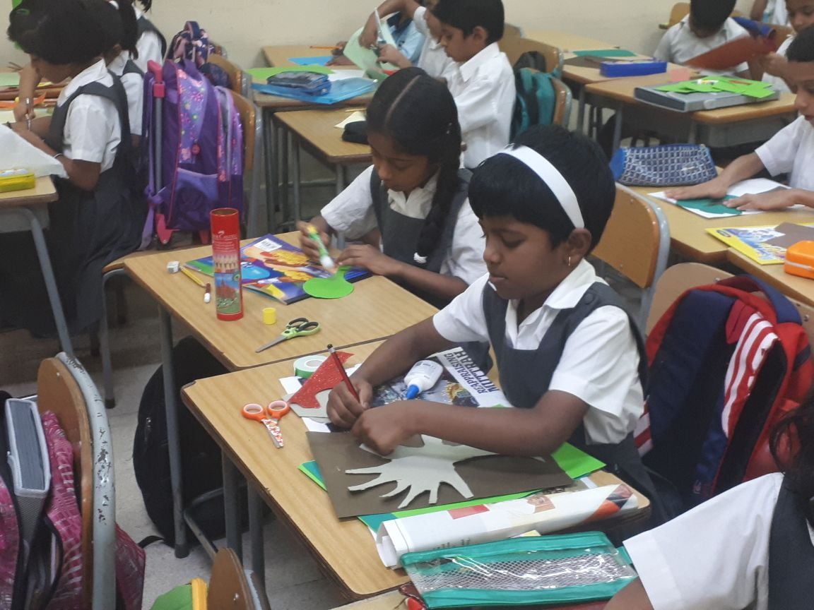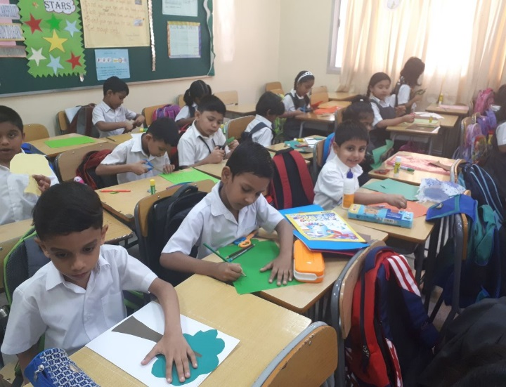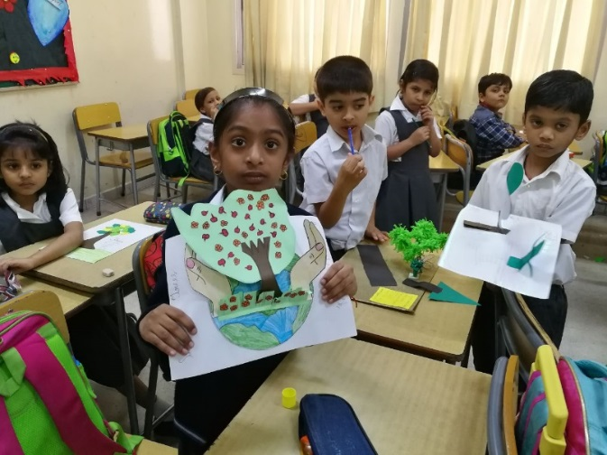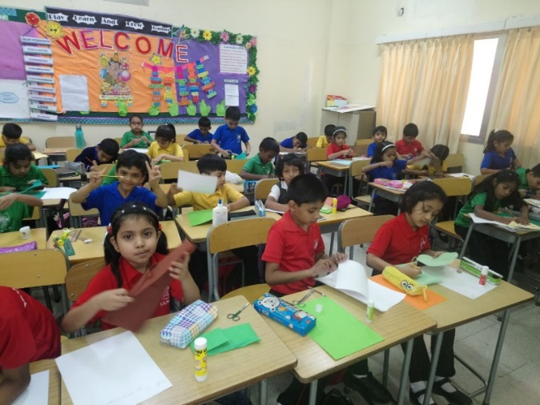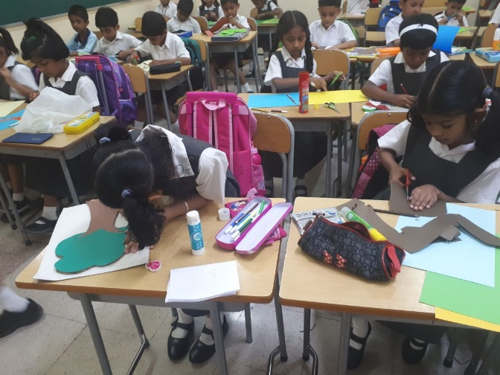

**Paper Tree Craft**

**CLASS-2**

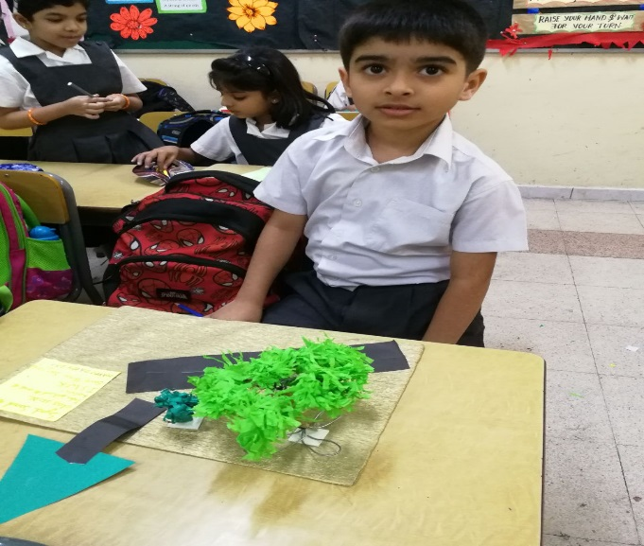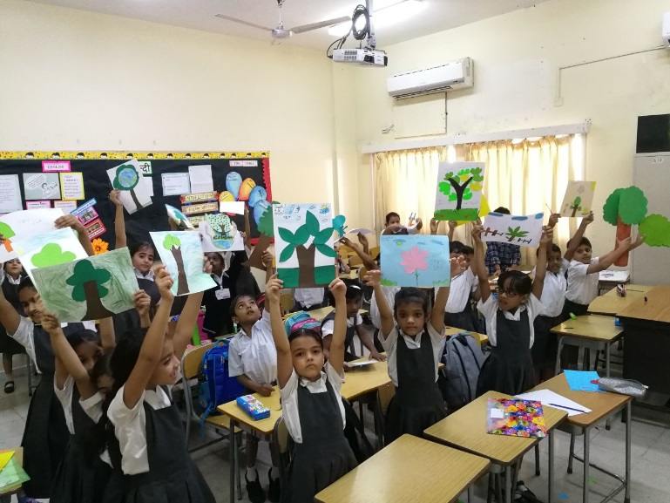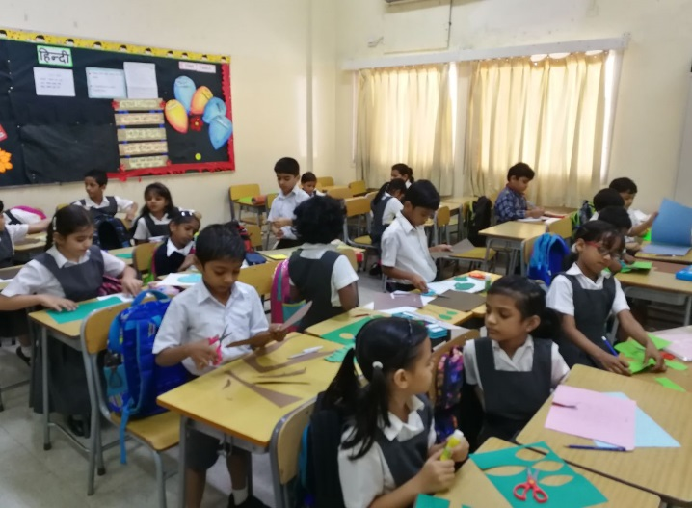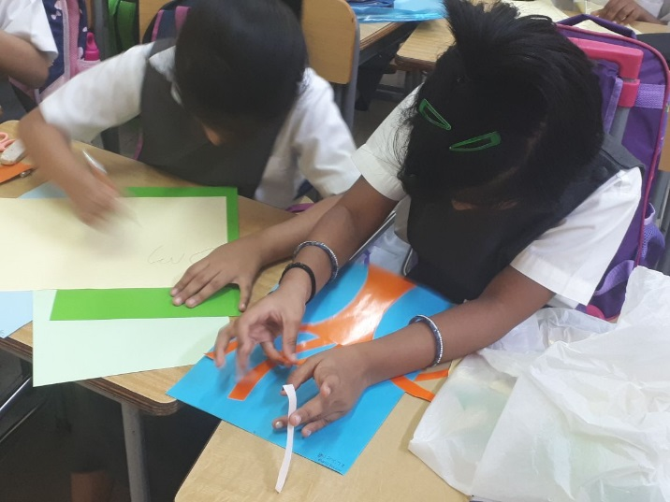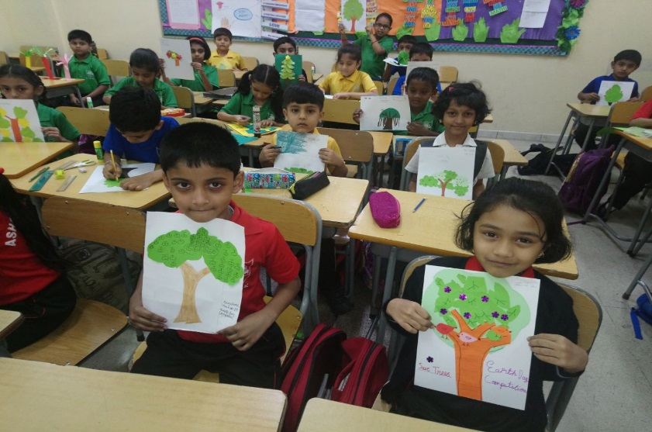





NILESH BISWAL (I-J)

CHIRAAYU (I-K)

TANMAYI (I-L)

SECOND PLACE

FIRST PLACE

**GRADE-1**

ISRA SAMEER (I-J)

SAMARTH (I-K)

DRISHTI HEDGE (I-L)

YASHVASIN GHODKE (I-J)

CATHERINE (I-K)

SREEVEDHIKA (I-L)

THIRD PLACE





**GRADE-2**

FASIYA (II-K)

TAHSEEN FATHIMA (II-L)

SAI KIRAN POOJARY (II-M)

SYED SAAD AHMED (II-N)

AADI SRIKESHAV KRISHNAKUMAR (II-K)

ROYCE JOSON (II-L)

DAKSHITHAA SUTHAKAR (II-M)

GAURI SIVA (II-N)

FIRST PLACE

SECOND PLACE

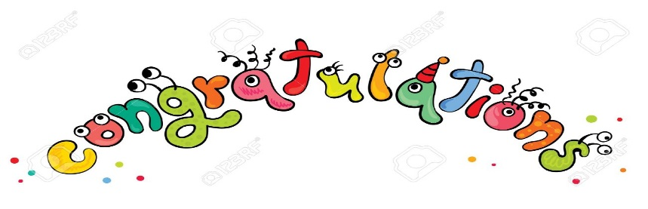

ANUSHRI PRASAD (II-K)

RAVLEEN ELSA ROCKSON (II-K)

HARINI SRI SARAVANABABU (II-L)

ESHAN NISAR (II-M)

ALAN MUHAMMED KATTMADAM (II-N)

THIRD PLACE