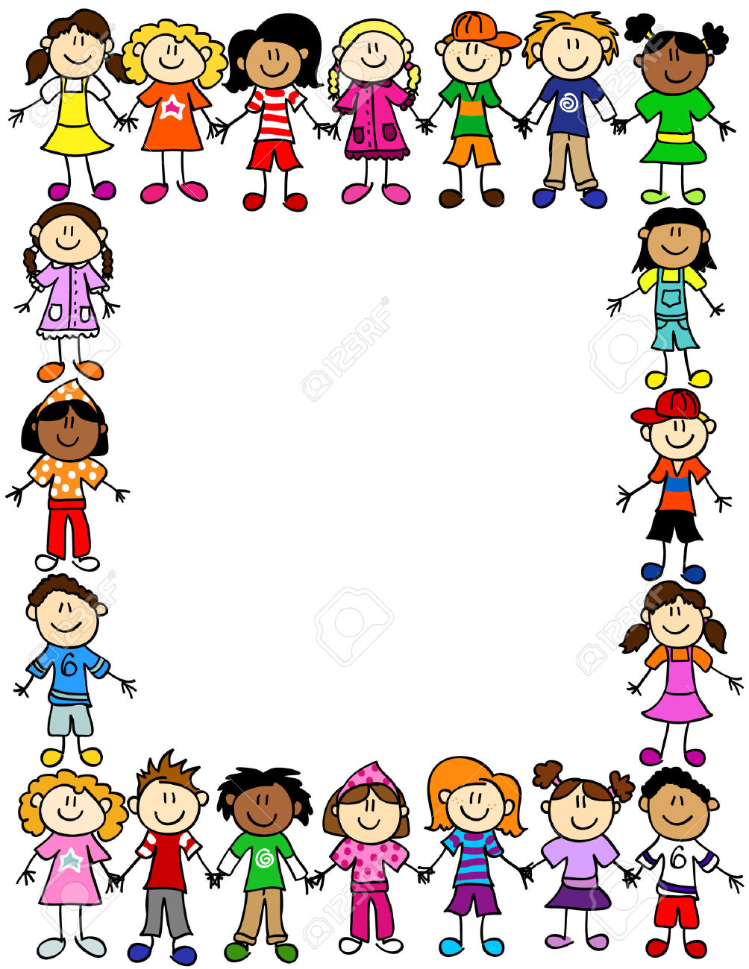

The concerts held this year was an amazing success! The children performed with great ease, confidence and immense talent. The concerts are an integral part of our co – scholastic activities and play a major role in our curriculum. They not only build confidence in the child but they also gain a great sense of responsibility.

\

