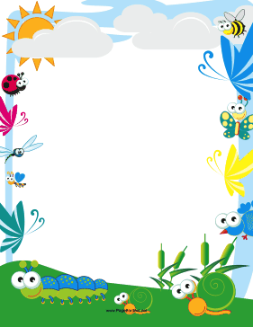

***ENGLISH WEEK (2017 -2018)***

***PRIMARY DEPARTMENT***

***CLASSES III, IV & V***

“Language is the dress of thought.” ‒ Samuel Johnson”

Classes III, IV & V of the Primary Wing celebrated English Language by organizing an English Week from the 6th to 10th August 2017, wherein many competitions were organized. It was a week of excitement, with the children being fruitfully engaged in various tasks.

The basic objectives of organizing English Week this year were as follows -

* to arouse students’ interests in the language
* to introduce students to the joys of public-speaking, writing poetry, making advertisements and comic strips
* to broaden students’ horizon in fictional and non-fictional material through games and activities
* to arouse students’ interests in learning English through language games

In order to achieve the above mentioned objectives, different activities were conducted. Some of the competitions were storytelling, spell bee, show and tell, crossword and handwriting, poetry writing, editing, book reviewing, making advertisements, aural comprehension, JAM, etc.

In conclusion, the students and teachers emerged wiser and more knowledgeable about English in the first maiden experience of English Week. It was truly an enjoyable and enriching time. We all look forward to the next academic year and shall come up with even more interesting and challenging activities for the students.

The week concluded with rich experiences for students and enhancement of their interest in various literary areas.

The maiden experience of the English Week at ISWK was truly enriching.



