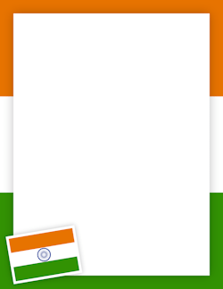

**GANDHI JAYANTHI SPECIAL ASSEMBLY**

**PRIMARY AFTERNOON SHIFT**

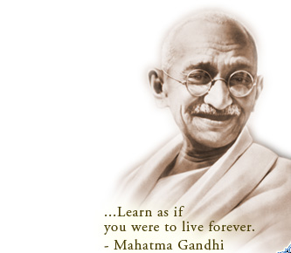

**M.K. Gandhi was a person who will always be in our hearts.  He is also known as ‘Bapu’ or ‘Father of the Nation’.  He has also earned the title of ‘Rastrapita’.  His full name is Mohandas Karamchand Gandhi. Born on 2nd October 1869, Porbandar, Gujarat.**

**The Gandhi Jayanthi Assembly was held by the Afternoon Shift students of classes I L and II N on 2nd Oct 1208 highlighting the life of M.K. Gandhi . The young talent performers conveyed their message very forcefully effectively through their dance and short skit.**