GANDHI JAYANTHI celebrations at iswk primary wing

Class v [morning shift]

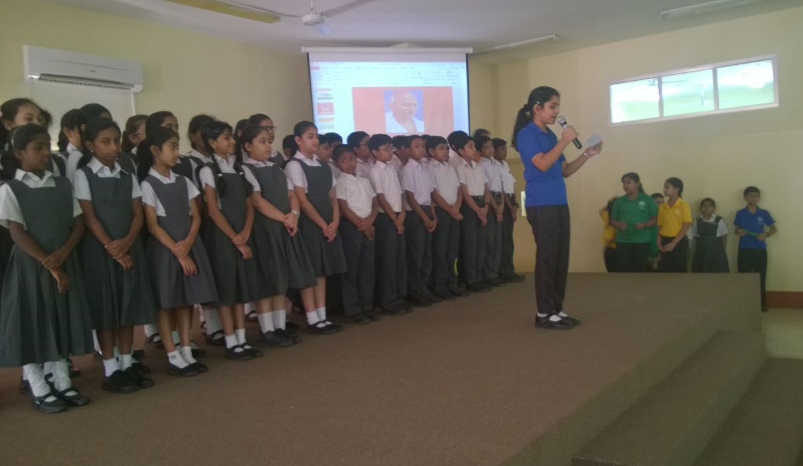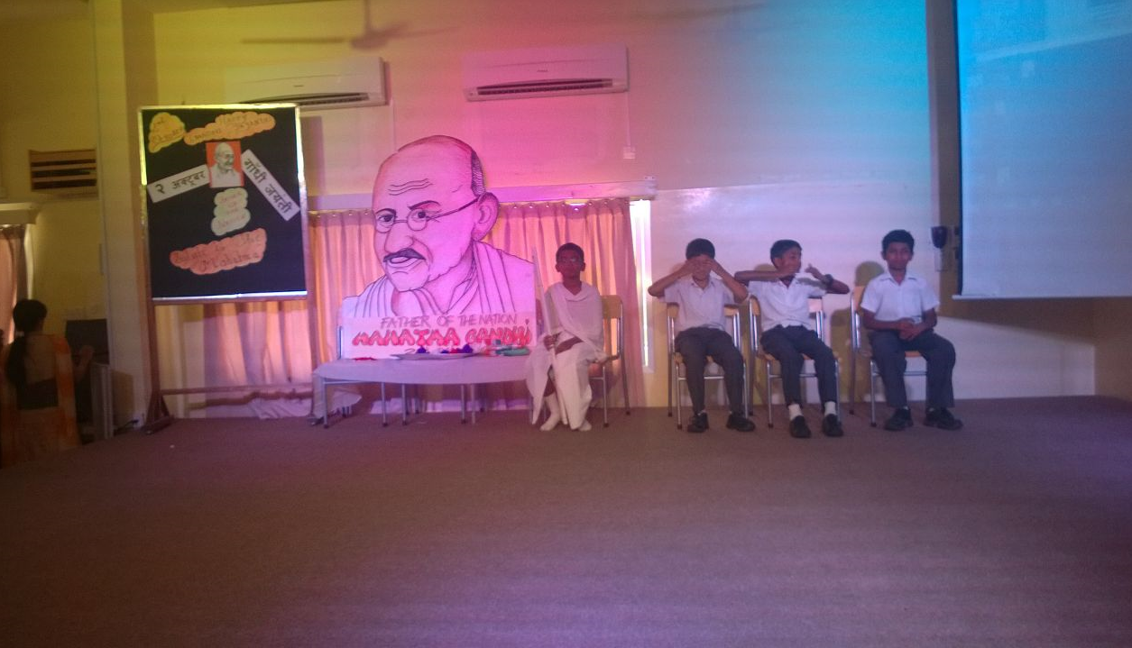

GANDHI JAYANTHI celebrations at iswk primary wing

Class v [morning shift]

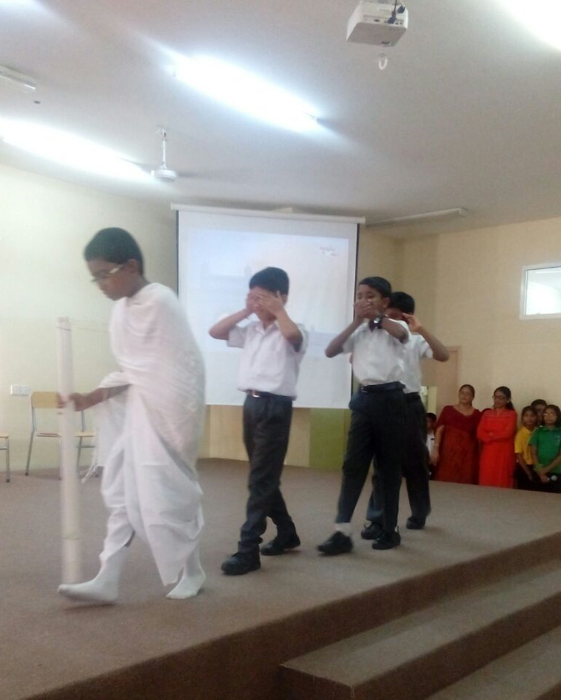

GANDHI JAYANTHI celebrations at iswk primary wing

Class v [morning shift]

