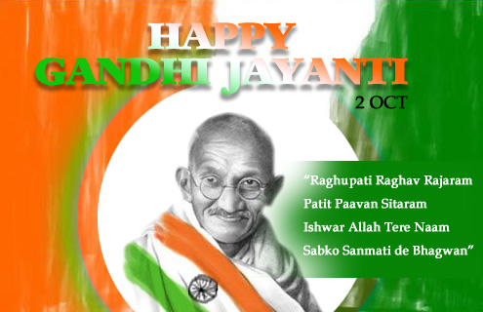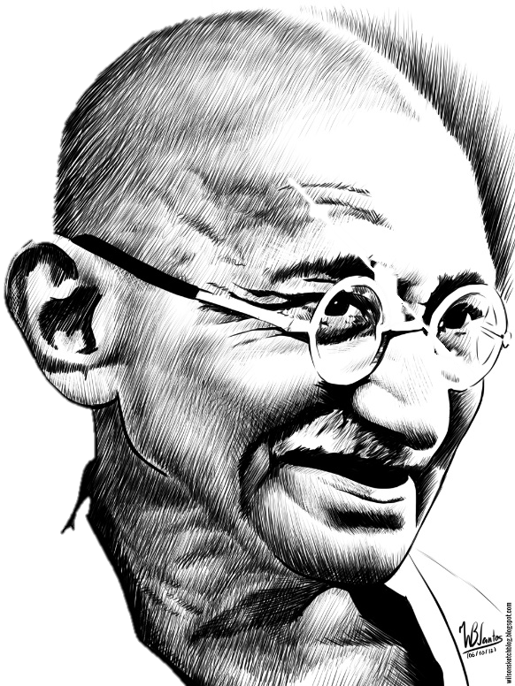

On October 2, 2017 the students celebrated the birth of Mahatma Gandhi by starting their school day with a Special Assembly presented by the Grade II students.

A skit on Mahatma Gandhi’s life was presented by the students which emphasized on the moral principle of honesty. Gandhiji’s principle of non-violence was also depicted and explained to the children. A dance was also presented. A student of class II K, Moin, presented a Hindi poem as a tribute to the Father of the Nation. Finally a video showing the life of Gandhi was also presented to educate the children.

A quiz was later conducted on Mahatma Gandhi which further enlightened all the students. The Vice Principle addressed the students on the importance of truth, honesty and cleanliness. We also conducted the Swachh School Abhyan on this occasion. Here is a glimpse of the Gandhi Jayanthi Assembly.



